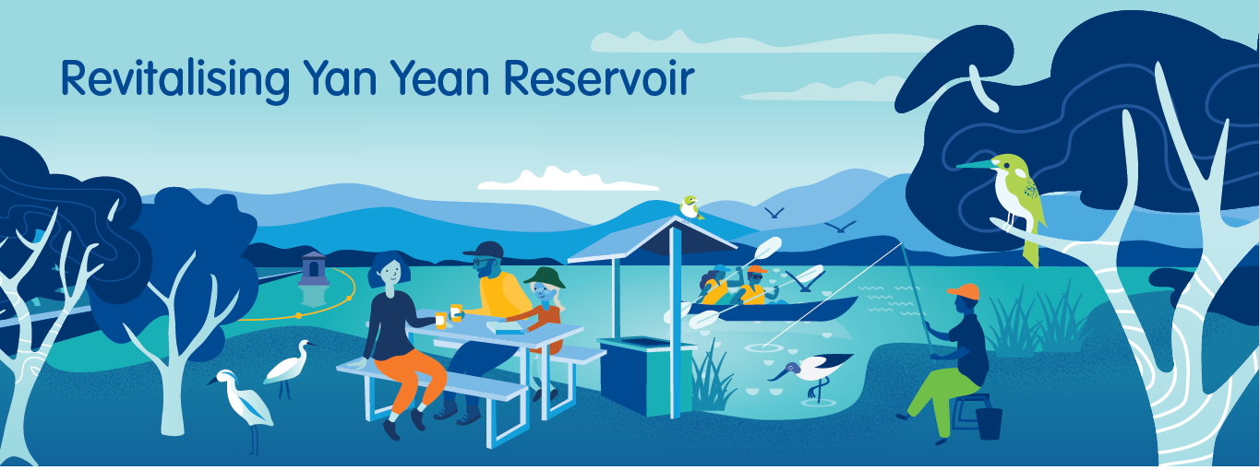

Revitalising Yan Yean Reservoir
Phase One Engagement Findings

Project overview
Melbourne Water is exploring new ways Yan Yean Reservoir can offer recreational and open space opportunities for the community. The ‘Revitalising Yan Yean Reservoir’ project builds upon the previous technical investigations and social research to explore ideas with the community that will be considered in the development of a Draft Master Plan for Yan Yean Reservoir.
Phase 1 engagement took place during April and May 2022. The purpose of this engagement was to understand what the community values about Yan Yean Reservoir, their aspirations for its future use, and hear any concerns or considerations for additional features and activities. This engagement also aimed to build community understanding of the existing function and values of the reservoir and to promote the potential benefits of offering new recreational and open space opportunities. This summary report presents key findings from Phase 1 engagement for this project.

How did we engage?
A range of events and activities were undertaken with the community to promote the project and seek their ideas. These included:
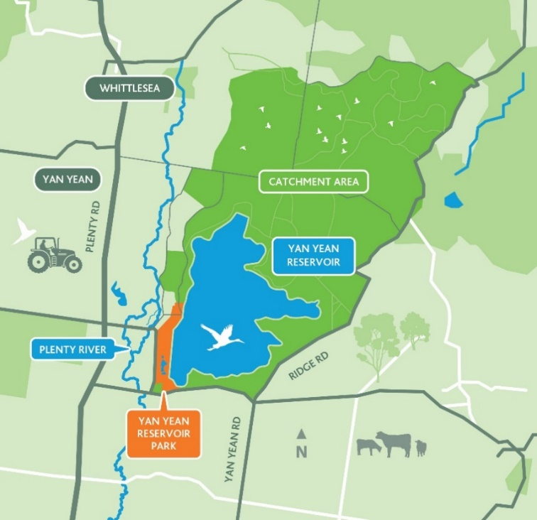
- an online survey
Figure 1: An image showing the location of Yan Yean Reservoir
- three community information sessions in high-traffic locations near the reservoir (Whittlesea Monday Market, Mill Park Library, Yan Yean Reservoir Caretaker’s Cottage)
- two site tours to show interested community members around specific locations in the closed catchment area of Yan Yean Reservoir
- a community workshop at Mill Park Library attended by a mix of residents, community groups, organisational representatives, and project partners (Council and Parks Victoria).

Who participated?
Approximately 936 participants were engaged and provided a wide variety of ideas to inform the preparation of the Draft Master Plan. Numbers included:
- 731 online surveys completed
- approximately 80 community information session participants
- 75 site tour participants
- 20 community workshop participants.

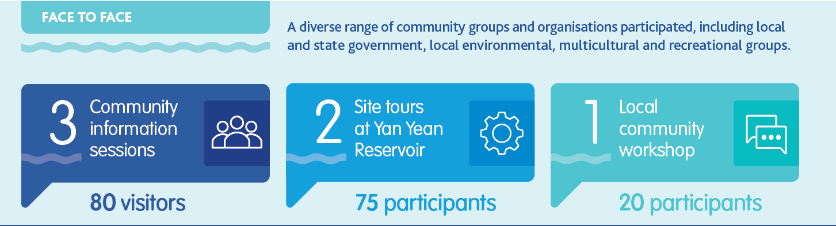

Community groups that may have an interest in the project were specifically invited to participate in the engagement. There was a total of 104 participants who identified that they belong to a community group or organisation, these included the following:
- cultural/community groups
- environmental groups
- multicultural groups
- recreational groups
- local groups/organisations
- local businesses
- local government
- Victorian government
Survey participants
Survey participants mostly lived in suburbs around Yan Yean Reservoir -Doreen, Mernda, Eden Park, Kinglake, Whittlesea, Humevale and South Morang. The heat map below shows the locations of the survey participants.
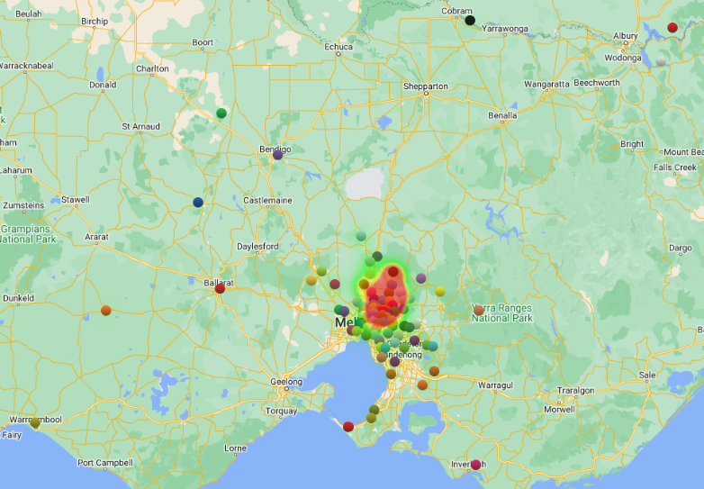
Figure 2: A heat map showing the locations of survey participants (dots represent participants’ postcodes) (n=725)

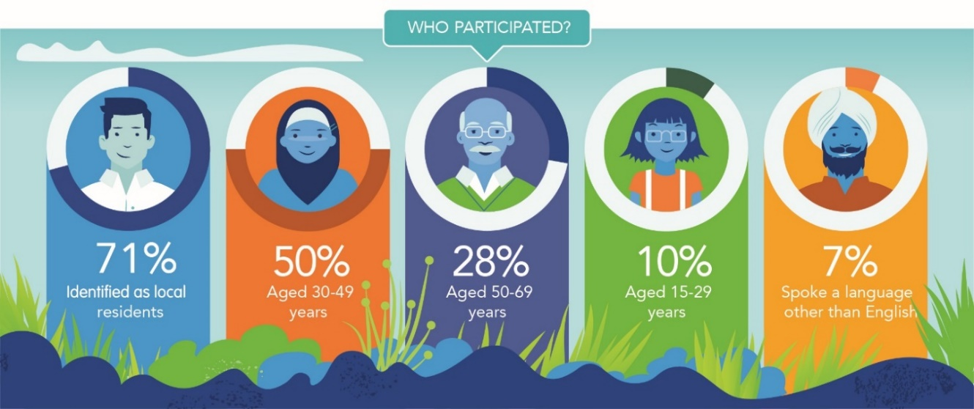
Figure 3: Key demographics of survey participants (n=731)
In addition, 2.4% of survey participants identified as Aboriginal / Torres Strait Islander.

What we heard

Overall
Participants across all engagement activities felt optimistic about the project. Most participants were excited to know that there may be an opportunity to enjoy more recreational spaces at Yan Yean Reservoir.

Values

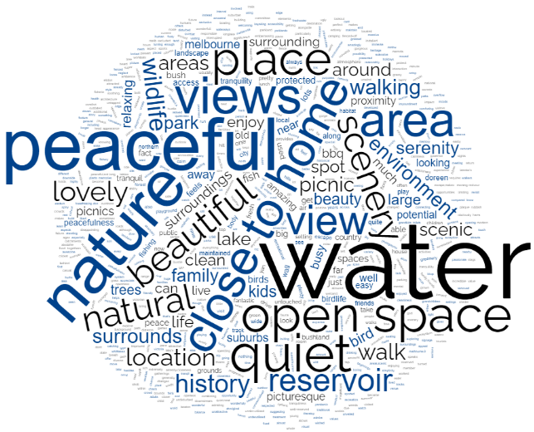
Figure 4 displays the key words from survey responses regarding what they value about Yan Yean Reservoir and surrounds.

Figure 4: Word Cloud summary of the key words appearing in survey responses to ‘What do you value about Yan Yean Reservoir and surrounds?’ (N=731)

These responses led to the main themes below.
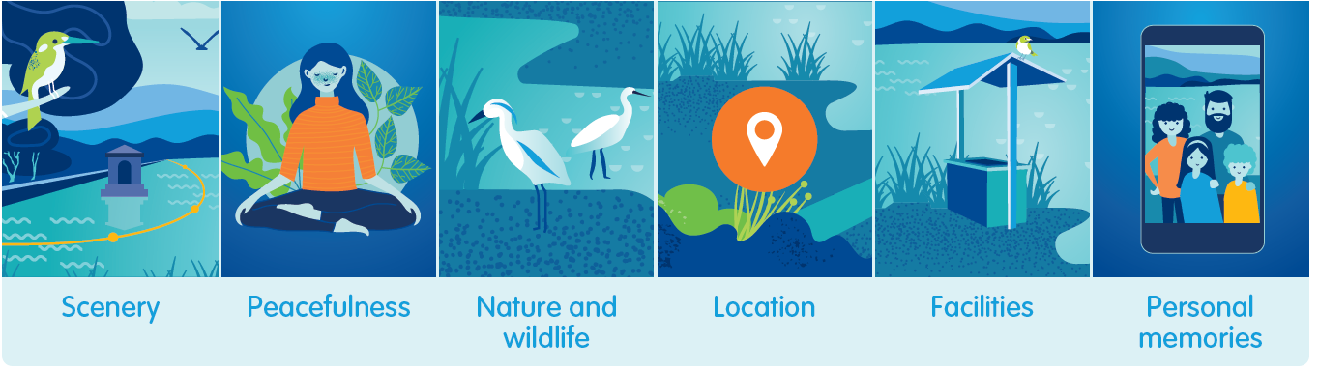
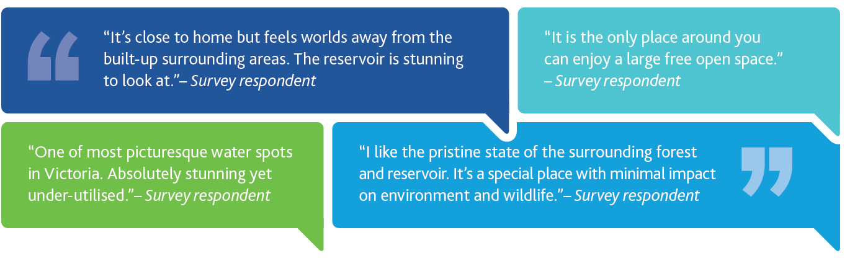

Ideas for future uses at Yan Yean Reservoir
Suggested ideas for future recreation at Yan Yean Reservoir included a range of active recreation, nature-based activities, social activities, and educational programs. Other suggestions from site tour and workshop participants included cultural and educational programs (for example a community café, cultural tours and signage, and Indigenous heritage programs).

The infographic below summarises the key ideas from survey responses.
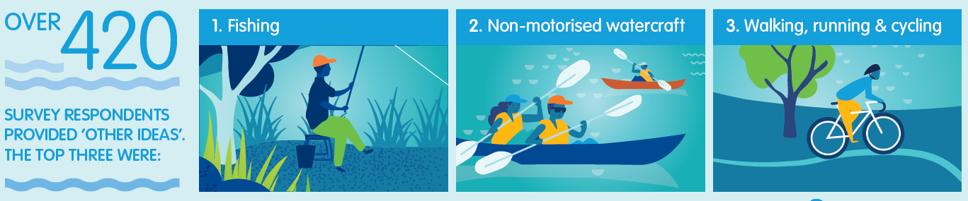
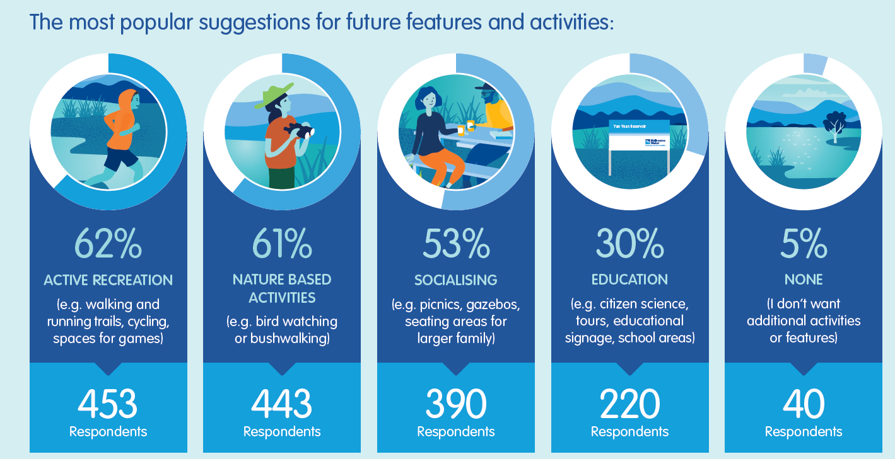

Benefits of additional features and activities
Participants noted that opening the reservoir for additional activities would bring a lot of benefits. These included:
- better meeting their recreational needs. Survey respondents often referenced the lack of available large open space close to home.
- increased social connection. Respondents mentioned the increase in features would increase their time spent with their family and friends.
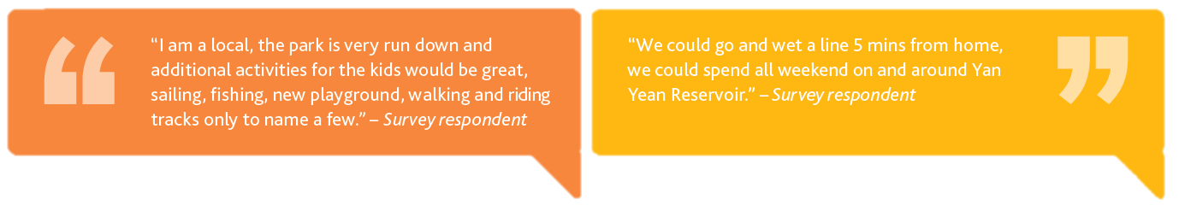
- improved mental and physical health. Respondents suggested that the increase in features would provide a space to relax and connect to nature.

Features to support diverse user groups
To ensure Melbourne Water could consider how best to support all community members being able to access and enjoy Yan Yean Reservoir, participants suggested a range of considerations, these included:
- improvements to park facilities
- additional outdoor equipment
- all-ability access, road access and parking
- seating, trails, signage
- security and safety features.
Workshop participants looked at potential challenges and opportunities for specific groups in the community, including the LGBTQIA+ community, people with disability, culturally and linguistically diverse communities and young people (aged under 30). Opportunities identified included safety features, all-ability access, use of community languages in signages and public transport.

Further considerations for the project
There were a broad range of concerns, challenges and considerations raised by participants as being important for Melbourne Water to for this project. These were captured in the following top three themes:
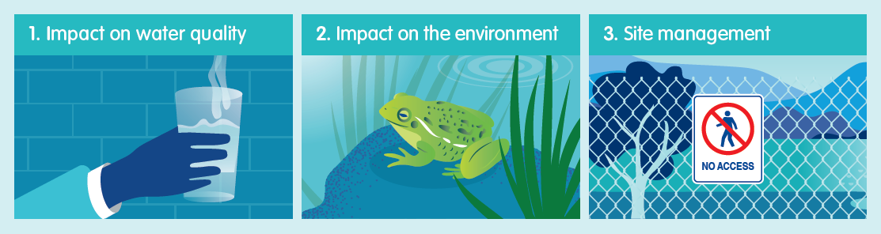
Impact on water quality: For example, concerns around the potential risk of reducing water quality if undesirable behaviour is not managed.
Impact to the environment: For example, concerns around potential increases in littering, risk of fire, or potential damage to existing natural habitat and threatened local wildlife.
Site management: For example, concerns about lack of staffing to monitor visitors’ behaviour, and disturbance to nearby residents.

Design principles to guide the development of the Draft Master Plan
Workshop participants were presented with a series of draft design principles. These principles were prepared to guide the development of the Draft Master Plan. They provide shared understanding and transparency of what drives decision-making in the master plan process. Applying the principles will help find the appropriate balance between potentially competing objectives.The draft design principles are listed below:
- Protect Melbourne’s world class drinking water.
- Enhance community health and wellbeing.
- Protect and enhance cultural values.
- Protect and enhance biodiversity.
- Protect and enhance heritage.
- Ensure a sustainable future for recreation at Yan Yean.
- Promote research, education and an engaged community.
Participants were asked about their level of comfort with the principles and if there are any gaps in the principles. Most workshop participants stated they were ‘comfortable’ or ‘very comfortable’ with these principles. Whilst no gaps were highlighted, participants did observe the potential for conflict between principles, for example, between increased visitation and protection of biodiversity and suggested further detail to be considered in applying the principles during the master plan process.

What’s next?
The findings from this phase of community engagement will be used to inform the development of a Draft Master Plan for Yan Yean Reservoir. Melbourne Water will undertake further technical investigations to understand how these community ideas could be designed and delivered in balance with the important existing function and values of Yan Yean Reservoir.
Please ensure you go to the YourSay ‘Revitalising Yan Yean Reservoir’ website and click FOLLOW to be kept up-to-date on the progress of this project.

