Maribyrnong River Flood Review
Engagement Report - Public Consultation and Submissions Stage
May 2023

Aboriginal Acknowledgement
Melbourne Water respectfully acknowledges Aboriginal and Torres Strait Islander peoples as the Traditional Owners and custodians of the land and water on which all Australians rely. We pay our respects to Bunurong, Gunaikurnai, Taungurung, Wadawurrung and Wurundjeri Woi-wurrung, their Elders past, present and future, as Traditional Owners and the custodians of the land and water on which we rely and operate.

Executive Summary
This report outlines the engagement activities undertaken to support and inform the public consultation and submissions stage of the Maribyrnong River Flood Review. Flood impacted residents, community members and stakeholders were invited to participate in the review over a two-month consultation period from 17 January to 17 March 2023. This process provided a vital opportunity for those impacted to participate and contribute to our understanding of the flood event. Contributions were invited in two forms:
- Submissions: for community and stakeholders wanting to provide input to be considered in relation to the matters included in the Terms of Reference of the independent flood review.
- Share Your Experience: for community with information to share outside the Terms of Reference of the independent flood review, including personal experiences of the flood event.
A total of 63 submissions to the Review were received and 51 personal experiences of the flood event were shared. All submissions have been provided to the independent Review Panel for consideration and published on Melbourne Water’s YourSay engagement platform. The final report from the Review Lead is anticipated to be released towards the end of 2023.
Flood impacted residents, community members and stakeholders were also invited to share their experiences and stories before, during the after the event. A collation of these personal stories and experiences of the October 2022 flood event have been published in the separate ‘Shared Experiences’ report. The stories and reflections captured in the Shared Experiences report provide a rich perspective and historic record of the event. As per our commitment to the community, we will share the report collating the collective stories and experiences of flood impacted residents with the independent Review Panel. It will also be shared with our partner agencies in flood management to inform lessons learned and any areas for improvement. The report has also been shared with community and stakeholders via the YourSay engagement platform
Six community information sessions were held throughout the consultation and submissions stage; four in person events and two online. Over 110 people attended across the six sessions. These information sessions provided the community an opportunity to learn about the independent Review process and scope, to share their experiences of the flood event and to connect and speak directly to Melbourne Water and representatives from our partner agencies involved in the flood event and recovery.
The in-person community sessions were supported by representatives from VicSES, impacted Councils (Maribyrnong, Melbourne, Moonee Valley, Brimbank), Emergency Recovery Victoria (ERV), Department of Families, Fairness and Housing (DFFH), Red Cross and Victorian Council of Churches Emergencies Ministry (providing counselling support for impacted residents).
A comprehensive communications program was implemented to inform residents and stakeholders about how they could engage, participate and contribute to the public consultation and submission stage, this included:
- Media announcement
- Community bulletin letterboxed to 32,275 impacted and nearby residents and businesses
- Social media posts targeted to impacted suburbs, re-shared by impacted Councils
- Maribyrnong Council community newsletter (weekly newsletter to impacted residents and businesses)
- Local Council channels (neighbourhood houses and friends of groups)
- YourSay engagement website live throughout the consultation period – all information available here, including how to make a submission.
Key Themes and Observations
This report includes a detailed summary of the following key themes emerging from the submissions received and stories and experiences shared during the public consultation and engagement phase.
- Flood Awareness and preparedness – before the event
- Inadequate information, warnings and alerts
- Observations of the flood event
- Agency Response – before during and after the event
- Community Spirit
- Ongoing impacts
- Insurance and property values
- Causes and contributors to the flood
- Flemington Racecourse Wall
- Planning and development decisions
- Rivervue
- Flood modelling
- Maribyrnong River Flood Review Terms of Reference
- Integrity of review
- Looking to the future – enhanced flood awareness and preparedness
- Looking to the future – flood mitigation strategies
The key themes summarised within this report reflect and represent Melbourne Water’s observations about what we have heard from community throughout this stage of the review, and are independent of the Review Panel’s consideration of submissions. The views and opinions expressed within the key themes included in this report represent the voice of participating community and stakeholders, and are not the views or opinions of Melbourne Water, or the independent Review Panel.
These observations will help to inform Melbourne Water’s response and our work with partner agencies as we determine next steps in addressing the lessons learnt through this process.

Table of contents
Executive Summary 3
Introduction 7
About the Review 7
About this report 8
Engagement Approach 9
Objectives 9
Our approach 9
Engagement design considerations 10
Overview of Engagement Activities 11
Submissions 11
Share your experience of the flood event 12
Community Information Sessions 12
Information and communications 14
Key findings 18
Number of contributions 18
Key themes – what we heard 18
Post event evaluation 26
Next steps 28

Introduction

About the Review
On Friday 14 October 2022, significant flooding of the Maribyrnong River occurred. In response, an independent review was established by Melbourne Water to investigate the flood's causes and contributors within the urban part of the catchment. The Maribyrnong River Flood Review is being undertaken by an independent Review Panel and is guided by a Terms of Reference which detail the review process, scope, and role of the independent Review Panel.
The review will be delivered over six key stages, outlined below:
Date | Stage | Status
17 January – 17 March 2023 | Public consultation and submissions period | Complete
April 2023 | Submissions publicly released and provided to Review Lead | Complete
May 2023 | Community Shared Experiences Report published  Update to community on review progress | Complete
May – August 2023 | Review Lead considers submissions and all relevant information, conducts meetings, consultations or site visits as required | In progress
September – October 2023 | Review Lead writes up report and submits to Melbourne Water | Not started
November 2023 | Anticipated public release of the Review Report | Not started
Table 1 - Key Dates

To support the submissions stage of the review, Melbourne Water undertook a 2-month public consultation and engagement program which occurred from the 17January to 17 March 2023. During this engagement program, community and key stakeholders were invited to contribute to the review in one of two ways:
- by making a submission to the independent Review Panel addressing the Terms of Reference.
- by sharing experiences – acknowledging the scale of community impact, Melbourne Water invited community impacted by the flood event to share their stories and experiences of the October 2022 flood event.

About this report
The purpose of this report is to document the engagement and communications activities undertaken to support the Public Consultation and Submissions stage of the Maribyrnong River Flood Review which occurred from 17 January 2023 to 17 March 2023.
The first section of this report provides an overview of the engagement objectives and activities that were undertaken. The second section of this report summarises the findings from this engagement, including a summary of the key themes that have emerged from what we heard from flood impacted community, residents, businesses and stakeholders.
A second report known as the Maribyrnong River Flood Review – Shared Experiences Report captures the collective stories, experiences and images shared by flood impacted community members through the engagement process. This report is available on the YourSay engagement page.
Melbourne Water would like to acknowledge and thank the community members who participated in the public consultation and submissions stage of the review and thank those who made a submission and shared their experiences of the 2022 Maribyrnong River flood event.

Engagement Approach
This section provides an overview of the objectives and engagement approach that underpinned the public consultation and submissions stage of the Maribyrnong River Flood Review.
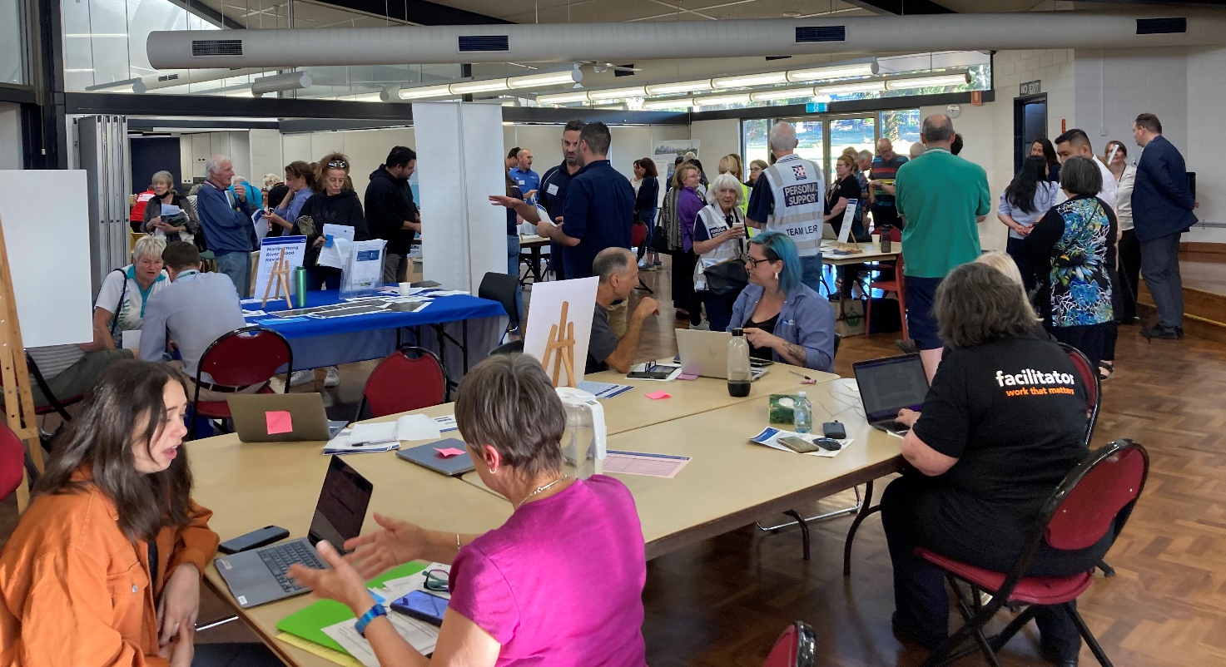
Image 1: Maribyrnong Community Information Session

Objectives
The purpose of the engagement was to:
- Inform flood impacted residents, community and stakeholders about the independent Maribyrnong River flood review process.
- Enable flood impacted residents, community and stakeholders to make a submission to the Flood Review.
- Listen to and capture the community’s experiences before, during and after the Maribyrnong River flood event to help inform Melbourne Water’s and other agencies, understanding of the event.
- Respond to questions, concerns, share knowledge and information about flood management.
- Provide flood impacted residents and the community a forum and channels to engage, be heard, valued and respected, acknowledging the trauma that many had experienced and are still facing.

Our approach
Melbourne Water conducted a comprehensive two month public consultation and engagement program, from 17 January to 17 March 2023.
During this engagement program, flood impacted residents and key stakeholders were invited to contribute to the review in one of two ways:
- by making a submission to the independent Review Panel addressing the Terms of Reference.
- by sharing experiences – acknowledging the scale of community impact, Melbourne Water invited community impacted by the flood event to share their stories and experiences of the Maribyrnong River flood event.
Make a submission | Share your flood experience |  | 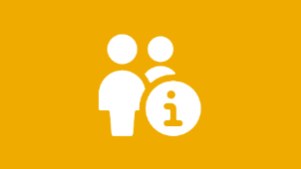  Attend a community information session
Share information and views relevant to the Terms of Reference of the independent Flood Review by making a written submission online, via email or post | Share information outside the scope of the Independent Review including personal stories and images at one of the community information sessions, online, via email or post |  | Attend one of two on-line or four in-person community information sessions to learn more about the review and submission process, share flood experiences and at the in-person sessions, to speak with the various agencies involved in the flood event
YourSay Engagement  Hub for online engagement |  | Enquiries  via a dedicated project inbox, the Melbourne Water enquiries phone number or at a community information session
Figure 1 Engagement activities

Engagement design considerations
The design of the engagement was informed by an understanding of the community demographics of the flood impacted areas. Local council representatives were also consulted throughout the planning, design and delivery of the engagement phase to help inform the engagement approach. From this, two primary characteristics were identified:
- engaging with community post disaster, including displaced residents
- engaging with culturally and linguistically diverse communities.

These characteristics informed the design considerations for our engagement approach, these included:
- Community information sessions were delivered as a mix of online and place based in-person events. Sessions were scheduled on both weekdays and weekends.
- The in-person sessions were designed as ‘drop-in’ sessions allowing residents and community members the opportunity to speak one-on-one with Melbourne Water, local council and flood management agencies.
- Psychological first aid was available at each of the in-person community information sessions.
- All information on the YourSay engagement platform was translated into the top five languages relevant to the flood impacted communities - Vietnamese, Chinese, Greek, Italian and Arabic.
- Submissions to the independent Review and share your experience could be made in the author’s preferred language, and submitted either online via the YourSay engagement form, via email or post. Share your experience submissions could also be made verbally at all community information sessions.
- Interpretation and translation services were available upon request.
- A community bulletin was distributed to over 30,000 households via a letterbox drop in the suburbs most impacted by the floods. Local council channels were also used to ensure the bulletin was provided to displaced residents (e.g. Maribyrnong City Council’s weekly community newsletter circulated to flood impacted residents and business). Interpretation and translation services were included on the bulletin.

Overview of Engagement Activities

Submissions
Flood impacted residents, community members and stakeholders with information and views to share relevant to the Terms of Reference for the independent Flood Review were invited to make a submission to the independent Flood Review.

Submissions could be made in writing via an online submission form on the YourSay engagement page, email or post. Submissions could be made in the submitters preferred language, and translation services were available upon request.

A total of 63 submissions were received.

Share your experience of the flood event
Flood impacted residents, community members and stakeholders wanting to share their personal stories and reflections were invited to share their experiences before, during and after the flood event. ‘Share your experience’ contributions could be made in person at one of the six community information sessions, in writing (including images and videos captured during the flood event), via an interactive map on the YourSay engagement page or email.
Melbourne Water appointed a community engagement consultant with extensive experience engaging with flood impacted communities, to facilitate and support the ‘Share Your Experience’ component at the online and in-person community information sessions. Articulous Communications have prior engagement experience working with communities in New South Wales and Queensland, post flood emergencies. The stories and experiences shared were transcribed by the engagement facilitators at the event.
Articulous Communications was also engaged to prepare a report collating all stories and experiences shared throughout the public consultation and engagement stage. The shared experiences help capture part of the historical record of the flood event and how the event has impacted participating community members. This report is known as the Maribyrnong River Flood Review Shared Experience Report and has been published on the YourSay engagement page. Melbourne Water will share this report with the independent Review Panel, as well as relevant agencies (including local councils, VicSES and State government) for their consideration.
A total of 51 people shared their experiences of the flood event.

Community Information Sessions
Melbourne Water held a series of community information sessions; two online and four in-person. The sessions provided flood impacted residents, community members and stakeholders the opportunity to learn about the independent Review process and scope, to share their experiences of the flood event, and, at the in-person sessions, engage with and speak directly to representatives from Melbourne Water and partner agencies involved in the flood event and recovery.
A total of 127 people attended across all six sessions (114 unique visitors, noting some attended more than one session).
The dates and locations of these six community information sessions are summarised in the table below.
Date | Time | Location and number of attendees
Tues 24 Jan | 6:30 – 8:30pm | Online – Zoom  22 people attended
Thur 2 Feb | 6:30 – 8:30pm | City of Melbourne (CoM) - Kensington Town Hall  17 people attended
Sat 11 Feb | 3:30 – 5:30pm | Moonee Valley (MVCC) - The Clock Tower Centre – Moonee Ponds  18 people attended
Thur 16 Feb | 6:30 – 8:30pm | Brimbank City Council (BCC) - Keilor Meeting Place (Old Shire Hall)  15 people attended
Tue 21 Feb | 6:30 – 8:30pm | Maribyrnong City Council (MCC)- Maribyrnong Community Centre  43 people attended
Wed 1 Mar | 6:30 – 8:30pm | Online – Zoom  11 people attended
Table 2 - Community Information Session dates, locations and numbers of attendees

Agency representation
To provide an enhanced, personalised experience for community members, delivery of the four in-person community information sessions was supported by:
- Representatives from Melbourne Water.
- Representatives from across the four impacted Local Council areas: City of Melbourne, Moonee Valley City Council, Maribyrnong City Council and Brimbank City Council.
- Representatives from key agencies, including Victorian State Emergency Services (VicSES), Emergency Recovery Victoria, Department of Families, Fairness and Housing, Red Cross and Victorian Council of Churches Emergencies Ministry (providing counselling support for impacted residents).

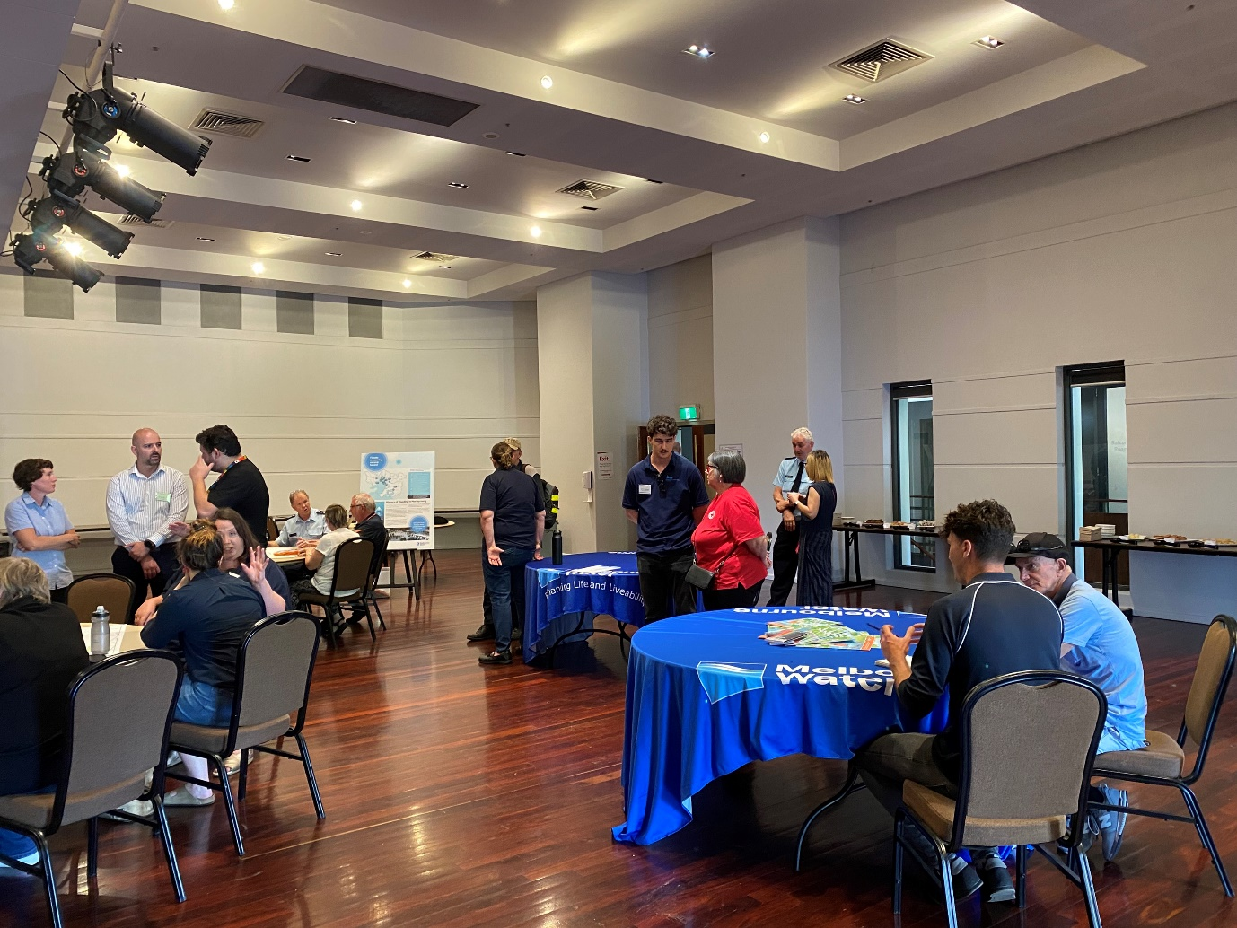
Image 2: Moonee Ponds Community Information Session

Information and communications
The following table outlines key communication activities implemented to inform and engage the community.
Activity | Description | Reach & Engagement
YourSay Engagement Platform | The Maribyrnong River Flood Review was featured on Melbourne Water’s YourSay platform a digital hub for online engagement and primary source of key information including:  - About the Review  - How to participate  - Resources and Information  - Contact details  The platform also enabled residents, community members and stakeholders to contribute to the review by:  - Making a submission  - Sharing your experience  - Registering to attend a community information sessions  - Sign up to follow and receive updates  - Ask a question  - Evaluation survey  Information was translated in the top five community languages. | - 4,233 site visits  - 7,082 page views  - 71 Followers  - 128 online contributors (includes online submissions to the review and share your experience map, event registrations and evaluation forms)  - 49% referrals from social media (mainly Facebook)  - 150 Terms of Reference downloads  - The most visited page (after the main page) was community information sessions, then make a submission
Melbourne Water website | High-level overview of the Review and relevant information. This webpage was designed to direct interested community members to the YourSay engagement platform to find out more information and contribute to the review. | 1,348 visits
Proactive media announcements | Proactive media announcements to keep the community up to date, direct people to YourSay and promote the community information sessions. | 2 proactive media stories were published on the Melbourne Water website and the YourSay engagement platform.
Community Bulletin | The Community Bulletin was designed to directly reach and inform residents and impacted communities about the Maribyrnong River Flood Review process and scope, opportunities to participate and how to find further information.  The bulletin included a map of the review area, a QR code linked to the YourSay engagement platform and contact details. | - 32,275 bulletins distributed to households and businesses in impacted suburbs.
Social media posts and advertisements | A targeted social media campaign that included 8 organic posts and 8 paid promotional advertisements were posted throughout the engagement period. The primary purpose of the social media advertisements was to:  - Inform community of the opportunities to participate in and contribute to the Maribyrnong River Flood Review, and  - Direct residents to the YourSay engagement platform for information  Paid promotional advertisements were targeted at the following flood impacted postcodes: 3031 (Kensington, Flemington), 3032 (Maribyrnong, Ascot Vale), 3034 (Avondale Heights) and 3036 (Keilor). | 8 organic posts across Facebook, LinkedIn, Twitter and YouTube  - 8,533 impressions (no. times the post was displayed to a user)  - 222 engagements (interactions with the post)  - 94 clicks through to the YourSay engagement page.  8 ads across Facebook and Instagram:  - 2,843 clicks through to YourSay engagement page
Letters to key stakeholders | Tailored letters distributed via email at the start of the submissions process to inform key stakeholders of the review, including the Terms of Reference, engagement and submissions process and community information sessions. | Letters were emailed to:  - the four impacted local Councils of Maribyrnong, Melbourne, Moonee Valley and Brimbank  - VicSES  - Emergency Recovery Victoria  - Red Cross  - The Victorian Racing Club (VRC)
Local Council Channels | Key messages, including the community bulletin, social media posts, link to YourSay page and promotion of the opportunities to attend Community Information Sessions were shared via local Council channels. | Information  published in Maribyrnong City Council weekly community newsletters targeted to flood impacted community.  Social media posts re-shared by local Councils.

Further, people were encouraged to submit all enquiries to a dedicated email address maribyrnongriver.floodreview@melbournewater.com.au. Enquiries were also received by the Melbourne Water Customer Call Centre and taken on notice at the community information sessions. Over 80 enquiries were received and responded to during the public consultation and submissions stage.

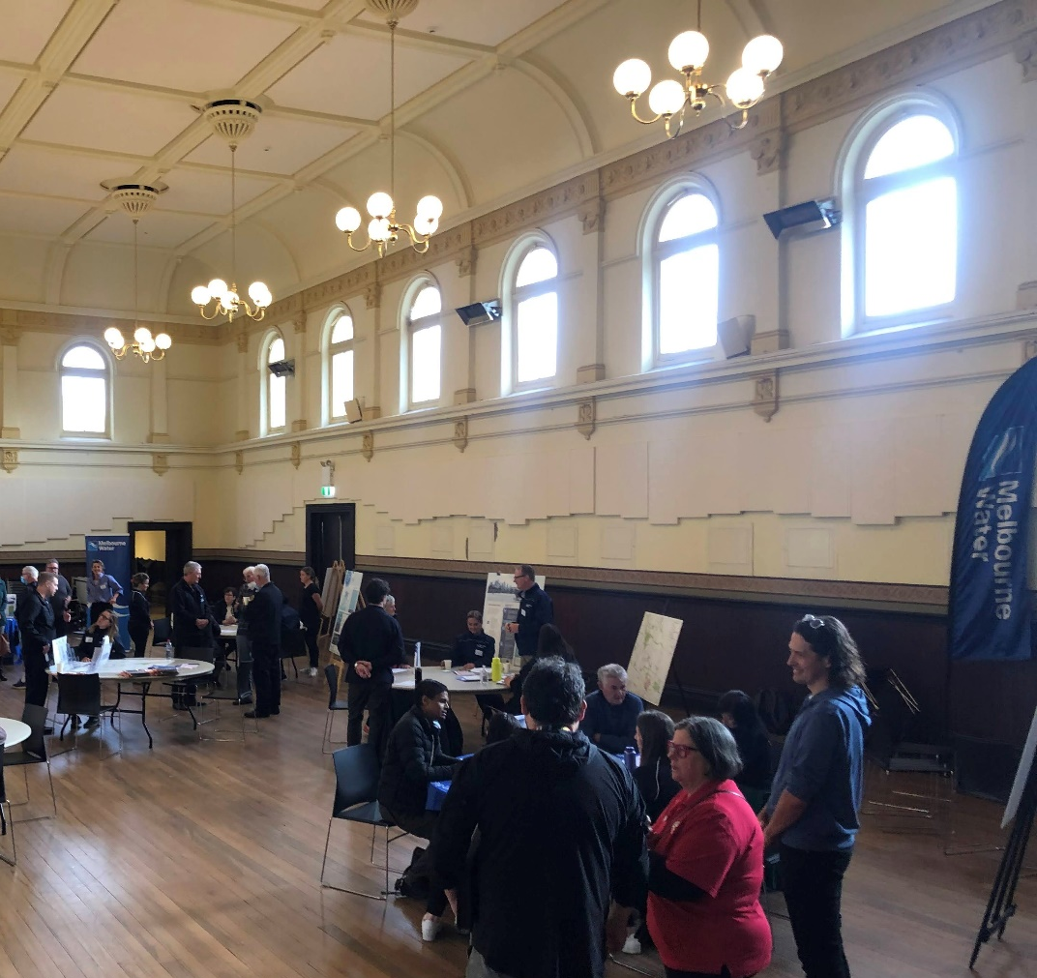
Image 3: Kensington Community Information Session

Key findings
This section summarises the feedback, key themes and findings gathered throughout the consultation period. Responses were provided by a range of participants including residents and businesses impacted by the floods and key stakeholders with an interest in the independent Flood Review.

Number of contributions
A total of 63 submissions were received; 35 submissions were received via email, 27 via the online submission form on the YourSay engagement page and one via post.
A total of 51 community members shared their personal experiences of the flood event. 39 were transcribed from conversations with community at the shared experience hub present at each of the six community information sessions, seven were shared online via the interactive map on the project’s YourSay engagement webpage, and five were submitted via email with images provided.

Key themes – what we heard
The following table summarises, in no particular order, the key themes emerging from the submissions received and stories and experiences contributed by community members.
The key themes summarised below represent Melbourne Water’s observations and interpretations about what we have heard from community throughout the consultation and submission period, and are independent of the Review Panel’s consideration of submissions. The views and opinions expressed within the key themes summarised below represent the voice of participating community and stakeholders, and are not the views or opinions of Melbourne Water, or the independent Review Panel.
These observations help to deepen Melbourne Water’s understanding of the flood event and will inform our work with partner agencies as we determine next steps in addressing the lessons learnt through this process.

Key Theme | What we heard
Flood Awareness and preparedness – before the event | Participants indicated they were largely unaware of their flood risk and lacked an understanding about when or how to act during a flood event.  Some residents expressed concern about the consistency and accuracy of available flood resources such as flood risk maps.  Long-term residents of the area expressed concern that flood literacy of new residents in the area was low.  Some participants questioned why households in flood risk areas had not received property specific flood risk information in over 10 years.
Inadequate information, warnings and alerts | Whilst many participants felt the flood warnings and alerts were inadequate, some participants commented that too many inconsistent warnings were issued in the days leading up to the event causing confusion about how to respond.  Others commented that they could not access or understand important information.  Some participants spoke about receiving warnings from concerned family, friends and neighbours.  Many participants reflected that alerts and warnings were issued too late for people to prepare for and evacuate during the flood event.  Other participants spoke about the inaccuracy in warnings and alerts they received and the confusion in receiving warnings from various sources, adding to confusion about the urgency of the event.  Some participants questioned why community meetings were not held in the week leading up to the flood event to inform and prepare residents for the flood risk.
Observations of the flood event | Many participants commented that the level, speed and intensity of the flood waters was greater than expected, taking many residents by surprise. Long-term residents of the area commented that the flood was the biggest they had experienced.  Many participants reported observing sources of flooding from overflowing stormwater drains.  Other participants commented on the amount of debris and rubbish in the aftermath of the flood.
Agency Response – before during and after the event | Participants felt the response by government, both state and local, as well as agencies such as Melbourne Water and the SES was inadequate. It was generally commented that people expected more ‘boots on the ground’ before, during and after the flood.  Participants observed the inconsistency of information, including flood warnings and flood mapping and resources, across the various agency websites and apps (including Bureau of Meteorology, Melbourne Water and VicSES) .  Participants expressed concerns about lack of translators or support for those with English language difficulties or those less familiar with technology.  Participants expressed concern about the lack of ongoing and long-term flood recovery support from the various agencies involved in flood response and recovery.
Community Spirit | Many participants praised friends, family, neighbours and volunteers for coming together to support each other.
Ongoing impacts | The engagement sessions heard that the recovery is still ongoing, with many people facing long-term emotional and financial impacts. A sense of uncertainty for the future was shared by many community members. The impacts participants shared included:  - Ongoing impacts to mental health and wellbeing; stress, anxiety, uncertainty about the future  - Significant loss and damage to property, personal belongings, access roads and equipment, also raising concerns about responsibility for covering these costs  - Displacement, many residents were still in emergency accommodation when we heard from them  - Experiences of financial hardship and devaluation of property  - Loss of independence for retirees  - Environmental impacts, including damage to riverbanks
Insurance and property values | Many participants expressed concern about the impact to their property values in the wake of the flood event.  Some participants expressed frustration with challenges and issues dealing with slow insurance processes.  Others highlighted difficulties obtaining or affording insurance even prior to the flood event, with many commenting on the substantial increase to their insurance premiums in the wake of the flood event.
Causes and contributors to the flood | Some participants shared their observations about what may have caused or contributed to the extent and duration of the flood:  - The volumes of water flowing down from the upper catchment of the Maribyrnong River  - Flemington Race Course flood wall  - Cumulative impact of planning decisions over time allowing development in the flood plain and subsequent loss of flood plain storage  - Development along the river including Edgewater, the Chase, Metro Tunnel  - Release of water from the Rosslynne Reservoir in the days leading up to the flood event  - Backflow from stormwater drains  - Poor maintenance under Farnsworth Avenue bridge creating a choke point  - High tide influence  - Inaction on previous reports provided over the years  - Impacts of dredging  - Increased urbanisation in the upper catchment.
Flemington Racecourse flood wall | Participants expressed a strong desire to understand what impact the Flemington Racecourse Wall may have had on the duration and extent of the Maribyrnong River Flood.  Some participants observed the differing views from consultants reviewing modelling for the Flemington Race Course Wall around the time of its approval.  Some participants expressed a strong desire for the removal of the Flemington Racecourse Wall.
Planning and development issues | Some participants commented on historical planning decisions and raised concerns about the cumulative impact of planning decisions allowing development in the flood plain and how mitigations might have failed.  Some participants would like to understand if Metro Tunnel flood works and other new and proposed developments might exacerbate resident’s flood risks.  Other participants expressed concern that planning controls (such as Land Subject to Inundation Overlays) don’t reflect flood risk maps and modelling or the extent of flooding that was experienced in this event.  Calls to urgently update flood modelling and planning scheme controls for the Maribyrnong River, with some participants calling for a State-wide or metro-wide approach to flood modelling and updating planning schemes.
Rivervue retirement village | Strong views that the review needs to get to the bottom of why Rivervue was flooded  Residents were completely unaware of the flood risk  Requests for the review to investigate the planning and development history for the site  Desire to understand the decision to move the location of the Land Subject to Inundation Overlay (LSIO)  Some participants observed flooding from stormwater drains  Mention was made of the steep embankment on the opposite side of the river and lack of culverts in the Canning Street / Cordite Ave bridge.
Flood Modelling | When discussing Melbourne Water’s flood modelling, participants expressed a range of views and concern including:  - observed discrepancy between predicted and actual flood levels – was Melbourne Water’s flood modelling accurate  - The need for flood modelling to account for climate change and to reflect the most recent flood intelligence  - Concerns regarding what flood modelling recent planning decisions have been based on – was this flood modelling undertaken before the Flemington Racecourse Wall was built?  - Observed inconsistencies across various flood maps  - Questions raised about the accuracy of Melbourne Water’s flood modelling in the immediate lead up to the flood and predictions potentially delaying flood warnings  - Desire for greater transparency of how Melbourne Water and Bureau of Meteorology model floods in the Maribyrnong River catchment.
Maribyrnong River Flood Review Terms of Reference | Some participants criticised the scope of the Maribyrnong River Flood Review, saying the terms of reference were too limited  Some participants requested clarity on whether or not the emergency warning system is included in the scope of the Review, including Melbourne Water’s flood modelling and predictions which inform the warning system.  Participants also requested clarity about whether or not Rivervue planning decisions are included in the scope of the review, including the decision to move the flood plain boundary (Land Subject to Inundation).  Some of the areas participants would like the review scope to cover include:  - Melbourne Water’s responsibilities under the State Emergency Management Plan and the Flood Strategy for Port Phillip and Western Port  - The management of Roslynne Reservoir in the days / weeks leading up to 14 October 2022  - Provide answers as to why Rivervue development was approved, and a review of the planning history for this site.
Integrity of review | Some participants questioned if they can trust that the Review is independent.
Looking to the future - Enhanced flood awareness and preparedness for at risk community | Many participants expressed the need for enhanced flood awareness and preparedness education, so that people would be better informed about their flood risk and how to prepare, respond and act in a flood event.  Feedback was provided about the need for greater community flood literacy to assist with understanding and interpreting flood alerts and warnings and flood modelling.  Some participants raised the need for the flood risk of a property to be available at the time of purchase and made available to tenants who may be unaware of the flood risk.
Looking to the future – flood mitigation strategies | When looking to the future, communities are looking for solutions to prevent future flooding.  In particular, participants would like to know:  - What actions are being taken now to mitigate flooding happening in the future  - Increased investment in infrastructure such as levees and improved drainage systems  - Removal of infrastructure along the Maribyrnong River that is found to have adversely impacted the extent and duration of the flood event.

Post event evaluation
Who attended and why?
Of the 114 unique attendees at the Community Information Session, 101 (89%) were community including households, businesses and community groups. The remaining 13 (11%) were representatives from key stakeholder groups including Members of Parliament, Local Councillors and local council representatives.
Further, of the 101 community attendees, the majority (88 people, or 87%) resided within the four target postcode areas of 3031, 3032, 3034 and 3036, with a breakdown as follows:
- 3032 (Maribyrnong, Ascot Vale residents) – 52 people
- 3034 (Avondale Heights residents) – 17 people
- 3036 (Keilor residents) – 10 people
- 3031 (Kensington, Flemington) – 9 people
Maribyrnong City Council area had the highest number of impacted community across the four target local council areas. This is reflected in the largest number of attendees participating across the six community information sessions being from the Maribyrnong City Council area, with a total of 52 participants. The fourth in-person community information session held at Maribyrnong Community Centre also had the highest number of attendees, with 43 people attending this session.
At registration, attendees were asked why they were attending. Attendees were able to select multiple reasons for attending. The main reasons for attending were:
- ‘Flood Affected’ - 22 responses
- ‘Flood Review and Submissions’ - 19 responses
- Flood Recovery, including building permits and insurance - 12 responses
- Flood Awareness and Preparedness (including flood response and warnings) - 12 responses
- To participate in the share your experience activity - 8 responses
Event evaluation survey
Attendees of the community information sessions were provided the opportunity to provide feedback on the information sessions by responding to a door survey recorded by an event volunteer at the in-person sessions, by completing an online evaluation form available on the YourSay engagement page, or in writing via email or post.
A total of 54 responses to the community information session evaluation survey were received. There were two key themes from the evaluation:
- Feedback on the format of the in-person information sessions – the majority of participants in the community information sessions shared they liked the drop-in style of the in-person sessions, and appreciated the opportunity to meet face to face with the various agencies involved in the flood response and recovery efforts. Some of the respondents who liked the format of the in-person sessions would have like a formal presentation at the beginning of the session.
- Desire for more information about the flood event – some of the feedback provided in the event evaluation forms included a desire for more information about the flood event, such as flood level data and an understanding of why the flood occurred and what actions are being taken to mitigate the risk and impact of future flooding events.

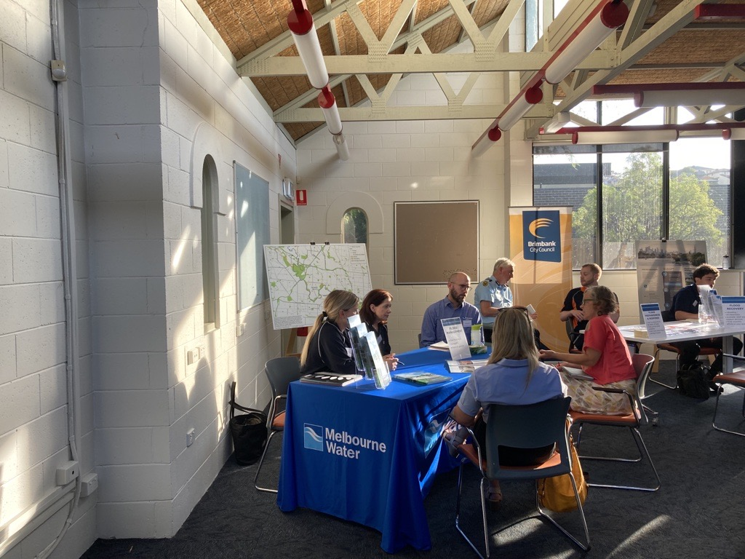
Image 4: Keilor Community Information Session

Next steps
All submissions have been provided to the independent Maribyrnong River Flood Review Panel and released publicly via the YourSay engagement page (with personal details removed). The Review Panel may meet with submitters if they want to find out more about the matters raised in submissions, or request further information. The final report of the independent Review Panel is anticipated to be released in November 2023.
The report summarising community’s experiences of the flood event has been made available online via the YourSay engagement page. The report will be shared with relevant agencies involved in the flood event, including VicSES and local councils, and provided to the independent Review Panel to help inform their overall understanding of the flood event.
Melbourne Water is committed to working together with relevant agencies to identify lessons learned from the community feedback and improvements to our cross-agency work.

