|  |
| --- |
| Cardinia Creek Hydrological and Fish Risk Assessment  Risk Assessment report  Final  16 April 2021  Melbourne Water |
| Risk Assessment report  Melbourne Water |

|  |  |
| --- | --- |
| Cardinia Creek Hydrological and Fish Risk Assessment | |
| Project No: | IS305400 |
| Document Title: | Risk Assessment report |
| Document No.: | R.01 |
| Revision: | 00 |
| Document Status: | Final |
| Date: | 16 April 2021 |
| Client Name: | Melbourne Water |
| Client No: | N/A |
| Project Manager: | Simon Treadwell |
| Author: | Fiona Gilbert, Simon Treadwell, Rebekah May |
| File Name: | Cardinia Creek Hydrological and Fish Risk Assessment_Draft risk assessment report_FINAL_RM |
|  | |
| Jacobs Group (Australia) Pty Limited ABN 37 001 024 095 Floor 11, 452 Flinders Street Melbourne VIC 3000 PO Box 312, Flinders Lane Melbourne VIC 8009 Australia T +61 3 8668 3000 F +61 3 8668 3001 www.jacobs.com | |
| © Copyright 2019 Jacobs Group (Australia) Pty Limited. The concepts and information contained in this document are the property of Jacobs. Use or copying of this document in whole or in part without the written permission of Jacobs constitutes an infringement of copyright.  Limitation:  This document has been prepared on behalf of, and for the exclusive use of Jacobs’ client, and is subject to, and issued in accordance with, the provisions of the contract between Jacobs and the client.  Jacobs accepts no liability or responsibility whatsoever for, or in respect of, any use of, or reliance upon, this document by any third party. | |

Document history and status

| Revision | Date | Description | Author | Checked | Reviewed | Approved |
| --- | --- | --- | --- | --- | --- | --- |
| 1 | 1/6/2020 | Draft 1 | FG ST |  |  |  |
| 2 | 6/6/2020 | Draft 2 | FG ST |  |  |  |
| 3 | 12/6/2020 | Draft 3 for client and stakeholder comment | FG ST | ST | ST | ST |
| 4 | 16/4/2021 | Final | FG, ST, LC | ST | ST | ST |
|  |  |  |  |  |  |  |
|  |  |  |  |  |  |  |

Contents

Executive Summary iv

1. Introduction 2

1.1 Background 2

1.2 Objectives and approach 3

1.3 Report Structure 3

2. Background and PSP details 4

2.1 Minta Farm PSP 5

2.2 Officer South Employment PSP 8

2.3 Cardinia South PSP 8

3. Critical fish habitat and requirements 10

3.1 Dwarf Galaxias 10

3.1.1 Presence in Cardinia Creek 11

3.1.2 Critical flow components 14

3.2 Australian grayling 14

3.2.1 Habitat and flow requirements 14

3.2.2 Presence in Cardinia Creek 16

3.2.3 Critical flow components 18

4. Fish risk assessment approach 19

4.1 Broad approach 19

4.2 Hydrological and hydraulic modelling 19

4.2.1 Hydrological modelling 19

4.2.2 Hydraulic modelling 21

4.3 Risk assessment criteria 21

5. Results 25

5.1 Summary modelling results 25

5.1.1 Hydrological modelling 25

5.1.2 Hydraulic modelling 26

5.2 Risk assessment 27

5.2.1 Reach One – Minta Farm to Cardinia Creek drop structure 27

5.3 Reach 2 and Reach 3 – Cardinia Creek drop structure to Westernport outlet 32

5.3.1 Channel stability risks 33

6. Summary and recommendations 40

6.1 Summary 40

6.1.1 Impacts associated with Minta Farm PSP 40

6.1.2 Impacts associated with Officer South Employment and Cardinia South PSPs 40

6.2 Mitigation recommendations 41

6.2.1 Minta Farm PSP 41

6.2.2 Officer South Employment and Cardinia South PSPs 41

6.3 Next steps 42

7. References 43

Appendix A. Hydrological modelling methodology

A.1 Selection of appropriate catchment modelling framework

A.2 PSP development: review of MUSIC models

A.2.1 Adjustment of climate period and inputs

A.3 Selection of representative climate years

Appendix B. Reach 1 - Dwarf galaxias anabranch pools

Appendix C. Cardinia Creek Conservation Zone wetland habitat restoration opportunities

Executive Summary

This study investigated the potential impacts to two protected fish species (Australian grayling and dwarf galaxias) as a result of the proposed development of the Cardinia Creek South, Minta Farm and Officer South Employment Precinct Structure Plan (PSP) areas in Melbourne’s outer south-east. This involved hydrological and hydraulic modelling to predict changes to the flow regime of Cardinia Creek as a result of altered stormwater inflows from the developed PSP areas. The potential for the predicted flow changes to have an adverse impact on Australian grayling and dwarf galaxias within the Cardinia Creek Conservation Area were then assessed.

Risk summary

The risk assessment considered the spatial extent of risks related to the location of outfalls from each of the PSPs. Figure E1 highlights the areas of risk along the creek associated with each outfall.

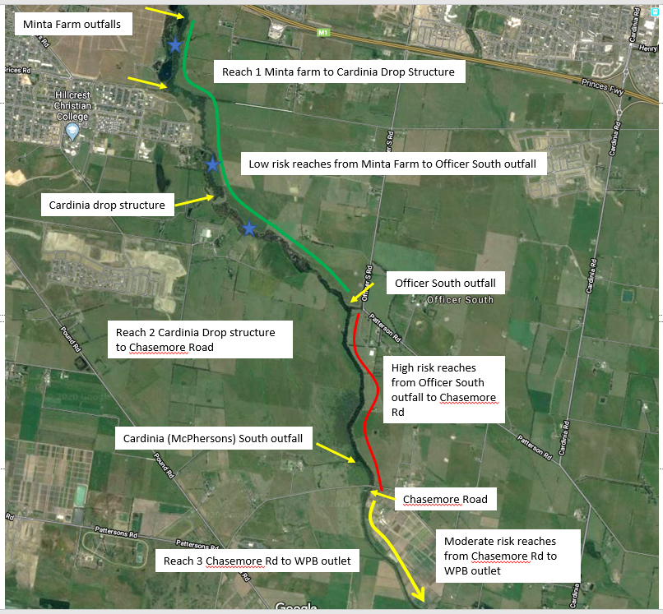

Figure E1. Reach risk rating (green-low, yellow-moderate, red-high). Blue stars indicate habitat for (and recorded locations of) dwarf galaxias and Australian grayling

Impacts associated with Minta Farm PSP

There are overall increases in the volume of water entering Cardinia Creek via both the Minta Farm north and Minta Farm south outfalls, however, the increase in volume is not significant enough to result in a substantial change in low flows in Cardinia Creek and there is no significant increase in the frequency or duration of high flow events that inundate dwarf galaxias habitat in this reach. This is because the area associated with the Minta Farm developments is small compared to the upstream Cardinia Creek catchment area, so the contributing flows from the PSP areas are consequently relatively small in the context of upstream catchment flows. However, there are a range of other risks to dwarf galaxias habitat in the Minta Farm area that need to be addressed as part of development. These include construction works associated with the Minta Farm north outfall and the decommissioning of Pond 2, construction works associated with the remediation of the Pond 3 embankment, and the overflow regime associated with the remodelled ephemeral habitat associated with Pond 3.

Low risks are also present in Reach 2 downstream of the Cardinia Drop structure through the section of that reach where Australian grayling have been recorded. This suggests that any changes in flow are unlikely to represent risks to Australian grayling survival or alter movement and spawning cues (e.g. movement through existing fishways) at the local scale. Moreover, the change in flows are unlikely to represent a risk to channel stability with there being no significant increase in the frequency or duration of flows above the magnitudes that would contribute to increased erosion risks.

Impacts associated with Officer South Employment and Cardinia South PSPs

There is a potential risk to stream condition downstream of the Officer South Employment and Cardinia South outfalls (although most of the impact is associated with the Officer South Employment PSP being a larger catchment area than the Cardinia South PSP). In particular, there is an increase in the number of flow events that occur at a sub-daily (i.e. hourly) duration that exceed critical bed mobilisation flows which could contribute to increased channel erosion and scour of vegetation. This has the potential to impacts on the quality of habitat through the reach and may also interrupt movement cues for Australian grayling that need to move through this reach for downstream spawning and upstream juvenile migration in autumn and spring respectively. Further downstream, to Westernport Bay, risks are mitigated to some extent because of the larger channel capacity associated with the Cardinia Outfall through the Koo Wee Rup Flood Protection Area.

Mitigation recommendations

Minta Farm PSP

Key risks associated with the Minta Farm PSP relate to construction impacts associated with outfall construction, Pond 2 decommissioning and Pond 3 embankment rectification. Recommendations are:

* That ecological principles are incorporated into all design and construction activities in the vicinity of the Cardinia Creek anabranch, including all temporary and permanent works associated with outfall and embankment construction.
* That the design for the Pond 2 decommissioning consider opportunities for incorporating dwarf galaxias and growling grass frog habitat elements into the restored floodplain habitat
* That the overflow from the Pond 3 ephemeral zone incorporates the ability to manipulate flow releases into the dwarf galaxias anabranch as part of an adaptive management plan for the protection of dwarf galaxias habitat.
* That opportunities for incorporation of new dwarf galaxias and growling grass frog habitat is considered and incorporated into the establishment of the Cardinia Creek Conservation Zone (see Appendix C for preliminary mapping of potential wetland locations within the proposed conservation zone).

Officer South Employment and Cardinia South PSPs

The critical risks associated with Officer South Employment PSP (and to a lesser degree Cardinia South PSP) relates to high peak hourly flows from the proposed outfall. The Officer South Employment drainage scheme design, in particular, is nearly ten years old and requires revision to more clearly identify opportunities to reduce peak flow rates.

It is recommended that the Officer South Employment and Cardinia South PSP drainage designs be reviewed with the intent of identifying opportunities to reduce peak flow rates, maintain the current frequency and duration of flows in Cardinia Creek that exceed bed mobilisations flows (370 ML/d at Chasemore Road) and limit where possible the increase in magnitude of the 1:1-1:5 year ARI events. The reviews need to consider the cumulative impacts of the two PSPs on creek flows. With regards to the review of the Officer South Employment PSP drainage scheme, the review needs to consider the relative contribution that the Officer Precinct (already developed to the north of the Officer South Employment Precinct) makes relative to development that will occur within the Officer South Employment Precinct, noting that the Officer Precinct is subject to a different set of regulatory requirements under the Melbourne Strategi Assessment program.

Next steps

The results of this work will be used by Melbourne Water to assist in the review and update of drainage designs in the Officer South Employment PSP and Cardinia South PSP to identify potential solutions to mitigating peak flows. These solutions will be modelled through MUSIC modelling and compared with the current outfall regimes to test if risks can be reduced.

Important note about your report

The purpose of this report and the associated services performed by Jacobs is to review information related to the flow in Cardinia Creek and to advise on potential risks to native fish from changes in flows predicted to occur under future urban development in 3 PSP areas in accordance with the scope of services set out in the contract between Jacobs Group (Australia) and Melbourne Water.

In preparing this report, Jacobs has relied upon, and presumed accurate, information and models (or confirmation of the absence thereof) provided by Melbourne Water and/or other sources. Except as otherwise stated in the report, Jacobs has not attempted to verify the accuracy or completeness of any such information. If the information is subsequently determined to be false, inaccurate or incomplete, the observations and conclusions in this report may change.

The passage of time, manifestation of latent conditions or impacts of future events may require further examination of the project and subsequent data analysis, and re-evaluation of the data, findings, observations and conclusions expressed in this report. Jacobs has prepared this report in accordance with the usual care and thoroughness of the consulting profession following applicable standards, guidelines, procedures and practices at the date of issue of this report. No other warranty or guarantee, whether expressed or implied, is made as to the data, observations and findings expressed in this report, to the extent permitted by law.

This report should be used in full, and no excerpts are to be taken as representative of the findings. No responsibility is accepted by Jacobs for use of any part of this report in any other context.

This report has been prepared on behalf of, and for the exclusive use of, Melbourne Water, and is subject to, and issued in accordance with, the provisions of the contract between Jacobs and Melbourne Water. Jacobs accepts no liability or responsibility whatsoever for, or in respect of, any use of, or reliance upon, this report by a third party.

# Introduction

## Background

Melbourne’s outer south east is a rapidly growing area, with specific growth precincts set out for urbanisation and development. The development of this area from its current, predominantly rural land use to an urban land use has the potential to impact the hydrology and ecological values of local waterways, including Cardinia Creek.

Cardinia Creek is noted for its high ecological values. These are recognised by the inclusion of the Cardinia Creek corridor Biodiversity Conservation Area 36, as outlined in the Victorian Government’s Biodiversity Conservation Strategy (BCS) (DEPI 2013a) (Figure 1‑1). The BCS sets out a range of Conservation Areas that are required to protect Matters of National Environmental Significance (MNES) in Melbourne’s growth corridors.

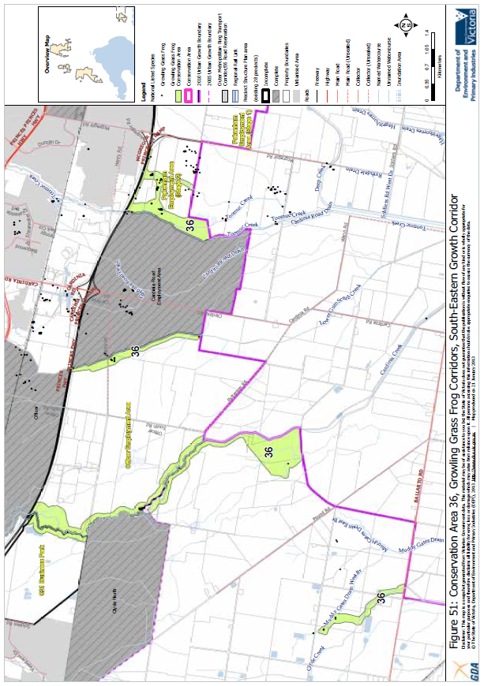

Figure 1‑1 Cardinia Creek Biodiversity Conservation Area 36 (DEPI 2013a)

Biodiversity Conservation Area 36 is noted for supporting the following biodiversity values of national significance:

* Australian grayling population within high quality habitat at Cardinia Creek
* Dwarf Galaxias population within high quality habitat at Cardinia and Clyde Creeks
* Growling Grass Frog populations within high quality habitat
* The Minta Farm wetlands in the Minta Farm Precinct was identified as a site likely to support nationally important populations of some migratory waterbirds.

Three specific urban development growth precincts (as set out in Precinct Structure Plans) are located adjacent to Cardinia Creek with drainage outfalls to the creek, namely Cardinia Creek South (previously called the McPherson PSP), Minta Farm and Officer South Employment PSPs. A condition of development for these PSPs is that the habitat for the EPBC-listed Australian grayling and Dwarf Galaxias populations within the Cardinia Creek corridor is protected and managed.

This study has been commissioned to assess the potential for adverse impacts to these two species resulting from hydrological change associated with development of these three PSPs. The outcomes from this project will inform discussions on this matter between key stakeholders, including DELWP, VPA, City of Casey, Shire of Cardinia, and landowners.

## Objectives and approach

The key objective of the project is to determine risks to Australian grayling and Dwarf Galaxias as a result of any changes to flow regime caused by development in the three nominated PSP areas. Development of the PSP areas into urban land use with a high percentage of impervious surfaces will alter stormwater runoff patterns from these areas into the creek, and potentially the hydrological conditions and flow regime of the Creek overall. There are two main risk pathways to Australian grayling and Dwarf Galaxias associated with hydrological changes:

1. Changes in flow regime that result in loss of important flow cues / flow components (e.g. base flows, autumn and spring freshes etc.) that initiate or support critical life history responses (e.g. spawning and/or migration, maintenance of wetland habitat etc).
2. Changes in flow regime that result in degradation of habitat critical to the survival of all life history stages (eggs, larvae, juveniles and adults).

To meet the project objectives, Jacobs developed models to simulate altered stormwater and creek flows as a result of each PSP development. We have developed both a **hydrological model** for the catchment and a **hydraulic model** for selected locations that represent known or potential good quality habitat for Australian grayling and Dwarf Galaxias. The hydrological model has been used to determine changes in flow in Cardinia Creek following the development of PSPs, with associated changes to stormwater runoff. The hydraulic model has been used to determine creek flow magnitudes that represent various levels of physical risk to the creek (e.g. excessive shear stress) or that inundate important habitats (e.g. backwaters or off-stream wetlands). Following the establishment of critical flow thresholds, the hydrological models were used to investigate changes in those critical thresholds and translate those changes to risks to fish, either directly, or via impacts on habitat.

## Report Structure

This report outlines the assessment of risks to fish (dwarf galaxias and Australian grayling) from changes in hydrological regime in Cardinia creek due to urban development in 3 PSP areas. The report covers:

* A project background, PSP development details, and summary of project requirements (Chapter 2)
* A review of the flow and habitat requirements of the dwarf galaxias and Australian grayling in the study area. (Chapter3), including critical flow criteria against which risks will be assessed.
* A description of the fish risk assessment framework and modelling approach (Chapter 4)
* Risk Assessment results (Section 5). This chapter compares modelled flow scenarios with critical flow components to to determine level of risk for fish in Cardinia Creek
* Summary and mitigation recommendations (Chapter 6)

# Background and PSP details

This report assesses potential impacts from three PSP areas in the Cardinia Creek catchment. Cardinia Creek is located south east of Melbourne, and flows from Cardinia Reservoir to Westernport Bay (Figure 2‑1). The upper catchment is predominantly rural/residential. The middle catchment is an area of rapidly expanding urban development, and includes the three PSPs that are the subject of this study. The lower catchment of the creek is an agricultural area, which has been heavily modified and subject to drainage and channelisation in the lower reaches.

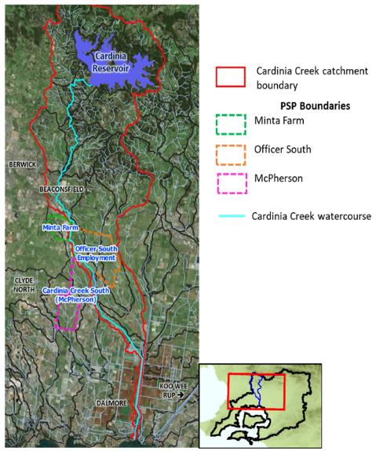

Figure 2‑1 Cardinia Creek catchment and PSP locations

The study area itself is located from the Princes Freeway downstream to Westernport Bay. For the purpose of assessment, the area has been broken into 3 reaches; Reach 1 – Princes Freeway to the Cardinia Drop Structure, Reach 2 – Cardinia Drop Structure to Chasemore (McCormacks) Road and Reach 3 - Chasemore Road to Westernport Bay. Figure 2‑2 shows the study reaches and the locations of specific PSP outfalls location.

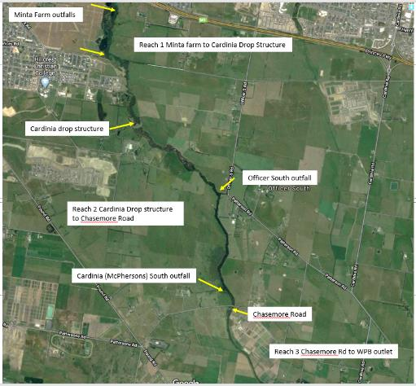

Figure 2‑2 Aerial image of PSP area showing PSP outfalls, and study reaches

Planning for each PSP includes development of drainage and stormwater management plans and treatment measures, which are designed to manage potential flooding and ecological risks. More details of each PSP, including drainage design intents, are provided in the following sections.

## Minta Farm PSP

The Minta Farm PSP is the northernmost development reviewed as part of this investigation.

The current Minta Farm site is a 286 hectare site located in Berwick, used primarily for non-intensive cropped agriculture. The Minta Farm Precinct Structure Plan (PSP) incorporates large areas of residential and office development. The development has been informed by the PSP drainage strategies, which have been prepared to manage onsite drainage and water quality, and changes in the hydrological regime caused by increased runoff following development, and to minimise impact to Cardinia Creek’s high value habitat and ecological values.

The *Minta Farm Drainage Strategy – Wetland Systems and Outfalls into the Cardinia Creek* report (Alluvium, 2019) outlines the key characteristics of the site and the relevant drainage and stormwater management measures in place.

The site currently contains a number of large waterbodies that were constructed around 60 years ago by building an embankment between the creek and the floodplain, for use as farm dams. These waterbodies now support sensitive ecological values in the area and are included in Conservation Area 36 as identified in the Melbourne Strategic Assessment; any works in the conservation area requires approval from DELWP and/or the Commonwealth (Alluvium, 2019). Figure 2‑3 is taken from Figure One of the Alluvium (2019) Drainage Strategy report, and shows an aerial view of the Minta Farm site including farm waterbodies (ponds) and Cardinia Creek. The embankment separating the ponds from the creek is also marked.

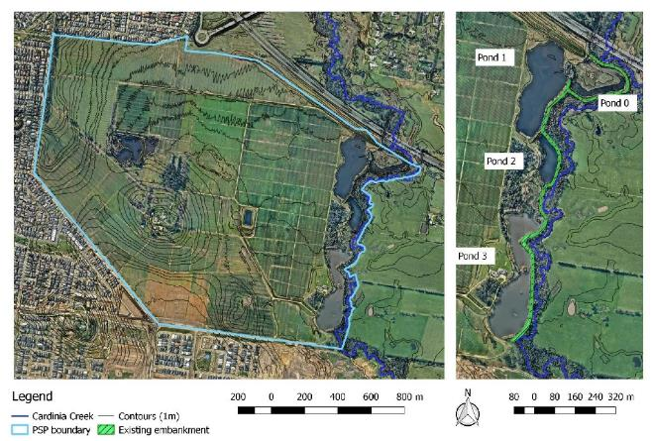

Figure 2‑3 Minta Farm aerial view showing PSP boundary, location and nomenclature of ponds, and Cardinia Creek

The drainage strategy considered current hydrological conditions, key ecological values, and modelled changes under future development. Drainage and stormwater management measures were then developed to minimise impacts.

The key principles to be considered were provided by Melbourne Water, and include:

* **Stormwater quantity and flood management** – can the size and location of overland paths safely convey a 1% AEP event within road reserves, or is a waterway corridor required? The flow management strategy for Minta Farm PSP is designed to align with the principles advocated in the “Drainage Strategy for the Overall Cardinia Creek Catchment” (Stormy Water Solutions 2012), which reviewed and consolidated several previous investigations and provided recommendations for a catchment-wide strategy from new development within the Cardinia Creek Catchment south of the Pakenham Bypass. However, this study assessed flood impacts from a safety and property perspective and did not consider impacts of peak flood flows on waterway values.
* **Ecological protection and enhancement** – the impact on the existing ecological values needs to be minimised and opportunities for enhancement should be considered.

The key drainage strategy design criteria for Minta Farm, relating to stormwater quantity and ecological protection are as follows (Alluvium, 2019):

* Retarding basins are not required within the Minta Farm site, however wetland retardation is required for rainfall events up to the 1 year ARI
* Flood mitigation works will be required at the Cardinia Creek Outfall (downstream of McCormacks Road) to ensure all flows are maintained within the leveed outfall
* Flow management for ecological protection of ecological values in existing ponds 0 and 3 (e.g. 1.5 year ARI) should be provided. It is expected that this attenuation could be provided as a “by-product” to constructing wetlands for stormwater quality treatment
* Overland flow paths within the Minta Farm site to safely convey the 1% AEP flows
* Maintain hydrological regime in Pond 0 to support Latham Snipe and the Growling Grass Frog
* Retain the current hydrological regime in Pond 3 (areas of permanent open water for foraging and breeding habitat for state listed waterbirds)
* Retain the breeding waterbird islands within Pond 3
* Retain and enhance Dwarf Galaxias habitat
* Develop at least some wetlands to provide protection and management of habitat provided for waterbirds and Dwarf Galaxias, consequently providing key Growling Grass Frog wetland habitat
* Maintain and enhance shallow areas within existing wetlands and create new shallow, well-vegetated wetlands
* Minimise disturbance to existing swamp scrub by minimising works between the toe of the existing embankment and Cardinia Creek.

The recommended design for Minta Farm includes two separate drainage systems: a northern section (Minta Farm north) where low flows outfall through Pond 1 (WL1) and high flows outfall via a proposed west-east waterway corridor outfall, and a southern section (Minta Farm south) that incorporates new stormwater treatment wetlands prior to discharge to Pond 3 with overflow to Cardinia Creek via a new outfall at the southern end of Pond 3 (taken from Alluvium (2019) Figure 19):

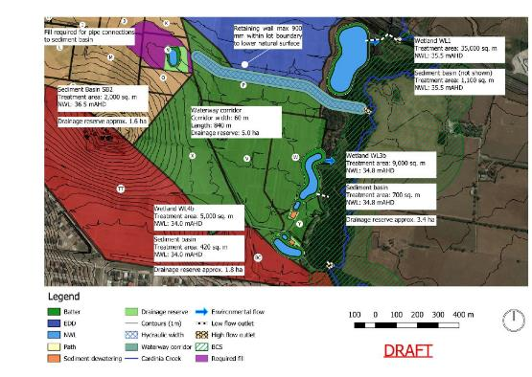

Figure 2‑4 Drainage and waterway corridor plan for Minta Farm

## Officer South Employment PSP

The Officer South Employment PSP is located on the east side of Cardinia Creek. The proposed drainage scheme for Officer South Employment PSP (which also incorporates inflows from the Officer PSP, which is already being developed north of the Princes Freeway) involves a waterway corridor, including a number of stormwater treatment wetlands, being constructed along the Officer South Road with an outfall to Cardinia Creek approximately half way between the Cardinia Drop Structure and Chasemore/McCormack Rd (Stormy Solutions (2011). The scheme also requires flood mitigation works in Cardinia Creek Outfall channel itself to provide protection to the Koo Wee Rup Flood Protection District. The conceptual design focuses on containing the 100 year ARI event but notes that through the process of functional design that the scheme will need to include elements that extend the detention range in order to protect the existing ecology and channel morphology of the Cardinia Creek downstream of the outfall (suggested by Stormy Solutions (2011) as flows up to the 1.5 year ARI event). However, the current design is not explicit in how the scheme will achieve this.

Melbourne Water is in the process of progressing towards function design for the Officer South Employment drainage scheme. The outcomes of the current project should be used to inform the functional design requirements of the scheme.

## Cardinia South PSP

The Cardinia Creek South (formerly known as McPherson) PSP is the furthest downstream of the three PSPs on the western side of Cardinia Creek. Cardinia Creek forms the north eastern boundary of the PSP. Clyde Creek passes through the south western corner of the PSP, and Bailieu Creek flows through the northern part of the PSP before discharging into Cardinia Creek at the southern end of the PSP boundary.

The *Stormwater Management Strategy – McPherson Precinct Structure Plan* (Alluvium 2016) report acknowledges the presence of high value species in Cardinia Creek and the need to cater for Australian grayling and Dwarf Galaxias. The report highlights the key principles for stormwater management, namely:

* *Reduce runoff and peak flows* - reduce peak flows from urban development by local detention measures and minimising impervious areas. Local detention and retention enables effective land use for flood mitigation by utilising numerous storage points in contrast to the current practice of utilisation of large retarding basins. This approach subsequently reduces the infrastructure required downstream to effectively drain urban developments during rainfall events.
* *Protect natural systems* - protect and enhance natural water systems within urban developments. Promoting and protecting natural waterways as assets allows them to function more effectively and supports the ecosystems that rely on them.

The scheme design identifies the need for construction of an increased area of treatment wetlands and *identifies the size and location of mitigation works required to accommodate and offset the impact of urban development on the local and downstream receiving waters”.* The design includes a series of sediment basins and wetlands.

The report also references a previous report’s key finding that “*no flow mitigation is needed to manage run‐off in large events up to and including the 100 year ARI event. However the study also identified that flow mitigation for smaller flood events (up to the 2 year ARI event) is required for ecological protection. The airspace above wetland systems will provide storage capacity to offset the impacts on peak flows for smaller flood events (up to the 2 year ARI event)”*  Wetlands have been primarily designed on the basis of meeting BPEMG for nutrient and TSS removal, as well as the mitigation of the 2 year ARI events, rather than any other specific flow related priorities.

As with the Minta Farm and Officer South Employment schemes, the Cardinia South Stormwater Management Strategy identifies the need for flood mitigation works downstream at the Cardinia Creek outfall (and extending 6 kilometres upstream) to mitigate development effects, ensure the 100 year ARI flow can be maintained within existing levee structures and not pose additional risks to the Koo Wee Rup Flood Protection District.

# Critical fish habitat and requirements

The key project objective is to determine risks to dwarf galaxias (*Galaxiella pusilla*) and Australian grayling (*Prototroctes maraena*) as a result of any changes to flow regime from the PSP development, and resultant impacts on critical flow components or habitat. This chapter describes dwarf galaxias and Australian grayling and their respective habitat and flow requirements, and flow thresholds that represent risks to life history requirements and general habitat condition.

## Dwarf Galaxias

Dwarf galaxias are a small (typically ~40 mm long) freshwater fish of national conservation significance. They are endangered in Victoria and listed as threatened under the *Flora and Fauna Guarantee Act* (1988) and are listed as vulnerable under the Commonwealth *Environment Protection and Biodiversity Conservation (EPBC) Act* (1999).

They are a wholly freshwater species that inhabit slow flowing and still, shallow, permanent and temporary freshwater habitats such as swamps, drains and backwaters, often containing dense aquatic macrophytes and emergent plants (Sadlier *et al.*, 2010).

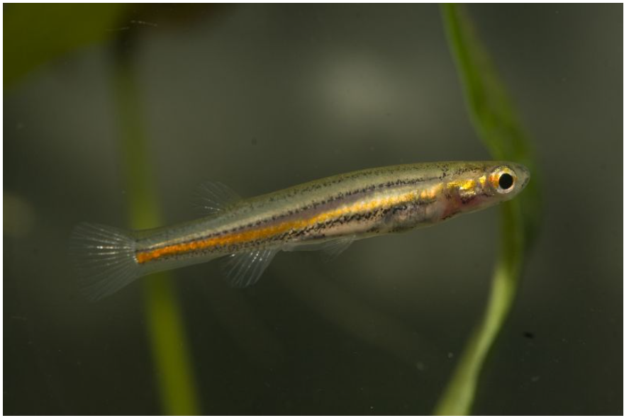

Figure 3‑1 Dwarf galaxias (*Galaxiella pusilla*) Image credit Rhys Coleman and Andrew Weeks [1]

They do not undertake large‐scale migratory movements but they do move between local habitats during flood events to recolonise seasonal habitats (Sadlier *et al.*, 2010). Dwarf galaxias are adapted to seasonal wetting and drying; low flows allow wetlands and anabranches to dry out to a series of isolated refuge pools in summer and autumn, while high flows in late autumn inundate anabranches and create spawning habitat.

Spawning occurs from April through to December and appears to correspond to seasonal inundation of low-lying wetland and floodplain habitats as described below.

Habitat for dwarf galaxias can be generally categorised as follows (Biosis, 2012):

* Transient habitat only - typically parts of floodplains or ephemeral habitats that retain water for less than a month following inundation, or habitats dominated by faster flowing hydraulic habitats (e.g. riffle/run) that do not offer the no flow/slow flow hydraulic habitats (e.g. backwater/pool/glide) preferred by Dwarf Galaxias. Transient habitats are important for dispersal and foraging.
* Spawning habitat only – typically ephemeral habitats with abundant aquatic or fringing terrestrial vegetation (e.g. grasses) that pool for sustained periods (e.g. 1-3 months) during the spawning period (April-December) following inundation but ultimately contract back into short- or long-term refuge habitats nearby.
* Short-term refuge habitat – habitats that only retain water for short periods (i.e. 3+ months or throughout wet years), or, habitats that retain water for longer but do not have the required attributes likely to be required to support a permanent, self-sustaining population of Dwarf Galaxias. Such habitats are typically colonised or re-colonised following a flooding event. In the case of short-term refuge habitats that ultimately dry out, these can at least initially be extremely productive for spawning and recruitment, however such populations are often lost to habitat desiccation unless a flow/flooding event allows individuals to disperse beforehand. There is some evidence that dwarf galaxias can survive for short periods of time in crayfish burrows if surface water disappears (Rhys Coleman, Melbourne Wat, pers. com.).
* Long-term refuge habitat: – habitats that retain water for long periods (i.e. years) or permanently and always support a self-sustaining population of Dwarf Galaxias. Typically these are perennial waterways, or the deepest pools within an ephemeral waterway, or a dam or wetland on a floodplain.

Dwarf Galaxias populations in these habitats are typically referred to as source populations, since it is these populations that persist during dry conditions and from which Dwarf Galaxias will again disperse during suitable flow conditions (e.g. flood) (Biosis, 2012).

Ideal habitat is characterised by dense aquatic submerged and emergent vegetation and overhanging riparian vegetation (Sadlier *et al.*, 2010).

Around Melbourne, preferred habitat includes wetlands and creek anabranches that partially or completely dry out over summer and are inundated in winter (Rhys Coleman, Melbourne Wat, pers. com.). The habitats are often associated with remnant Swampy Riparian Woodland Ecological Vegetation Class (EVC83) along creeks and drainage lines in Melbourne’s south east and in permanent wetlands and dams containing abundant macrophytes.

The general flow/water regime requirements for dwarf galaxias are (Sadlier *et al.*, 2010):

* Low flows in summer that allow drying of floodplain wetlands and backwaters, yet retain permanent water in long-term refuge habitats, such as anabranches and permanent wetlands/dams.
* Short duration high and overbank flows in winter/spring that inundate spawning and short-term habitat wetland habitats and provide connection between long-term habitats and spawning / short-term habitats.

### Presence in Cardinia Creek

In Cardinia Creek, dwarf galaxias have been recorded from small wetlands, backwaters and anabranches associated with Cardinia Creek (Biosis, 2012 and see Figure 1). Most records have been from around and upstream of the Pakenham Bypass, however, historical and recent records have been from anabranches of Cardinia Creek adjacent to the Minta Farm PSP and the Clyde North PSP. The distributions are likely to reflect a combination of the presence of suitable habitat and also survey effort, so it cannot be assumed that dwarf galaxias are not located more broadly across the local area if suitable habitat exists. This could include areas not directly connected to Cardinia Creek, such as road side drains and farm dams that retain permanent water (e.g. due to connections to groundwater or from local catchment flows).

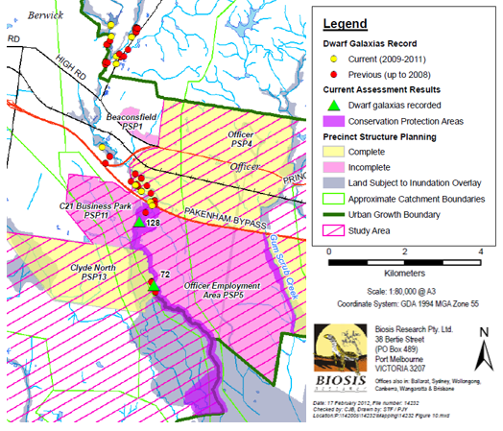

Figure 3‑2 Locations of historical and recent dwarf galaxias records in Cardinia Creek (adapted from Biosis, 2012)

The Minta Farm record site (site 128 and see Figure 3‑3) is an anabranch of Cardinia Creek located on the western side of the creek within a narrow, inset floodplain comprising Swampy Riparian Woodland EVC (Figure 3‑4). The anabranch is located against the eastern base of an embankment and appears to contain both short-term and long-term refuge habitat. It is also connected to Cardinia Creek and receives inundation from time to time during higher flow events. This would enable the re-wetting of short-term habitat and provide opportunities for dispersal and movement into spawning habitats. The anabranch also receives occasional overflows from lakes on Minta Farm directly into the anabranch (see Figure 3‑4G) and it is possible that seepage through the embankment helps maintain moist conditions.

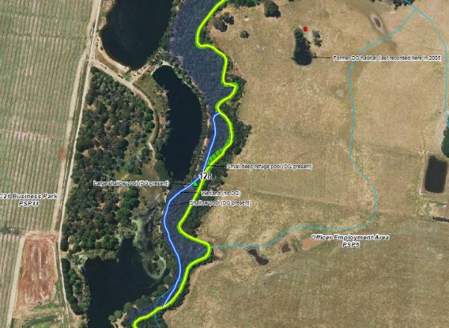

Figure 3‑3 Site 128 - dwarf galaxias record in an anabranch of Cardinia Creek adjacent to lakes on Minta Farm (source Biosis, 2012)

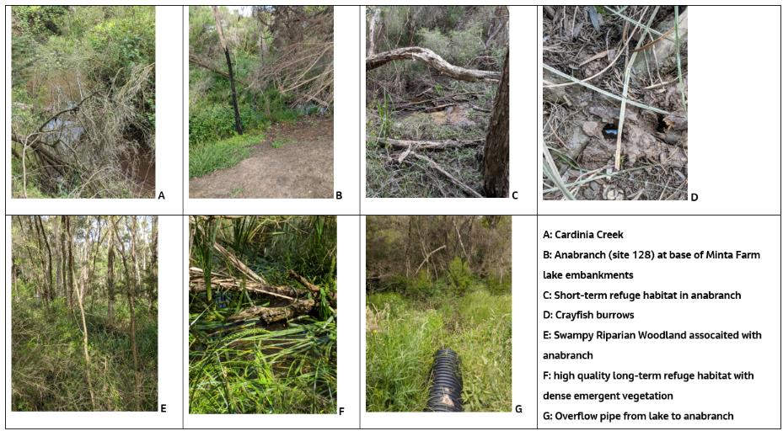

Figure 3‑4 Cardinia Creek Dwarf galaxias habitat, from site visit photos

Dwarf galaxias have also been recorded from an anabranch downstream of Minta Farm and upstream of the Cardinia Creek drop structure (Figure 3‑5). This site was not visited as part of the current study, but based on the description of Biosis (2012) appears to contain similar habitat to site 128. Cardinia Creek downstream of the Cardinia Creek drop structure does not appear to be suitable dwarf galaxias habitat, although some off-channel wetlands around McCormacks Road have been identified as potential habitat (GHD, 2017)

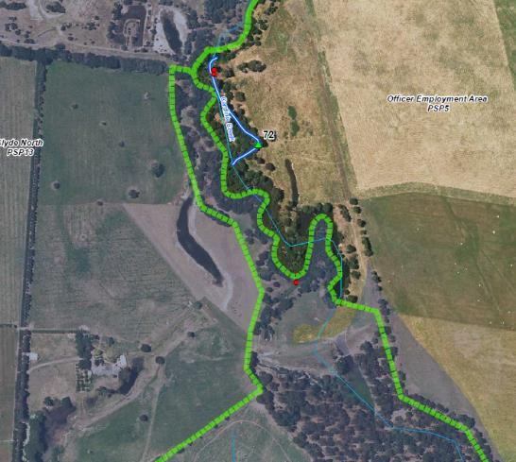

Figure 3‑5 Site 72 - dwarf galaxias record in an anabranch of Cardinia Creek upstream of the Cardinia Creek drop structure (source Biosis, 2012)

Collectively the populations are likely to be part of a broader population that includes those recorded upstream of the Pakenham Bypass. Preferred habitats are associated with the Cardinia Creek floodplain (such as the anabranches at site 72 and 128). During high flow events fish from localised populations are likely to move between long-term habitats and colonise spawning and short-term habitats, using Cardinia Creek as a temporary dispersal habitat. The protection of these anabranch habitat types and the flow regime required to provide seasonal wetting and drying is necessary for the protection of the current dwarf galaxias population.

### Critical flow components

Critical components of the flow regime for dwarf galaxias are high flows that inundate pools, anabranches and other floodplain wetland habitats located at Minta Farm and north of the Cardinia Creek drop structure. The pool and anabranch habitat that is inundated at high flows also relies on variation in streamflows including periods of low flow, to maintain a natural wetting and drying cycle in the anabranches.

High flows are required to inundate these habitats. Hence, there should be no change in the timing, frequency or duration of flows in Cardinia Creek that inundate these anabranch habitats. A reduction in high flows would lead to a reduction in inundation and potential loss of habitat, loss of connections and loss of spawning triggers. However, an increase in the frequency and duration of high flows that create continuous flow through anabranch habitats (especially in summer and autumn) would create unsuitable hydraulic conditions and favour colonisation by predatory mosquito fish. An increase in high flows should also therefore be avoided.

## Australian grayling

### Habitat and flow requirements

Australian grayling (Figure 3‑6) are endemic to coastal streams in south eastern Australia including Cardinia Creek and the nearby Bunyip River. They are vulnerable in Victoria and listed as threatened under the *Flora and Fauna Guarantee Act* (1988) and are listed as vulnerable under the Commonwealth *Environment Protection and Biodiversity Conservation (EPBC) Act* (1999).

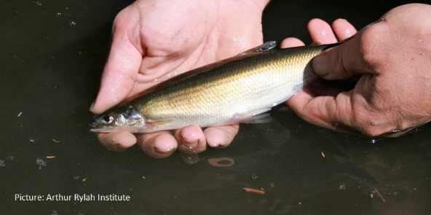

Figure 3‑6 Australian grayling (image courtesy Arthur Rylah Institute)

Australian grayling is a diadromous species that require high flows in autumn to facilitate their downstream migration, cue spawning and to carry their eggs and larvae out to sea. Individuals live for 3-5 years, but females do not mature until they are two years old (McDowall, 1996). Mature females will not release their eggs without high autumn flows (O'Connor and Mahoney, 2004). Australian grayling larvae develop at sea and juveniles move into freshwater reaches. Recent evidence suggests that juveniles do not necessarily return to the same rivers where they were spawned (Crook *et al.*, 2006) and therefore populations may persist in some rivers where adults have failed to spawn for several years. Altered flow regimes, as well as other factors such as barriers to movement and habitat degradation, are likely contributors to the decline.

Spawning and movement patterns of Australian grayling were recently investigated in the nearby Bunyip River using drift sampling (2008–2011) and acoustic telemetry (2009–2010) (Koster *et al.*, 2013). The results of the study are useful for helping to understand the potential life history requirements for Australian grayling in Cardinia Creek. The results demonstrate that Australian grayling in the Bunyip River migrate downstream to a location just upstream of the estuary to spawn, and that increased river flows in Autumn are an important cue to that migration. Adult Australian grayling lay eggs in gravel or on the stream bed at the upstream edge of the estuary. The eggs hatch after about 12 days and the newly emerged larvae are washed into the sea. Adult Australian grayling often travel large distances (up to 30 km) to reach spawning habitats in response to increased flows. A journey in the Bunyip River, from immediately downstream of the confluence with the Tarago River to the spawning area at the top of the estuary takes approximately five days.

The magnitude and duration of Autumn high flow events influenced the behaviour of migrating fish. Downstream migration occurred over a broad range of observed flows (i.e. 50-160 ML/day), but the number of fish migrating was much greater when flows were greater than 120 ML/day (Figure 3‑7). Individual fish would abort their migration if discharge declined before they reached the spawning area, but would resume their migration if flow increased again (Koster *et al*., 2013). The drop in flow required to disrupt downstream migration varied for individual fish. Koster *et al.* (2013) monitored fish over several flow events and observed aborted migration when flows declined from 70 to 65 ML/day over two days and when flows declined from 120 to 90 ML/day over three days.



Figure 3‑7 Daily numbers of Australian grayling moving downstream and daily mean discharge in the Bunyip River during the 2009 and 2010 spawning period

Following spawning, eggs/larvae are washed downstream to the sea and after about four-five months (i.e. in spring – summer) the juveniles migrate back upstream into the freshwater reaches of rivers (Berra, 1982, Crook et al., 2006). It is unknown what triggers Australian grayling juveniles to return to freshwater reaches, although spring tides, phases of the moon and temperature are often triggers for spring migration from estuarine reaches to freshwater in other diadromous species. However, some preliminary sampling of juvenile immigration over the last few years in the Bunyip River, Barwon River and Cardinia Creek shows catches were lowest in years when flows were low throughout spring, potentially indicating that lower flow conditions may result in fewer fish being attracted to river mouths, or that low flows prevented upstream passage due to barriers (Amtstaetter *et al.*, 2019).

The general flow/water regime requirements for Australian grayling are:

* Sufficient minimum flows to maintain access to suitable adult habitat.
* Autumn high flows to trigger downstream adult movement and spawning. Autumn flows need to be sufficient to also allow return adult movements after spawning, including through potential barriers to movement and fishways.
* Possible higher flows in spring to encourage upstream movement of juveniles and to enable movement through potential barriers and fishways.

### Presence in Cardinia Creek

Australian grayling have been recorded in low numbers in lower Cardinia Creek (Figure 3‑8Figure 3‑8). Most records are from around Chasemore / McCormacks Road and downstream of the Cardinia Creek drop structure near Thompsons Road (MW fish database, Ecology Australia, 2019). There is one record (1985) from upstream of the Cardinia Creek drop structure. The drop structure (Figure 3‑9) was constructed in the 1980s to control severe headward incision that occurred as a response to the channelisation and drainage of lower reaches. The drop structure includes a fishway, but its effectiveness at allowing upstream fish migration has been questioned (Ecology Australia, 2019). So it is not clear whether Australian grayling have ready access to reaches further upstream or whether a lack of survey means there are few records from upstream reaches. Lack of survey effort at appropriate times of the year is also thought to be the reason for no records downstream of Chasemore / McCormacks Road – Australian grayling would need to move through this reach for spawning and juvenile return migrations.

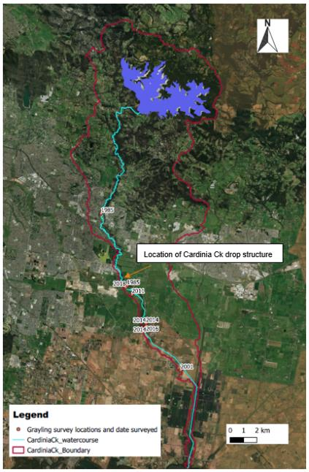

Figure 3‑8 Location (year) of Australian grayling records. Note all records post 1985 are downstream of the Cardinia Creek drop structure.

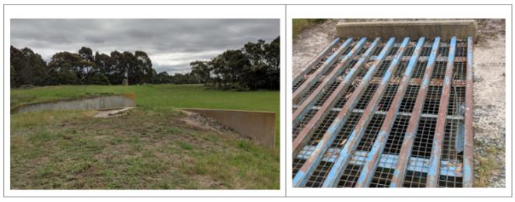

Figure 3‑9 Cardinia Creek Drop Structure (left - showing crest and spillway) and fishway (right - showing culvert through earth wall)

The creek through the lower reaches comprises a channelised section from Westernport Bay upstream to around McCormacks Road (Figure 3‑10). Upstream of McCormacks Road the creek flows through a more meandering natural channel albeit with deeply incised with high banks that are prone to slumping. However, the riparian zone is relatively well vegetated and pool and shallow run habitat is present with areas of good cover. Rock ramp style fishways have been constructed at McCormacks Road, at six locations upstream and at the Cardinia Creek Drop Structure. The fishways were re-constructed in 2018 (to replace existing structures built in 2002 at smaller erosion heads but which had been damaged by floods in the mid 2000s). The Drop Structure fishway was not upgraded at the time and there are concerns about its current effectiveness (Ecology Australia, 2019).

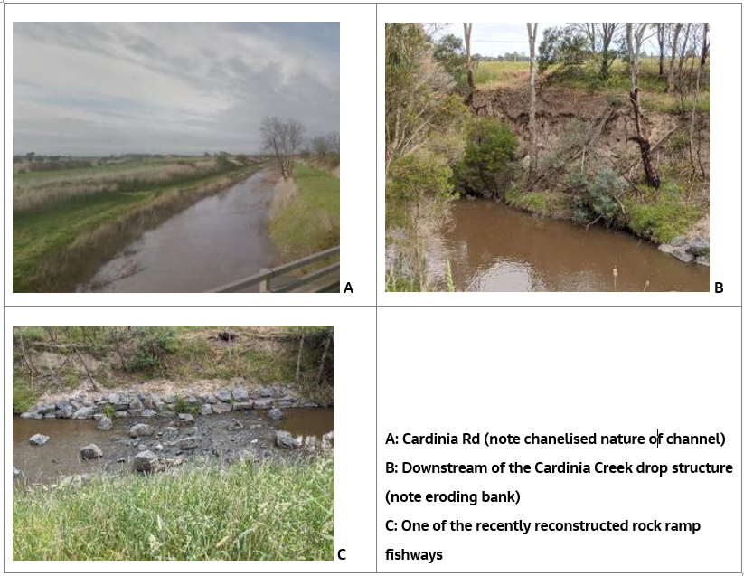

Figure 3‑10 Lower Cardinia Creek

### Critical flow components

Critical components of the flow regime for Australian grayling are low flows to maintain habitat and localised movement opportunities through rock fishways, higher flows in autumn to trigger downstream migration of adults, spawning and return movements to preferred habitat, and higher flows in spring to facilitate upstream migration of juveniles.

Flow threats include: reduction in summer low flows (reduces access to suitable habitat and creates barriers to movement (i.e. too shallow flow), change in frequency, timing and duration autumn freshes and spring high flows; increased frequency and magnitude of higher flows that could cause excessive bed and bank erosion, and barriers to movement – in particular the drop structure, which is likely to represent a barrier to upstream movement.

# Fish risk assessment approach

## Broad approach

The potential risks to fish associated with the PSP development are associated with changes to ecologically critical streamflows, which affect life history cues, hydraulic and physical conditions, and important habitat. The risk assessment framework is based around a quantitative assessment of specific hydrological metrics that are relevant to critical ecological requirements for fish. The approach is described in more detail in the *Cardinia Creek hydrological and fish risk assessment: Methods Statement* (Jacobs, 2019) and summarised below.

The risk assessment process includes a number of specific steps. Hydrological modelling was used to derive stream flows in Cardinia Creek under natural and current conditions. The impacts of development in the three PSPs were then added to the current stream flow regime using MUSIC model outputs from each PSP. Flows were then analysed to provide a quantitative assessment of changes in the frequency, duration and occurrence of flows of a particular magnitude. These flow magnitudes relate to critical flow components and flow volumes that correlate to specific critical ecological risk factors, for example high flows to inundate low-lying backwater areas and known dwarf galaxias habitat, and autumn ‘fresh’ flows to trigger migration for Australian grayling. Flow thresholds / criteria relevant to dwarf galaxias and Australian grayling were derived from a combination of literature reviews, expert opinion and the use of hydraulic models to estimate critical flow thresholds.

## Hydrological and hydraulic modelling

### Hydrological modelling

The hydrological modelling process used Source and MUSIC modelling software to simulate changes to catchment land use, runoff and resultant changes to stream flow.

The hydrological model was developed to:

* Provide daily flows at a range of locations in the catchment;
* Provide results at a sufficient temporal and spatial scale to assess trends in stream flow over time, and changes to critical flow criteria;
* Enable scenario modelling, including changes to land use, climate, stormwater management and streamflow, from pre-development condition prior to expansion of the urban growth boundary (pre 2010), and current (2019) and post-development conditions (Full PSP design);
* Derive flows for wet, average and dry climate condition.

Integrated hydrological modelling was completed using a MUSIC model for each PSP and a Source catchment model for Cardinia Creek Catchment. The Source and MUSIC models were established models provided by Melbourne Water. These methods are described briefly below. Further details on the Source catchment and PSP MUSIC modelling methodology for this study are provide in Appendix A.

MUSIC model

The PSP developments will substantially increase imperviousness surface area, which will result in an increase in runoff and the potential for changed flow regime in Cardinia Creek. A MUSIC model has been developed for each PSP to simulate stormwater and drainage management. The MUSIC model allows for assessment of sub-daily flow events, with flow outputs every six minutes. Nodes are available for each PSP outfall so that individual PSP impacts and cumulative impacts can be determined at spatially explicate locations relevant to specific outfall locations. Note, the MUSIC model used for Officer South Employment PSP includes the Officer PSP, although under current conditions flow form Officer PSP is directed to Gum Scrub Creek, bypassing the existing Officer South Drain.

SOURCE model

Catchment modelling was completed using the existing Western Port dSedNet Source model, which covers the whole Cardinia Creek catchment. Daily flow outputs from the Source model were available for a range of locations (Figure 4‑1):

* Gauge 228230 - Cardinia Creek upstream: This gauge represents catchment inputs upstream of the focus PSPs.
* Gauge 228382 - Cardinia Drop Structure: This gauge represents current and full development impacts associated with inflows from the Minta Farm PSP.
* Gauge 228228 – McCormacks / Chasemore Road: This gauge represents current and full development impacts associated with inflows from the Minta Farm, Officer South Employment and Cardinia South PSPs (or combinations thereof).
* Cardinia catchment outlet: This node represents cumulative outflow to Westernport Bay.

For each of these locations daily flows for natural, current and full develop scenarios were determined under a range of climate conditions including wet, average and dry conditions. (Table 4‑1).

Table 4‑1: Hydrological modelling scenarios to establish changes in flow regime due to different levels of urban development

| Scenario | Description | Catchment model configuration | Assumptions |
| --- | --- | --- | --- |
| Natural | Before European development | All forest land use (impervious fraction = 0)  No Cardinia storage releases | Channelised subcatchments remain unaltered in the model as it was not practical to change model configuration. The Hydraulic modelling informs the impact of channel morphology on fish habitat. |
| Pre-development (2010) | Pre-development prior to expansion of the urban growth boundary (pre 2010) | Reduce all urban areas in PSP subcatchments by 90% to reflect 2010 land use | Changes applied predominantly to residential land use types |
| Current (2019) | Current level of development (2019) | No change to model | Model land use is based on 2016/2017 data, but level of urban development up to 2019 has been minimal in the relevant subcatchments (based on Google Earth imagery) |
| Full development | Post- PSP development, including WSUD | Flow inputs from PSP MUSIC models as additional stormwater contribution | MUSIC models reflect the current PSP drainage designs |

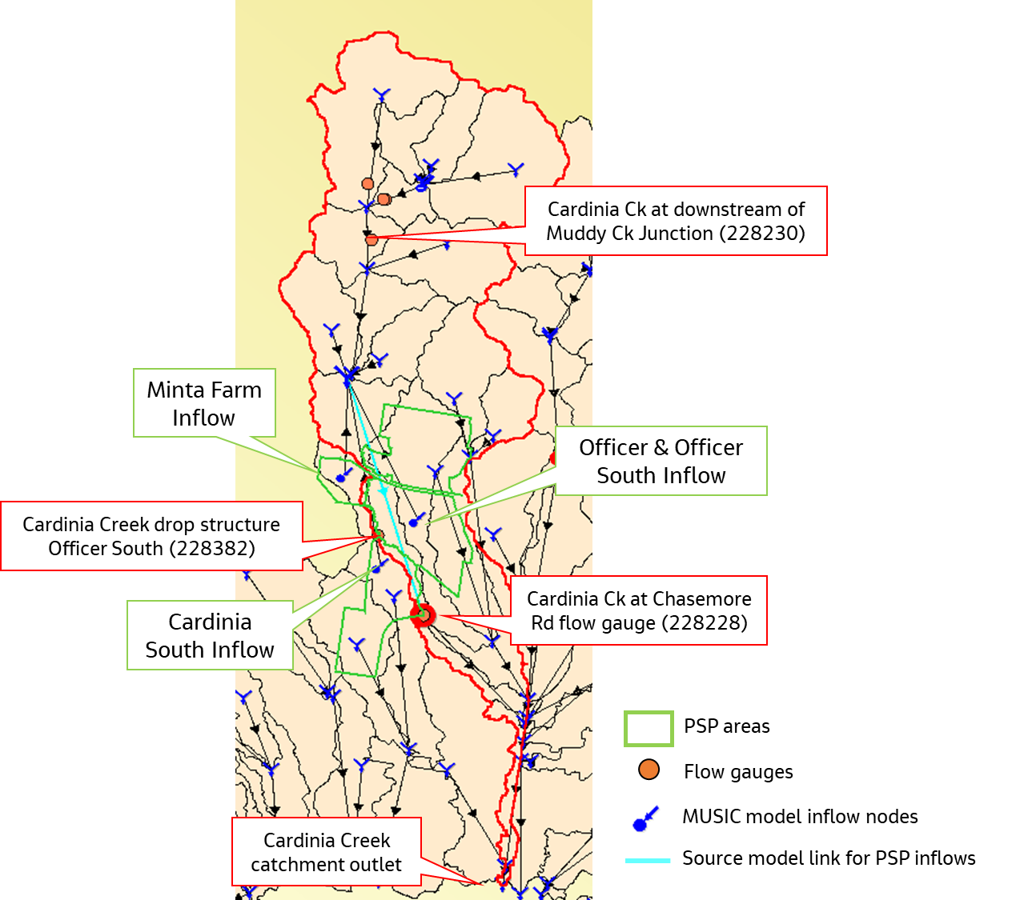

Figure 4‑1 Source catchment model layout, indicating PSP inflow node locations and model link and node reporting points.

### Hydraulic modelling

Hydraulic modelling, using 1-Dimensional HEC-RAS models, was used to establish thresholds for critical flow magnitudes related to inundation of Dwarf Galaxias habitat, shear stresses for initiating excessive channel erosion and depth of shallow areas for maintenance of fish passage.

Two 1-Dimensional HEC-RAS models of the Cardinia Creek system were provided by Melbourne Water as part of this assessment: The first model (SNPSP_HEC-RAS_001) covers the region from Minta Farm to Patterson Road. The second model (CardiniaCreek) represents the channelised section of Cardinia Creek between an area approximately 400 m north of Patterson Road to the outlet at Westernport Bay.

Models were interrogated to identify flow volumes that commence inundation of backwaters and anabranches identified as known or potential habitat for dwarf galaxias, and to extract flows that correlated to critical erosion thresholds at cross-section identified as at risk from excessive erosion. Details are provide in (Jacobs, 2019).

## Risk assessment criteria

Literature review and outputs from modelling were used to determine the relationship between Cardinia Creek streamflow and critical life history requirements for dwarf galaxias (Table 4‑2) and Australian grayling (Table 4‑3).

Table 4‑2 Flow components for dwarf galaxias life history and habitat requirements

|  |  |  |  |
| --- | --- | --- | --- |
| **Season** | **Flow component** | **Rationale** | **Threshold (at Minta Farm and Cardinia Drop Structure)** |
| **Summer and winter low flows** | Magnitude (percentage of time above specific magnitudes). | Low flows that disconnect floodplain wetland habitats and anabranch systems so that seasonal drying occurs, but sufficient to maintain moisture in the sub soils and in crayfish burrows (percentage of time below specific magnitudes). Minimum flows as per Australian grayling (see Table 4‑3). Maximum flow 100 ML/d to prevent excessive inundation of potential habitats. | **10 ML/d summer**  **30 ML/d winter**  **100 ML/d max to minimise excessive inundation of backwater habitats** |
| **High flows (anytime)** | Frequency and duration of time above critical thresholds for inundating dwarf galaxias habitat | Hec Ras modelling has identified anabranches and backwater areas along Cardinia Creek from Minta Farm to the Cardinia Drop Structure and determined the flow magnitudes that commence to inundate these habitats. Thresholds range from 150-1000 ML/d with most potential habitats inundated at between 250 and 500 ML/d. | **Range of flows from 150-1000 ML/d** |

Table 4‑3 Flow components for Australian grayling life history and habitat requirements

|  |  |  |  |
| --- | --- | --- | --- |
| **Season** | **Component** | **Rationale** | **Thresholds (at Cardinia Drop Structure, Chasemore Road and WPB outlet)** |
| **Summer low flows (December-May)** | Magnitude (percentage of time above specific magnitudes). Sufficient to maintain access to riffle and pool habitats and movement through fishways. | The current low flow recommendations for Cardinia Creek is 5 ML/d (as specified in Doeg, 2012).  Hec Ras modelling identified 10 ML/d is sufficient to maintain a depth of 10-20 cm over 90% of cross section).  Current fishway operational range is predicted to be 5-350 ML/d (Ivor Stuart, DELWP, Pers. Com.). | **5 ML/d for fishway operation** |
| **10 ML/d (10-20 cm over ~90% of cross sections** |
| **Autumn spawning freshes (April-June)** | Autumn fresh of sufficient magnitude and duration to enable spawning life cycle event to be completed. Typically10-15 days or longer based on research from the nearby Bunyip River (Koster *et al.*, 2013). | A range of event magnitudes have been selected and the duration (above threshold) and number of events per season are compared between current and developed conditions. These include events that range in duration from 5 days through to 15 days as per the duration suggested by Koster *et al.* (2013). | **25 ML/d** |
| **30 ML/d** |
| **40 ML/d** |
| **75 ML/d** |
| **Winter low flows (June-November)** | Magnitude (% of time above specific magnitudes). Sufficient to maintain access to riffle and pool habitats and movement through fishways- winter low flow is typically higher than summer low flows. | Hec Ras modelling identified 30 ML/d is sufficient to maintain a depth of 40 cm over 80% of cross sections in reach 1 and 50% of cross sections in reach 2. | **30 ML/d** |
| **Winter / spring High flows (Sep-Dec)** | High flows September-December to facilitate juvenile migration from marine environment. Flow needs to be sufficient to provide fish passage. | Event magnitudes (within the operational range of fishways and higher than the low flow thresholds) and the duration and number of events per season are compared between current and developed conditions. | **75 ML/d** |
| **150 ML/d** |
| **250 ML/d** |

For both species, hydraulic conditions are also important. Flows that result in excessive velocity or shear stress that scour habitats, particularly instream vegetation, result in habitat degradation that will impact both species. Urban development, for example, is known to increase the frequency of high disturbance events and increase the variation between minimum and maximum flows on any one day (Treadwell and Sandercock, 2017). High disturbance events are those that generate shear stress and velocities that scour bed and bank material, dislodge instream vegetation and prevent recovery. Other ecologically important components of the flow regime that are also known to be affected by urban development include changes in annual flows, zero flows, base flows, high flows, inter-daily variation, erosion thresholds and floodplain engagement flows (Duncan et al., 2014).

Hydraulic modelling was also used to determine the specific flow magnitudes that relate to potential physical impacts on the creek and channel, including the flows required to mobilise bed sediment, and high flows with potential to cause erosion and scour. These broader metrics are relevant to general stream conditions and erosion risk, which are important for fish, but also important for broader impacts to other values

Table 4‑4 presents a range of flow metrics that are useful for assessing impacts of urbanisation on ecological conditions that are relevant to fish and other ecological values. The values determined for each metric are described in the *Modelling outcomes report* (Jacobs 2020). The magnitude of the difference in metrics between pre-development and post-development conditions helps to define the level of risk that development in the 3 PSPs represents to the ecological conditions of the creek.

Table 4‑4 Flow components for habitat quality – these flows are to maintain instream habitat conditions for fish and other values and to minimise habitat/channel degradation (adapted from Duncan *et al.*, 2014)

|  |  |  |
| --- | --- | --- |
| **Component** | **Function / effect** | **Threshold** |
| **Shear stress rankings** | Different bed material mobilise at different shear stresses. Flow magnitudes that correspond the shear stress risk categories has been determined for the Cardinia Creek channel from the Hec Ras modelling of channel characteristics and using criteria from Gordon *et al.* (2004) (see Jacobs (2020) for details of shear stress risk categories). Assessment is against percent of time that flow exceeds various flow threshold / risk categories under current and full development scenarios. | <5 ML/d (very low risk, minimal movement of unconsolidated bed material) |
| 5.1-30 ML/d (potential movement of unconsolidated bed material, limited movement of consolidated / shielded fine bed material) |
| 30.1-200 ML/d (moderate risk, potential movement of shielded bed material) |
| 200.1-750 ML/d (high risk, likely movement of shielded bed material) |
| >750 (very high risk, scour of stiff clay, cobbles and potential impacts on in-channel vegetation) |
| **Bed mobilisation** | Represents a natural disturbance event that transports sediment and organic material, maintains channel form, flushes riffles etc. Metric is expressed as the fraction of time flow is >Q2yrARI/2 (Duncan *et al.*, 2014). The threshold is determined for the current flow condition and the change in duration is compared between current and full development flow scenarios. | Q2yrcurrentARI/2  Cardinia Drop Structure (376 ML/d)  Chasemore Rd (370 ML/d)  WPB outlet (638 ML/d)  Note the bed mobilisation flows fall within the high shear stress risk category. |
| **Variation in daily flow** | Large variations in day to day (and within day) flows (i.e. flashy flows) create excessive disturbance that impact on the ability of biota to persist in highly variable habitats. Highly variable flows with rapid changes can also result in bank slumping. Increases in flow variability can occur post development due to more rapid runoff from impervious surfaces.  Variation can be expressed as the sum of the absolute values of change in mean daily flows divided by the sum of the mean daily flows (Duncan *et al.*, 2014). This provides a measure of the variability of flows as an indicator of the duration of ‘disturbance events’ and stream flashiness. | Unitless metric: full development compared to current scenarios, a larger number means a higher flow variation. |
| **High flow frequency and duration** | Similar to the bed mobilisation metric but is based on the number of times and the duration that a high flow threshold is exceeded. The high flow frequency metric is typically defined as the number of events per year greater than 3 times the median flow and the high flow duration is the fraction of days that daily mean flow is greater than the annual mean flow (Duncan *et al.*, 2014). | **High flow frequency**  # events that exceed 3x the median flow  Cardinia drop structure (66 ML/d)  Chasemore Rd (79.4 ML/d)  WPB outlet (173 ML/d) |
| **High flow duration**  % of days flows is >annual mean flow  Cardinia drop structure (46 ML/d)  Chasemore Rd (52 ML/d)  WPB outlet (107 ML/d) |

The risk assessment framework adopts a quantitative approach to assessing risks. The risk assessment analyses both individual (i.e. for specific flow or hydraulic components) and cumulative risk associated with each PSP (i.e. the cumulative risk as a combination of individual risks, or the maximum limiting factor/risk). A range of locations are assessed, including above and below PSP outfalls, at critical habitat locations defined by hydraulic models, and cumulatively downstream of all three PSPs.

# Results

## Summary modelling results

### Hydrological modelling

This section presents the summary results of the hydrological modelling, full details are presented in (Jacobs, 2020).

Figure 5‑1 shows changes in flows between natural, current and full development scenarios based on modelled flow duration curves for the 10-year simulation period. Comparing the Current (2019) and Natural scenarios, there is a notable decrease in medium to low flows under natural conditions resulting from removal of Cardinia Reservoir releases (approx. 5 ML/d), a decrease in imperviousness and increased infiltration rates under a natural flow regime. The full development scenario produces a substantial increase in river flows from stormwater contribution in comparison to Current (2019) conditions, especially in the range of10-200 ML/d. There is negligible difference between the current (2019) and pre-development (2010) scenario, and therefore the pre-development (2010) scenario is not further discussed.

|  |  |
| --- | --- |
|  |  |
|  |  |

Figure 5‑1.Flow duration curves comparing catchment model flows at the Cardinia Creek Drop Structure Officer South flow gauge site, the catchment outlet and Upper Cardinia Creek for each scenario for the 10 year simulation period. There are no changes to urban development upstream of flow gauge 228230.

A comparison of dry, average and wet climate years shows that developed scenarios lead to a greater increase in flow across all climate types, although increases tend to be higher in wet and average climate years than dry years (see Figure 5‑2 for the Cardinia Drop Structure).

The implications of specific changes in flows for ecological values are presented in Section 5.2.

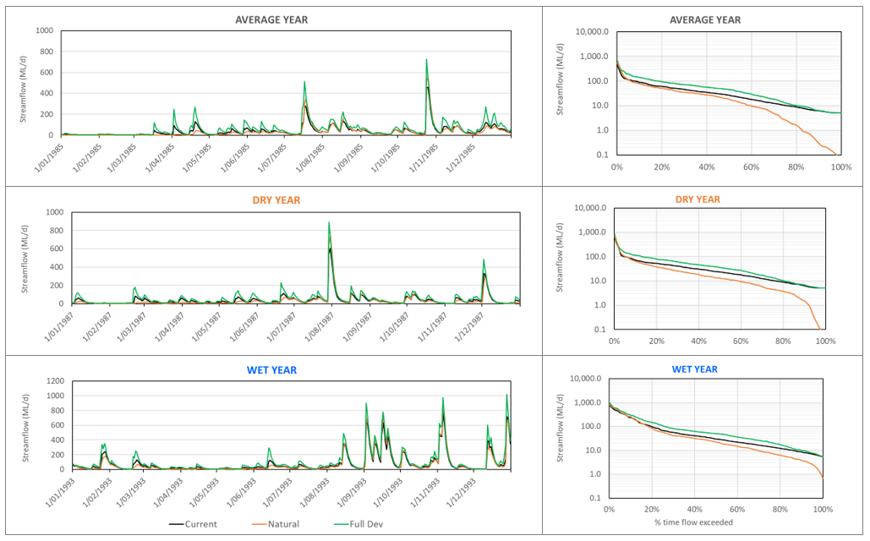

Figure 5‑2.Scenario modelling results for representative Wet, Dry, and Average years at Cardinia Creek Drop Structure (228230).

### Hydraulic modelling

Hydraulic models were interrogated to identify flow volumes that commence inundation of backwaters and anabranches identified as known or potential habitat for dwarf galaxias and to extract flows that correlated to critical erosion thresholds at cross-section identified as at risk from excessive erosion. Detailed results are provided in Jacobs (2020) and summarised below.

Flow thresholds that progressively inundate potential dwarf galaxias habitat were:

* 150 ML/d for commencement of inundation of low-lying backwater areas connected to the main channel
* 250-350 ML/d for inundation of known dwarf galaxias habitat
* 750-1000 ML/d for broadscale inundation of potential habitats

Shear stresses and flow velocity were determined for all cross sections in the HEC RAS models. Results were analysed for 2 reaches; Minta Farm to Cardinia Drop Structure (Reach 1) and Cardinia Drop Structure to McCormacks Road (Reach 2). Shear stresses in Reach 1 tended to be lower compared to shear stresses in Reach 2 for the same flow magnitude (Figure 5‑3). This is consistent with the channel form of the creek with Reach 1 being a more meandering channel with connection to floodplain areas during higher flows compared to Reach 2, which is incised and has limited floodplain connection

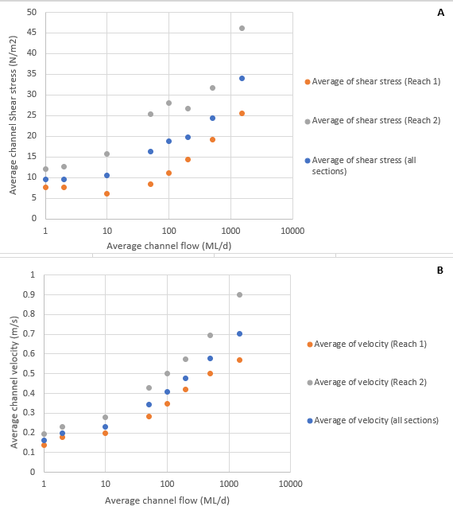

Figure 5‑3 Average channel Shear Stress (A) and Velocity (B) for a range of flows in reaches upstream (Reach 1) and downstream (Reach 2) of Thompsons Road RB.

## Risk assessment

### Reach One – Minta Farm to Cardinia Creek drop structure

**Reach One** comprises the stretch of Cardinia Creek from Princes Highway to the Cardinia Creek drop structure. It is the uppermost reach for this study, and includes the outfalls from Minta Farm North (MFN) and Minta Farm South (MFS) (see Figure 2‑2). Dwarf galaxias have been recorded from anabranches of the creek in the Minta Farm area and upstream of Cardinia Drop Structure as detailed in Section 3.1.

A specific flow regime is required to maintain the filling and drying regime that maintains suitable habitat conditions for dwarf galaxias in this reach. The focus of the risk assessment for this reach was an investigation of potential changes in flow which could affect critical dwarf galaxias habitat requirements, namely the frequency and duration of inundation of off-channel habitats. To avoid impacts on critical habitats and values, there should be no change in the timing, frequency or duration of flows in Cardinia Creek that inundate these anabranches. Increased frequency and duration of high flows that create continuous flow through anabranch habitats (especially in summer and autumn) create unsuitable hydraulic conditions and favour colonisation by predatory mosquito fish, and permanent inundation drowns vegetation that it critical to habitat quality. Reduced frequency and duration of flows (though unlikely to occur) could result in loss of habitat through reduced inundation of spawning habitats, and loss of refuge pools.

Results are presented for habitats located immediately downstream of the Minta Farm north outfall and for habitats located downstream of the cumulative impacts of Minta Farm north and south outfalls.

Low flow frequency

There is no significant change in the low flows in Reach 1, the results indicate that summer and winter low flows will remain below the levels that would regularly engage dwarf galaxias habitat (Table 5‑4). Specifically, under current conditions, flows through Reach 1 are less than 100 ML/d on 96% of days in summer, and less than 150 ML/d on 98% of days in winter. There is no increase in the percentage of time that flows exceed 100 ML/d or 150 ML/d downstream of the Minta Farm north outfall and only a 1-2% increase in the percentage of time that flows exceed 100 ML/d or 15 ML/d downstream of the cumulative impacts of Minta Farm north and south.

The regime should retain the seasonal disconnection of dwarf galaxias habitat and retain the presence of still water wetland habitats in the anabranches and off-channel habitats in Reach 1.

Table 5‑4 Current and modelled future occurrence of summer and winter low flow thresholds

|  |  |  |  |  |  |  |
| --- | --- | --- | --- | --- | --- | --- |
| Season | Flow component | Dwarf galaxias flow requirements | Threshold | Current | Minta Farm North PSP | Minta Farm North & South PSPs (Cardinia Drop Structure) |
| Summer low flows | Magnitude | Low flows that disconnect floodplain wetland habitats and anabranch systems so that seasonal drying occurs, but sufficient to maintain moisture in the sub soils and in crayfish burrows (percentage of time below specific magnitudes) | **< 100 ML/d** | 96% of time | 96% of time | 94% of time |
| Winter low flows | Magnitude | Winter low flows, maybe higher than summer flows but not continuously above invert levels to off-channel habitats. | **<150 ML/d** | 98% of time | 98% of time | 97% of time |

Anabranch inundation

Backwaters areas inundate progressively from 150 ML/d. Known anabranch and wetland habitats for dwarf galaxias inundate at 250-500 ML/d (see Section 4.3).

Table 5‑5 shows the frequency of occurrence of flows ranging from 150-1000 ML/d. The time exceeded, mean duration of flows above the threshold and mean interval between flow events is also shown for current and post development conditions immediately downstream of Minta Farm north and downstream of both Minta farm north and Minta Farm south outfalls.

There is very little change in the frequency or duration of flows that would inundate known dwarf galaxias habitat. For example, under current conditions, flows of greater than 250 ML/d occur every 0.3 years (Average Recurrence Interval (ARI)=0.3) (i.e. ~once every 4 months) and last for an average of 4.2 days. Under full-development conditions there is no change in the frequency of flows above 250 ML/d although when they do occur, they may last for a little longer (i.e. mean 4.2 days under current condition compared with mean 4.8 days under full-development conditions downstream of the combined Minta Farm north and south outfalls).

The slight increase in the duration of events occurs across all flow thresholds, indicating that development results in an extension in the duration of runoff entering Cardinia Creek. This extension in duration is only evident for the combined Minta farm north and Minta Farm south outfalls.

Table 5‑5 Anabranch inundation flows. The red box indicates flow thresholds that inundated known dwarf galaxias habitat

|  |  |  |  |  |  |  |  |  |  |  |  |  |
| --- | --- | --- | --- | --- | --- | --- | --- | --- | --- | --- | --- | --- |
| Flow threshold | Current | | | | Post-development Minta Farm north | | | | Post-development Minta Farm north & Minta Farm South | | | |
| ML/d | ARI | Time Exceeded | Mean duration (d) | Mean interval (d) | ARI | Time Exceeded | Mean duration (d) | Mean interval (d) | ARI | Time Exceeded | Mean duration (d) | Mean interval (d) |
| 150 | 0.2 | 5% | 5.0 | 91 | 0.2 | 5% | 5.2 | 90 | 0.2 | 7% | 5.5 | 77 |
| 250 | 0.3 | 3% | 4.2 | 141 | 0.3 | 3% | 4.3 | 141 | 0.3 | 3% | 4.8 | 135 |
| 350 | 0.4 | 2% | 3.2 | 170 | 0.4 | 2% | 3.2 | 155 | 0.4 | 2% | 3.9 | 169 |
| 500 | 0.8 | 1% | 2.1 | 226 | 0.7 | 1% | 2.1 | 226 | 0.7 | 1% | 2.6 | 241 |
| 750 | 2.0 | 0% | 1.6 | 608 | 1.8 | 0% | 1.5 | 521 | 1.9 | 0% | 1.6 | 608 |
| 1000 | 5.1 | 0% | 1.5 | 1216 | 4.6 | 0% | 1.5 | 1217 | 4.8 | 0% | 2 | 1216 |

Overall, modelling results suggest that there will be some small increases in flows in this reach, resulting in a minor increase in the average duration of anabranch inundation under mid-range flows, and a minor decrease in the interval between inundation events. These small changes do not represent any critical risks to anabranch habitat and conditions, that would be likely to impact on the dwarf galaxias population.

Dwarf galaxias habitat pool filling and drawdown

Along Reach 1 dwarf galaxias primary occupy anabranch and pool habitats adjacent to the creek, rather than the creek itself. The anabranches contract to a series of pools which progressively dry out in between inundation events. To assess the rates of refuge pool draw down, 26 pools of varying sizes and depths along the Cardinia Creek anabranch were identified and modelled to determine their filling and drawdown patterns. Pools were identified from Lidar data, and the size and depth of each pool determined (from Lidar). Example mapping outputs are shown in Figure 5‑6. The left panel shows an aerial view of the entire reach. The main channel is highlighted in blue with a dark blue centre line, and a series of pools (outlined in black) is shown along the anabranch alongside the main channel. The right hand panel shows a close up of the channel and the first pool along the anabranch; Pool 1 is located at the top of the anabranch just below the proposed Minta Farm North outfall, and the point at which the creek breaks into the anabranch at time of sufficient flow.

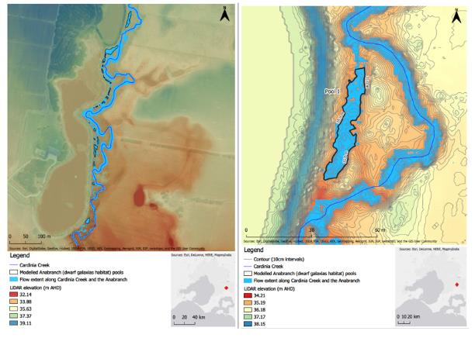

Figure 5‑6 Anabranch pool mapping (left panel) and a close up of pool 1 (right panel) (see Appendix A for a series of maps showing all modelled pools)

The water balance model calculated the time it would take for each pool to dry out, after being fully inundated. This was based on pool dimensions and depths, evaporation estimates (from Station 86375 – Cranbourne Botanic Gardens) and seepage estimates (based on literature values for stiff clay / organic rich bed composition). Figure 5‑7 shows the drying curve based on the total surface area of all pools in the anabranch. After an inundation event (y-axis, percentage of total surface area =1), the total surface area of pools decreases as the pools dry out. This process occurs more quickly in summer than in winter such that pools that fill in summer dry out more quickly than pools that fill in winter, due to higher temperatures and evaporation rates. For example, if the anabranch fills on January 1st, all the pools will dry out by mid-March (~2.5 months). In contrast, if the anabranch fills in June, then all the pools will dry out by mid-November (~5.5 months).

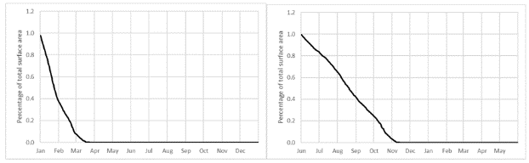

Figure 5‑7 Drying curve for all pools following a January (left) or June (right) inundation event.

The water balance can also be applied to individual pools. Figure 5‑8 shows the drying curve for the total Pool 1, the largest pool in the series. The left panel shows the specific depth drawdown in Pool 1 following a June inundation. From an initial depth of around fifty centimetres (water elevation 35.10 m AHD), the pool draws down over the period June – November, becoming dry (water elevation 34.50 m AHD) in mid-November. The same pattern is reflected in the surface area drawdown curve for the pool (right panel).

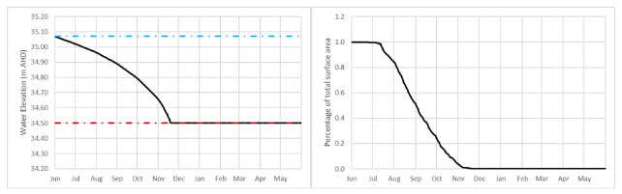

Figure 5‑8 Drying curve for Pool 1, showing depth (left panel) and surface area (right panel). Blue and red lines represent the individual pool full supply and empty levels respectively.

From the water balance modelling, pools need to be inundated every 3-5 months depending on the time of year in order to maintain some wetted habitat. Based on the inundation frequency assessments, pools are inundated 3-4 times per year with a mean interval between inundation of 140-226 days depending on pool location. This frequency is sufficient to inundate pools regularly enough so that the whole anabranch doesn’t dry (except perhaps for very dry years). The Minta Farm North outfall discharge does not substantially change the frequency of inundation, so pools should continue to be inundated at a suitable frequency to maintain permanently wet conditions (at least in some of the deeper pools). The modelling indicates that the frequency of inundation does not increase to the point that the anabranch pools would be permanently connected (or flowing), so the quality of still habitat in this reach should be retained.

Changed operations of Minta Farm lakes

In addition to potential changes in flow in Cardinia Creek as a result of development, there is the potential for a change in the operations of retained lakes in the Minta Farm PSP and this may impact the water regime of the anabranch habitat immediately adjacent the retaining walls of the lakes.

Under current conditions there is occasional (ad hoc) overflow from Pond 3 to the anabranch via an overflow pipe (see Figure 3‑4G). There is no data on the actual overflow regime and the overflow appears to only occur on an ad hoc basis if Pond 3 fills to the overflow point from local catchment runoff. However, this overflow may help provide occasional inundation of some local sections of the anabranch. Furthermore, seepage from the existing dam walls may be helping to maintain moist conditions in the anabranch pools.

Under full development Pond 3 will be modified to incorporate an area of ephemeral wetland in the vicinity of the current overflow pipes (Alluvium 2019) and existing walls will be upgraded. The regime for ephemeral wetland is predicted to be similar to the regime of the current system and the overflow pipes are intended to be retained. However, it is unclear whether this will nonetheless result in a change in the outflow regime of Pond 3 to the anabranch. It is also unclear if upgrading of existing dam walls will alter seepage rates that may currently be maintaining moist conditions. It is recommended that the overflow pipes incorporate a gate valve and the ability to draw water from Pond 3 from time to time in an adaptive management approach to maintain as close as possible the current regime in the Cardinia Creek anabranch.

Although the hydrological regime of dwarf galaxias habitat is predicted to remain unchanged, the reconstruction of the embankment of Pond 3, the decommissioning of Pond 2 and other drainage works have the potential to physically impact on the anabranch habitat. It is important that direct physical impacts are avoided as part of construction works. Moreover, it is important that the decommissioning of Pond 2 and the proposed restoration of the floodplain in that area incorporates ecological design principles that protect and enhance dwarf galaxias habitat and provide habitat for other values, such as growling grass frog.

Summary of risks to dwarf galaxias

Overall, these results show that changes in the frequency and duration of flows at the identified thresholds downstream of Minta Farm north outfall are minimal, and the risk of impacts to critical anabranch filling and drying patterns is very low. Further downstream, the cumulative impact of Minta Farm south outfall increases the duration of some higher flow events slightly, but not the frequency of higher flows to the extent that the inundation regime of potential dwarf galaxias habitat is likely to significant change.

Although the risks from changes in flow regime are low, there is a risk to dwarf galaxias habitat from physical disturbance during construction which needs to be carefully managed to avoid impacts.

## Reach 2 and Reach 3 – Cardinia Creek drop structure to Westernport outlet

**Reaches 2 and 3** comprises the stretch of Cardinia Creek, from below the drop structure down to the Westernport outlet. These reaches include the outfalls from Officer South Employment (OS) and Cardinia South (CS) PSPs. The proposed Officer South Employment PSP outfall flows into the creek near the corner of Officer South Road and Patterson Road, and the proposed Cardinia South PSP outfall flows in just upstream of Chasemore Road (see Figure 2‑2).

Based on recent surveys, Australian grayling have been recorded in the upper parts of Reach 2. This area includes pool and artificial riffle habitat (provided by rock ramp fishways). However, they also need to move through Reach 3 to and from Westernport Bay (Reach 3).

The flow components required to support Australian grayling include low flows to maintain depth over riffle habitats and fishways, autumn fresh flows to trigger downstream migration and spawning, and winter/spring freshes to facilitate upstream migration by juveniles. Hence the focus of the risk assessment for this reach is an assessment of potential changes in flow which could affect low flow magnitudes and frequency, and duration of freshes that trigger migration and spawning.

From a flow perspective there is no reduction in flow components that might represent a risk to Australian grayling in the upper parts of Reach 2 (as assessed by flow at the Cardinia Drop Structure) (Table 5‑9). For example, there is no reduction in summer low flows (they are >5 ML/d 100% of the time), so there is no loss of access to low flow habitat or reduction in the percent of time that the fishway is operational at low flow. However, there is an increase in the frequency and duration of some flows downstream of the Officer South outfall location as assessed by flow at Chasemore Road. This outfall joins the creek about halfway along Reach 2 but downstream of the section of creek where most Australian grayling have been recorded. Notably, the duration of Autumn freshes of various magnitudes increases.

For autumn fresh flows a flow event of 75 ML/d currently lasts an average 5.2 days at Chasemore Road and will increase to 7.8 days under full development. Also, under current conditions there is on average 1.25 events >75 ML/d and this will increase to an average of 2.1 events per autumn. The typical autumn event that would last for 10-15 days under current conditions (a duration that is similar to spawning events in nearby streams) is 30 ML/d at the Cardinia Drop Structure. Under full development the average duration of a 30 ML/d flow event increases to 20 days at Chasemore Road and 32 days at the Westernport Bay outlet. There is a similar slight increase in the frequency and duration of spring freshes.

The increase in the duration of autumn events is a result of increased runoff from the PSP areas contributing to flows already occurring from upstream areas (i.e. they are flow events that occur on top of already occurring catchment events as a result of increased imperviousness).

Summary of risks to Australian grayling

Although the increase in duration of flow events is unlikely to represent a risk to life history ques for Australian grayling, there is the potential for the peak magnitude of these events to also increase, which poses a risk to habitat conditions. These impacts act discussed in the next section.

Table 5‑9 Current and modelled future flow thresholds for components relevant to Australian grayling

|  |  |  |  |  |  |  |  |  |  |
| --- | --- | --- | --- | --- | --- | --- | --- | --- | --- |
| Season | Flow component | | Thresholds | At Cardinia Drop structure | | At Chasemore Rd | | At WPB outlet | |
| Component | Requirement | Current | +MFN+MFS | Current | +MF+OS+CS | Current | +MF+OS+CS |
| Summer low flows (December-May) | Magnitude (percentage of time above specific magnitudes) | Sufficient to maintain depth over riffle habitats and pool depths (~40-100 cm deep). The current low flow recommendation is 5 ML/d (as specified in Doeg, 2012) | **5 ML/d** for fishway operation | 100% of time | 100% of time | 100% of time | 100% of time | 100% of time | 100% of time |
| **10 ML/d** (10-20 cm over ~90% of cross sections | 60% of time | 66% of time | 65% of time | 70% of time | 85% of time | 85% of time |
| Autumn spawning freshes (April-June) | Autumn fresh of sufficient magnitude and duration to enable spawning life cycle event to be completed. Typically 10-15 days or longer is required based on research from other rivers. | A range of event magnitudes have been selected and the duration and number of events per season are compared between current and developed conditions | **75 ML/d** | 4.8 days 1.1 time per season | 4.9 days 1.6 per season | 5.2 days 1.25 per season | 7.8 days 2.1 per season | 13.4 days 2 per season | 14.5 days 2.6 per season |
| **40 ML/d** | 8.2 days 1.4 per season | 11.9 days 2.1 per season | 11 days 2.7 per season | 21.4 days 2.1 per season | 21.8 days 2.2 per season | 28.83 days 2.3 per season |
| **30 ML/d** | 15 days 1.5 per season | 21.5 days 1.7 per season | 20.3 days 1.6 per season | 30 days 1.8 per season | 32.6 days 1.8 per season | 49.9 days 1.6 per season |
| **25 ML/d** | 21.7 days 1.2 per season | 27 days 1.4 per season | 25.3 days 1.2 per season | 36.3 days 1.6 per season | 51.5 days 1.3 per season | 54.5 days 1.5 per season |
| Winter low flows (June-November) | Magnitude (% of time above specific magnitudes) | Sufficient to maintain depth over riffle habitats and pool depths. (40 cm over 80% of cross sections in reach 1, 50% of cross sections in reach 2 | **30 ML/d** | 22% of time | 31% of time | 28% of time | 43% of time | 52% of time | 59% of time |
| Winter / spring High flows (Sep-Dec) | High flows September-December to facilitate juvenile migration from marine environment | A range of event magnitudes have been selected and the duration and number of events per season are compared between current and developed conditions | **75 ML/d** | 8.7 days 2.6 per season | 11.6 days 2.5 per season | 10.4 days 3.4 per season | 14.1 days 4.1 per season | 25.8 days 3.3 time per season | 33 days 3.1 per season |
| **150 ML/d** | 5.5 days 2.1 per season | 6.9 days 2.1 per season | 6.0 days 2.7 per season | 6.7 days 3.7 per season | 12.4 days 3.2 per season | 13.9 days 3.4 per season |
| **250 ML/d** | 4.8 days 1.5 per season | 5.75 days 1.5 per season | 5.5 days 1.9 per season | 4.7 days 2.8 per season | 8.9 days 2.7 time per season | 9.6 days 2.8 per season |

### Channel stability risks

For the channel stability metrics (Table 5‑10) there is a slight increase in the percentage of time (34 to 44% of the time) that flows downstream of the proposed Minta Farm PSP outfalls fall within the moderate risk range for shear stresses compared with current (as modelled at Cardinia Drop Structure), however, overall risks to channel stability are considered low. However, downstream of the proposed Officer South and Cardinia South PSP outfalls (as modelled at Chasemore Road) there is the potential for a larger increase in the duration of time that flow falls within moderate and high shear stress risk categories, an increase in the percentage of time that flows exceed bed mobilisation thresholds and an increase in the number and duration of events considered to be high flows. Risks tend to be mitigated downstream of Chasemore Road due to the larger channel capacity of the Cardinia Outfall through the Koo Wee Rup Flood Protection Area (as modelled by flows at the Westernport Bay outlet).

Table 5‑10 Current and modelled future channel stability risks (daily modelled flow)

|  |  |  |  |  |  |  |  |  |
| --- | --- | --- | --- | --- | --- | --- | --- | --- |
|  |  |  | Cardinia Drop Structure | | Chasemore Road | | WPB outlet | |
| Component | Function / effect | Threshold | Current | +MFN+MFS | Current | +MF+OS+CS | Current | +MF+OS+CS |
| Shear stress rankings | Different bed material mobilise at different shear stresses. Flow magnitudes that correspond the shear stress risk categories has been determined for the Cardinia Creek channel. Assessment is against percent of time that flow exceeds various risk categories under current and full development | **< 5 ML/d (very low risk)** | 0% of time | 0% of time | 0% of time | 0% of time | 0% of time | 0% of time |
| **5.1-30 ML/d (low risk)** | 62% of time | 51% of time | 55% of time | 39% of time | 31% of time | 25% of time |
| **30.1-200 ML/d (mod. risk)** | 34% of time | 44% of time | 41% of time | 45% of time | 57% of time | 58% of time |
| **200.1-750 ML/d (high risk)** | 4% of time | 4% of time | 4% of time | 7% of time | 11% of time | 15% of time |
| **>750 (very high risk)** | 0% of time | 0% of time | 0% of time | 1% of time | 2% of time | 2% of time |
| Bed mobilisation | Represents a natural disturbance event that transports sediment and organic material, maintains channel form, flushes riffles etc. Metric is expressed as the fraction of time > Q2yrARI/2 (Duncan *et al.*, 2014). Threshold is determined for the current condition and change in duration compared between current and full development | % of time the flow exceeds Q2yrcurrentARI/2  Cardinia Drop Structure (376 ML/d)  Chasemore Rd (370 ML/d)  WPB outlet (638 ML/d) | 1.6% | 1.7% | 1.8% | 3% | 2.1% | 2.7% |
| Variation in daily flow | Large variations in day to day (and within day) flows (i.e. flashy flows) create excessive disturbance that impact on the ability of biota to persist in highly variable habitats. Highly variable flows can also result in bank slumping. | Full development compared to current, a larger number means a higher flow variation | 117.6 | 109.2 | 108.5 | 137.6 | 86.3 | 97.2 |
| High flow frequency and duration | Similar to the bed mobilisation metric but is based on the number of times and the duration that a high flow threshold is exceeded. The high flow frequency metric is typically defined as the number of events per year greater than 3 times the median flow and the high flow duration is the fraction of days that daily mean flow is greater than the annual mean flow (Duncan *et al.*, 2014). | **High flow frequency**  Number of events that exceed 3x the median flow  Cardinia drop structure (66 ML/d)  Chasemore Rd (79.4 ML/d)  WPB outlet (173 ML/d) | 8 | 9 | 8 | 11 | 7 | 8 |
| **High flow duration**  % of days flows is > annual mean flow  Cardinia drop structure (46 ML/d)  Chasemore Rd (52 ML/d)  WPB outlet (107 ML/d) | 25% | 27% | 26% | 42% | 28% | 37% |

The channel stability risks noted above are based on the modelled increase in average daily flows from the various PSPs. However, it doesn’t account for any sub-daily flow variation. For example, a storm event that generates runoff from the new urban areas might only last for a few hours so the peak flows to Cardinia Creek from these events might be quite high for a few hours, but when averaged across a day the daily average flow will be lower. Hence risks associated with sub-daily peak flows may be overlooked.

To explore this issue further the differences between daily and hourly peak flow from the PSPs were assessed. The following figures (Figure 5‑11 and Figure 5‑12) show the difference in magnitude of peak flows under current condition (blue) and with either the average daily PSP outflow (orange) or the peak hourly PSP outflow (red) added to the current daily event. Also, on each plot are relevant thresholds for dwarf galaxias habitat inundation and bed mobilisation.

For upstream sections of creek that are only impacted by the Minta Farm outfalls there is very little difference between the addition of daily average and hourly peak PSP outflow (Figure 5‑11). This is because the area associated with the Minta Farm PSP is not large relative to the upstream catchment, so the incremental increase in flows is small, and over a ten-year modelling period there is only one or two additional events that would inundate dwarf galaxias habitat or exceed bed mobilisation threshold compared to current. On this basis, the risks to dwarf galaxias habitat inundation and channel stability in the Reach from Minta Farm downstream to the Cardinia drop structure and even further on to the point of the Officer South Outfall location is considered low. This low impact reach also includes the area where most Australian grayling have been recorded.

However, there are large difference between daily and peak (hourly) flow increases downstream of the proposed Officer South outfall and Cardinia South outfalls (Figure 5‑12). This shows that there is potential for frequent sub-daily flow events to exceed the Bed mobilisation threshold for the reach downstream of these outfalls. Figure 5‑13 shows the change in the number, duration and timing of these increased flow events. Notable in this plot is that when peak hourly flows are incorporated into the modelling, flows that exceed the bed mobilisation threshold may also occur in summer and autumn when they otherwise don’t occur during this period under current conditions.

To further demonstrate the change in flow associated with the cumulative impact of all proposed PSPs outfalls, Figure 5‑14 shows the change in the Average Recurrence Interval (ARI) under current and developed conditions. There is very little change in the ARI downstream of the proposed Minta Farm north outfall. The magnitude of the 1:1 year event is the same (~600 ML/d) under current and developed conditions. However, at Chasemore Road the 1:1 year event changes from a flow of ~600 ML/d to a flow of ~800 ML/d (what was the 1:1 year flow now occurs twice per year). Moreover, flows that would have occurred once every 5 years (~1000 ML/d) are predicted to occur around once every 2 years.

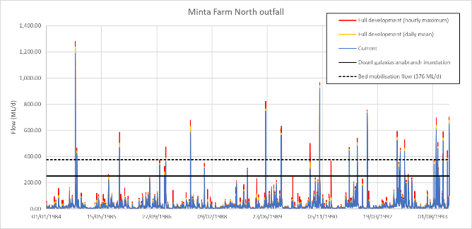

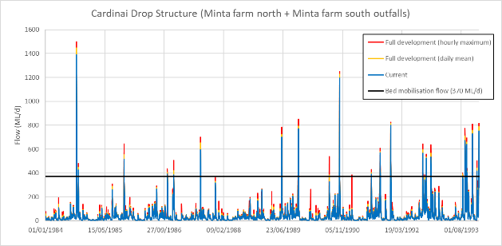

Figure 5‑11 Differences between current and peak daily or hourly full development flows downstream of the Minta Farm north (upper panel) and combined Minta Farm north and south outfalls (lower panel). Peaks are compared to the bed mobilisation threshold and the dwarf galaxias anabranch inundation threshold (at Minta Farm north).

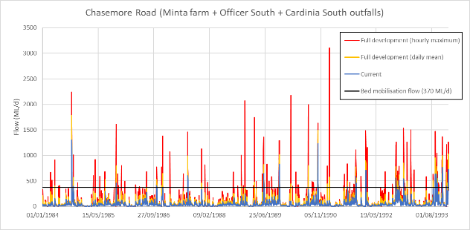

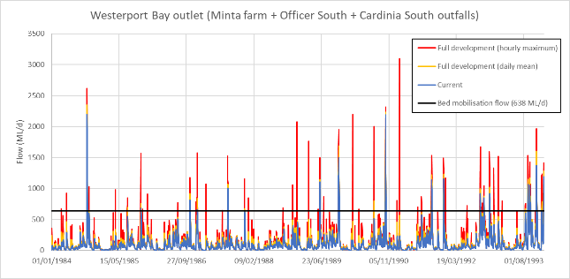

Figure 5‑12 Differences between current and peak daily or hourly full development flows downstream of the Minta Farm, Officer South and Cardinia South outfalls. Peaks are compared to the bed mobilisation threshold at Chasemore Road (upper panel) and Westernport Bay outlet (lower panel).

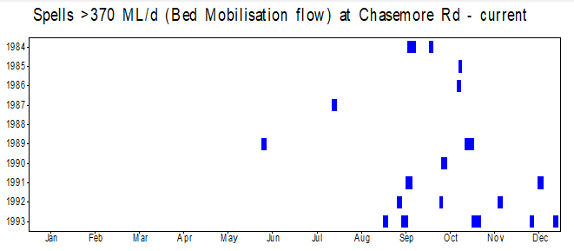

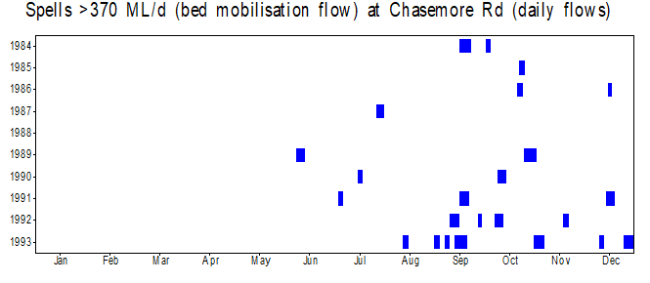

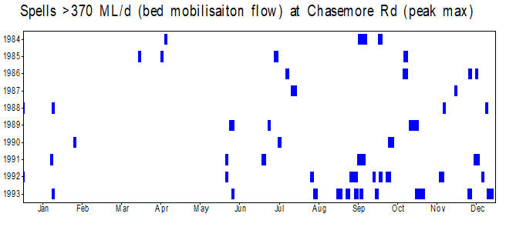

Figure 5‑13 Spells above the bed mobilisation flow at Chasemore Road under current (upper panel) and full development (peak daily-middle panel and peak hourly-lower panel) conditions

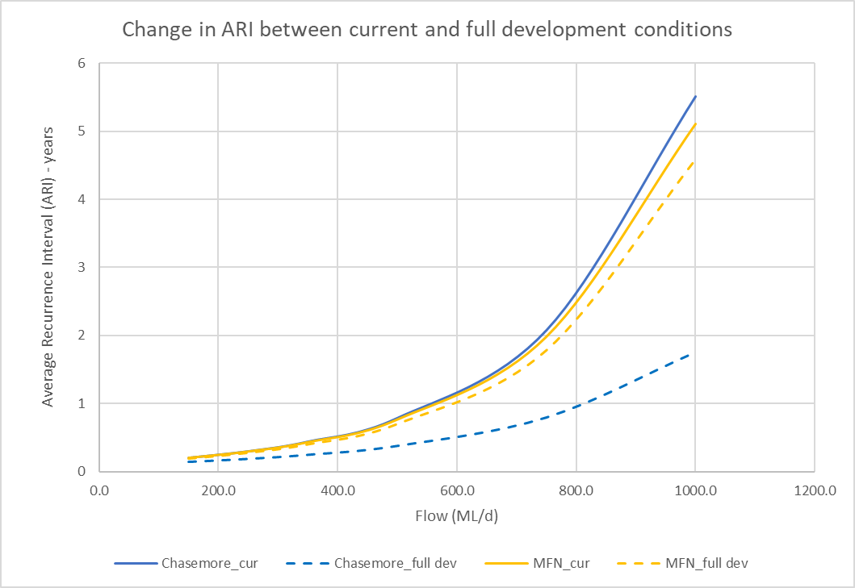

Figure 5‑14 Change in Annual Recurrence Interval for flows at Minta Farm North and Chasemore Road (cumulative impact of all PSPs) under current and full development conditions.

Summary of channel stability risks

The analysis of potential risks to channel stability indicates that there is little change in the risk profile associated with the proposed Minta Farm north and south outfalls. However, downstream of the proposed Officer South outfall there is potential for an increase in the frequency and duration of flows that exceed critical shear stress and bed mobilisation thresholds, particularly in association with an increase in the magnitude of peak sub-daily flow events. Even though peak flows only occur for short periods of time (hours), they still represent a risk to channel stability and may initiate erosion of bed and bank material that is subsequently transported downstream at lower flows.

These increased flow peaks could contribute towards excessive erosion of bed and banks compared to current conditions, may contribute to the scour of instream vegetation, and are also likely to impact on the quality of habitat for aquatic organisms that use or migrate through this reach.

# Summary and recommendations

## Summary

### Impacts associated with Minta Farm PSP

In summary, there are overall increases in the volume of water entering Cardinia Creek via both the Minta Farm north and Minta Farm south outfalls, however, the increase in volume is not significant enough to result in a substantial change in low flows in Cardinia Creek and there is no significant increase in the frequency or duration of high flow events that inundate dwarf galaxias habitat. This is because the area associated with the Minta Farm developments is small compared to the upstream Cardinia Creek catchment area, so the contributing flows from the PSP areas are consequently relatively small in the context of upstream catchment flows. However, there are a range of other risks to dwarf galaxias habitat in the Minta Farm area that need to be addressed as part of development. These include construction works associated with the Minta Farm north outfall and the decommissioning of Pond 2, construction works associated with the remediation of the Pond 3 embankment, and the overflow regime associated with the remodelled ephemeral habitat associated with Pond 3.

Low risks are also present in Reach 2 downstream of the Cardinia Drop structure through the section of that reach where Australian grayling have been recorded. This suggests that any changes in flow are unlikely to represent risks to Australian grayling survival or alter movement and spawning cues (e.g. movement through existing fishways) at the local scale. Moreover, the change in flows are unlikely to represent a risk to channel stability with there being no significant increase in the frequency or duration of flows above the magnitudes that would contribute to increased erosion risks.

### Impacts associated with Officer South Employment and Cardinia South PSPs

There is a potential risk to stream condition downstream of the Officer South Employment and Cardinia South outfalls (although most of the impact is associated with the Officer South Employment PSP being a larger catchment area than the Cardinia South PSP). In particular, there is an increase in the number of flow events that occur at a sub-daily (i.e. hourly) duration that exceed critical bed mobilisation flows which could contribute to increased channel erosion and scour of vegetation. This has the potential to impacts on the quality of habitat through the reach and may also interrupt movement cues for Australian grayling that need to move through this reach for downstream spawning and upstream juvenile migration in autumn and spring respectively. Further downstream, to Westernport Bay, risks are mitigated to some extent because of the larger channel capacity associated with the Cardinia Outfall through the Koo Wee Rup Flood Protection Area.

Figure 6‑1 highlights the areas of risk along the creek.



Figure 6‑1 Reach risk rating (green-low, yellow-moderate, red-high). Blue stars indicate habitat for (and recorded locations of) dwarf galaxias and Australian grayling

## Mitigation recommendations

### Minta Farm PSP

Key risks associated with the Minta Farm PSP relate to construction impacts associated with outfall construction, Pond 2 decommissioning and Pond 3 embankment rectification. Recommendations are:

* That ecological principles are incorporated into all design and construction activities in the vicinity of the Cardinia Creek anabranch, including all temporary and permanent works associated with outfall and embankment construction.
* That the design for the Pond 2 decommissioning consider opportunities for incorporating dwarf galaxias and growling grass frog habitat elements into the restored floodplain habitat
* That the overflow from the Pond 3 ephemeral zone incorporates the ability to manipulate flow releases into the dwarf galaxias anabranch as part of an adaptive management plan for the protection of dwarf galaxias habitat.
* That opportunities for incorporation of new dwarf galaxias and growling grass frog habitat is considered and incorporated into the establishment of the Cardinia Creek Conservation Zone (see Appendix C for preliminary mapping of potential wetland locations within the proposed conservation zone).

### Officer South Employment and Cardinia South PSPs

The critical risks associated with Officer South Employment PSP (and to a lesser degree Cardinia South PSP) relates to high peak hourly flows from the proposed outfall. The Officer South drainage scheme design, in particular, is nearly ten years old and requires revision to more clearly identify opportunities to reduce peak flow rates.

Such recommendations have been previously made in the development of the Officer South DSS requirements as quoted below by Stormy Solutions (2011), however, it would appear that specific peak flow reduction has not been achieved in the current design.

*“Development of the functional design of these elements must include clearly defining the current low flow regimes (volume, frequency, and duration) to the Cardinia Creek outfall. Flow regimes will need to be maintained post development in order to protect the existing ecology and channel morphology of the creek. It is proposed to use the extended detention range in all wetlands to control frequent flows from the developed areas to meet this requirement. This aspect of the design must be formulated during the functional design process.”*

It is recommended that the Officer South Employment and Cardinia South PSP drainage designs be reviewed with the intent of identifying opportunities to reduce peak flow rates, maintain the current frequency and duration of flows in Cardinia Creek that exceed bed mobilisations flows (370 ML/d at Chasemore Road) and limit where possible the increase in magnitude of the 1:1-1:5 year ARI events. The reviews need to consider the cumulative impacts of the two PSPs on creek flows.

## Next steps

The results of this work will be used by Melbourne Water to assist in the review and update of drainage designs in the Officer South Employment and Cardinia South PSPs (currently being undertaken) to identify potential solutions to mitigating peak flows. These solutions will be modelled through MUSIC modelling and compared with the current outfall regimes to test if risks can be reduced.

# References

Alluvium 2016, Stormwater Management Strategy - McPherson Precinct Structure Plan. Report prepared for

the Regional Planning Authority

Alluvium (2018) Review of the Cardinia Creek Conservation Area Austrlain Grayling and Dwarf Galaxia Assessment – Hydrological modelling. Report produced for Melbourne Water, Victoria.

Alluvium (2019) Preliminary Functional Design Report. Minta Farm Drainage Strategy, Wetland System and Outfalls into the Cardinia Creek. August 2019

Amtstaetter, F., O’Connor, J., Tonkin, Z., Koster, W., Stuart, I. & Hale, R. (2019) *VEFMAP Stage 6: Monitoring fish response to environmental flow delivery in Victorian coastal rivers,* Unpublished Client Report for the Water and Catchments Group. Arthur Rylah Institute for Environmental Research, Department of Environment, Land, Water and Planning, Heidelberg, Victoria.

Ball J, Babister M, Nathan R, Weeks W, Weinmann E, Retallick M, Testoni I, (Editors) Australian Rainfall and Runoff: A Guide to Flood Estimation, © Commonwealth of Australia (Geoscience Australia), 2019.

Berra, T.M. (1982) Life history of the Australian grayling, Prototroctes maraena (Salmonifromed: Prototroctidae) in the Tambo River, Vctoria. *Copeia***:** 795-805.

Biosis (2012) *Melbourne's Strategic Assessment: Dwarf galaxias surveys for the South East Growth Corridor*.

DEPI (2013a) *Biodiversity Conservation Strategy for Melbourne’s Growth Corridors*.

DEPI (2013b) *FLOWS - a method for determining environmental water requirements in Victoria. Edition 2,* Department of Environment and Primary Industries, Melbourne.

Chiew FHS, Peel MC, Western AW (2002) Application and testing of the simple rainfall-runoff model SIMHYD. In: Singh VP, Frevert DK (eds) Mathematical models of small watershed hydrology and applications. Colorado. Water Resource Publication, p. 335-67. ISBN: 1887201351

Crook, D.A., Macdonald, J.I., O’Connor, J.P. & Barry, B. (2006) Use of otolith chemistry to examine patterns of diadromy in the threatened Australian grayling *Prototroctes maraena*. *Journal of Fish Biology,* **69:** 1330-1344.

Cuddy SM, T Weber, L Cetin, S Wilkinson, D Gonzalez, A Freebairn, RA Coleman, A Gamboa Rocha, P

DELWP (2016) Guidelines for Assessing the Impact of Climate Change on Water Supplies in Victoria, Version 7.0, The State of Victoria Department of Environment, Land, Water and Planning.

Doeg, T.J. (2012) *Assessment of the passing flows regime from Cardinia Reservoir*.

Duncan, H.P., Fletcher, T.D., Vietz, G. & Urrutiaguer, M. (2014) *The feasibility of maintaining ecologically and geomorphically important elements of the natural flow regime in the context of a superabundance of flow,* Melbourne Waterway Research-Practice Partnership Technical Report. 14.5.

Ecology Australia (2019) *Cardinia Creek fishway monitoring,* Report to Melbourne Water.

GHD (2017) *Cardinia Creek conservation area Australian grayling and dwarf galaxias assessment*.

Gordon, N.D., McMahon, T.A., Finlayson, B.L., Gippel, C.J. & Nathan, R.J. (2004) *Stream Hydrology: An Introduction for Ecologists,* John Wiley & Sons, Chichester.

Jacobs (2019) *Cardinia Creek Conservation Area Hydrology and Fish Investigation: Methods statement*.

Jacobs (2020) *Cardinia Creek Conservation Area Hydrology and Fish Investigation: Modelling Outcomes*.

Koster, W.M., Dawson, D.R. & Crook, D.A. (2013) Downstream spawning migration by the amphidromous Australian grayling (<i>Prototroctes maraena</i>) in a coastal river in south-eastern Australia. *Marine and Freshwater Research,* **64:** 31-41.

McDowall, R.M. (1996) Freshwater fish of south-eastern Australia. Reed Books, Sydney.

O'Connor, J.P. & Mahoney, J.C. (2004) Observations of ovarian involution in the Australian grayling (*Prototroctes mareana*). *Ecology of Freshwater Fish,* **13:** 70-73.

Sadlier, S., Jackson, J. & Hammer, M. (2010) *National recovery plan for the dwarf galxias Galaxiella pusilla,* Victorian Department of Sustainability and Environment, Melbourne.

Stormy Water Solutions (2011) Officer South Development Services Scheme. Report prepared for Melbourne Water.

Treadwell, S. & Sandercock, P. (2017) Using science and hydraulics to inform stormwater management for improved river health outcomes: How much stream flow is too much? In: *2017 Victorian Stormwater Management Conference.* (Ed^Eds.

1. Hydrological modelling methodology

The following sections provide a description of the approach adopted for the hydrological modelling that is required to 1) quantifying flow criteria identified in Section 4.3 and 2) enable a comparison of different scenarios in order to establish risk to values.

* 1. Selection of appropriate catchment modelling framework

There are a number of existing models available to inform the hydrological assessment:

* MUSIC models for each of the PSP areas that simulate the current stormwater management and drainage designs for the PSPs.
* Source catchment model of Cardinia Creek, with catchment outlet at flow gauge 228228 Cardinia Creek at Chasemore Rd, Cardinia developed for assessing changes in flow regime resulting from the three PSP developments (GHD, 2017).
* Source catchment model of Westernport catchments developed for sediment modelling using the dSedNet sediment budget model (Cuddy et al. 2019).

We have completed a preliminary review of existing models and data, including critiques of the previous Source model of Cardinia Creek catchment (GHD, 2017). The Alluvium review (Alluvium, 2018) of the GHD Cardinia Creek Source model found that the model is ‘*significantly flawed and not suitable for determining impacts on Australian Grayling or Dwarf Galaxias as a result of urbanisation within the Minta Farm, Officer South and McPherson PSP areas*’. Alluvium recommended the following were addressed in subsequent hydrological modelling:

1. Modelling of full extent of Cardinia Creek catchment that is impacted by PSP areas
2. Three scenarios should be completed with the modelling: pre-development (or natural), pre-PSP development (prior to 2012), and full PSP development
3. Analysis of climate change impacts over long-term (1973 to current) using the DELWP Climate Change Guidelines (DELWP, 2016)
4. The model should assess the following metrics at sufficient spatial and temporal scale:

Flow timing

Flow magnitude

Flow volumes

Peak flow durations

Rate of rise and fall

Inundation level and frequency of floodplain habitat engagement

Given these modelling requirements, we used the Westernport dSedNet Source Catchments model for simulating the required hydrology in Cardinia Creek that will inform the environmental risk assessment. The Westernport dSedNet Source model was developed for Melbourne Water to assess soil erosion sources, and its transport through the Westernport catchment, and to provide a decision-support system (Catchment Planning Tool) for managing and mitigating sediment erosion impacting on the health of the Bay. The Source model covers all catchments draining to Western Port, including Cardinia Creek.

Cardinia Creek catchment has been delineated into 17 subcatchments of approximately 10-15 km2 in area. Each subcatchment is characterised by 28 land use types, largely focused on representing different sources of sediments and to facilitate scenario modelling. Hydrologically, the model has been configured with SIMHYD rainfall-runoff models (Chiew et al 2002), parameterised for 3 land use types that have distinct hydrological responses: Forest, rural and Urban.

SIMHYD is similar to the rainfall-runoff model used in MUSIC, which is the Simplified Urban Runoff Model (SURM). SURM is a simplified version of SIMHYD, with simplification of the soil moisture storage component of the model. SIMHYD is a ‘bucket’ style model with enough complexity to deal with the range of hydrologic responses which occur over a continuous time period. SIMHYD has been used in many applications across Australia, particularly where urban areas are likely to be important.

Impervious fractions for land uses were taken from the Melbourne Water 2018 MUSIC modelling guidelines (Melbourne Water, 2018). Based on ARR (2019) guidelines (Ball et al., 2019) the impervious fractions from the MUSIC guidelines were scaled (by 0.6) to exclude impervious areas that have no direct connection to the drainage network. This results in an effective impervious area (EIA) (Table A.1). These are used to parameterise the Pervious Fraction parameter (i.e., 1- EIA factor) in SIMHYD. In order to facilitate scenarios that test changes in impervious area the Pervious Fraction parameter in SIMHYD was fixed, and not altered in calibration. This allows consistent representation of directly connected imperviousness across the whole model extent.

Table A.1: Functional unit types and effective impervious area (EIA) factors

|  |  |  |  |
| --- | --- | --- | --- |
| **Land use** | **EIA Factor** | **Land use** | **EIA Factor** |
| Agricultural Industry | 0.30 | Grassland | 0.06 |
| Commercial | 0.54 | Grazing and Cropping | 0.06 |
| Industrial | 0.54 | Green Space | 0.06 |
| Apartments | 0.51 | Other | 0.3 |
| Low Density Residential | 0.36 | Horticulture | 0.06 |
| Medium Density Residential | 0.45 | Public Use | 0.42 |
| Residential Other | 0.45 | Quarry | 0.12 |
| Railway | 0.42 | Forest | 0 |
| Road | 0.39 | Plantation | 0.06 |

Routing models are set to straight-through routing (e.g. any observed attenuation of flows would occur within less than a day). This was necessary because the observed attenuation of flows at the links specified in the model would occur within less than a day and hence the effect of flow routing was unlikely to be significant.

In terms of the hydrology, the model is well calibrated at a daily timestep, and addresses all of the concerns raised by the peer review of the previous Cardinia Creek Source model as illustrated in Figure A.1. The Westernport dSedNet Source model estimates peak and low flows better than the Cardinia Creek Source model, which is important for providing quantitative metrics as outlined by the Alluvium review.

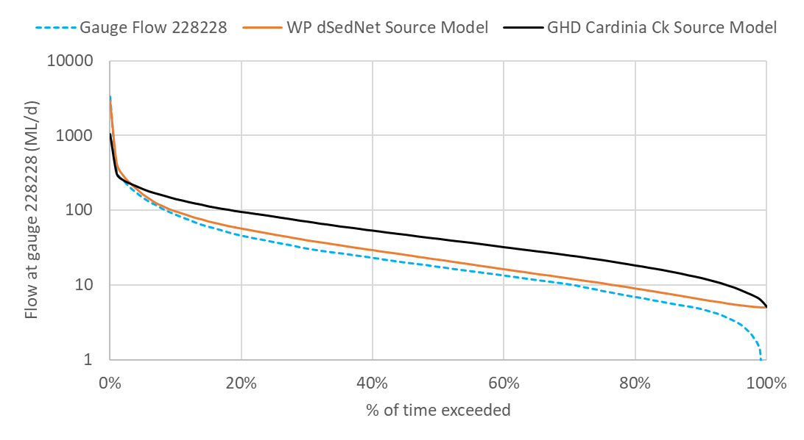

Figure A.1: Comparison of simulated flows and observed flow at 228228 Cardinia Creek at Chasemore Rd, Cardinia.

* 1. PSP development: review of MUSIC models

While the source model is suitable for modelling flows in Cardinia Creek catchment, it needs to be coupled with a model for each PSP that can simulate the post-development flows at the PSP scale. The proposed PSP developments will substantially increase the impervious area, and subsequently the proportion of rainfall which will become surface runoff. The stormwater management and drainage designs that are proposed for each PSP identifies the mitigation works required to offset the impact of urban development on the local and downstream receiving waters.

For deriving the specific impacts of development in the three PSP areas we used the existing MUSIC models, provided by Melbourne Water. The MUSIC models produce daily and sub-daily flows for post-development conditions (i.e. based on current PSP designs, changes in land use, increases in catchment imperviousness, drainage network design etc). The MUSIC modelled flows provide inputs to the Source catchment model as the additional contributing flows to Cardinia Creek at the outfall locations. This enables the catchment model to assess the cumulative changes across the catchment impacting the Bay. This approach provides an integrated solution for the hydrological modelling and assessment.

The appropriate MUSIC models for each PSP have been obtained from Melbourne Water and confirmed as representative of the current drainage design, including Water Sensitive Urban Design (WSUD) features. Melbourne Water has confirmed the MUSIC model versions as:

|  |  |  |
| --- | --- | --- |
| **PSP** | **Developer / reference** | **MUSIC model scenario & file** |
| Cardinia South (McPherson) PSP | Alluvium (2016) | No regional park scenario  *McPherson_North_85%_TSS_updated_PSP_May2017v2.sqz* |
| Officer South (includes Officer PSP) | Original model developed by Stormy Water Solutions (); Model updated by MW (2019) | *Officer & Officer Sth DSS_Jan2020.sqz* |
| Minta Farm PSP | Alluvium (2019) | Model is split into north and south areas  *minta south wl3 wl4 with pond 3 20191126.sqz* and *Minta_farm_north_treatment_scenario 1b.sqz* |

In terms of drainage design conceptualisation and features the Minta Farm and Cardinia South MUSIC models have been used unaltered. It is worth noting that the Cardinia South PSP MUSIC model contains areas that do not contribute flows to Cardinia Creek (i.e. Muddy Gates Drain flows south before discharging into Westernport Bay) and are thus excluded from the modelling for this project.

Given the Officer South Employment PSP drainage design and MUSIC model were developed in 2011, Melbourne Water have updated the model to reflect the actual stormwater quality treatment works built over the last 10 years in the area. Both the Officer DSS 1315 and Officer South DSS 1304 have been combined into a single MUSIC model, because part of the Officer South wetland system is designed to treat stormwater generated from the Officer PSP North of Pakenham Bypass. Future scheme stormwater treatment assets likely to be constructed in the future have been retained in the model. In addition, climate inputs have been updated to extend the MUSIC model simulation to a 10-year period (original model was constrained to 2004 climate input).

The following assumptions have been noted by Melbourne Water in consolidating the Officer/Officer South MUSIC models:

* All agricultural catchment source nodes north of Brown Road have been removed from the model to avoid double counting flows already generated by the Source Catchments model.
* Officer South DSS 1304: ORD 1 has not been constructed as a wetland, but has been retained as a waterway with a sediment basin constructed at Bridge Rd. Both ORD 2 & 3 wetlands are the stormwater quality treatment for Officer DSS, which are online wetland systems at this time and will be subject to further revision.
* All sediment basins for Officer South DSS are offline to the wetland system which is a change from the SWS (2011) drawings.
* Proposed wetland ORD 4A & 4B have been combined at this time as one wetland asset (ORD 4) with offline sediment basin assumed. Sediment basin S2 & S3 have also been combined at this time. The catchment area that feeds into each sediment basin (S2 & S3) has been designed with separate source nodes in the MUSIC model. The area for S2 has been taken from all of property no. 22-24 and the section of no. 25 which sits above the gas easement. The area for S3 is all of property no. 26 and the section of property no. 25 which sits to the right of the blue dotted line between nodes G2 and J1.
* ORD 5 is the last wetland treatment for Officer South catchment to then discharge flows from this wetland into Cardinia Creek. High flow from ORD 4 wetland will travel through ORD 5 wetland, and low flow will connect to existing drains which run alongside ORD 5 and into Cardinia Creek. The area for sediment basin S4 is taken from all of property no. 27 & 28 and the section of property no. 25 which sits to the left of the blue dotted line between nodes G2 and J1.
  + 1. Adjustment of climate period and inputs

In order to integrate the PSP inflows into the catchment model the MUSIC model simulation period needs to align with the simulation period of the Source model. The Source model has a simulation period of 1970 to 2016, but Cardinia reservoir releases begin in 1980. The Minta Farm MUSIC models use the Narre Warren rainfall template with simulation period of 1984-1993. The Cardinia South and Officer/Officer South MUSIC models use the Koo Wee Rup rainfall template with simulation period of 1971 to 1980.

The Koo Wee Rup rainfall template is recommended by the current Melbourne Water MUSIC modelling guidelines (Melbourne Water, 2018), but this simulation period would not include Cardinia Reservoir releases in the Source model, and would be less representative of current conditions from a catchment modelling perspective. Although the Koo Wee Rup rainfall template provides drier rainfall years, it is comparable to the Narre Warren rainfall template in relation to observed rainfall at the closest rainfall station to the PSPs (Berwick – 86299). Figure A.2 illustrates the correlation between observed total annual rainfall and the AWAP rainfall data used in the Source model and the rainfall templates used in the MUSIC models. Each of the model input datasets exhibit similar variations from the observed rainfall.

As such the Narre Warren rainfall template was adopted for the Officer South and Cardinia South MUSIC models to provide a comparative simulation period for the catchment modelling that included the Cardinia reservoir releases.

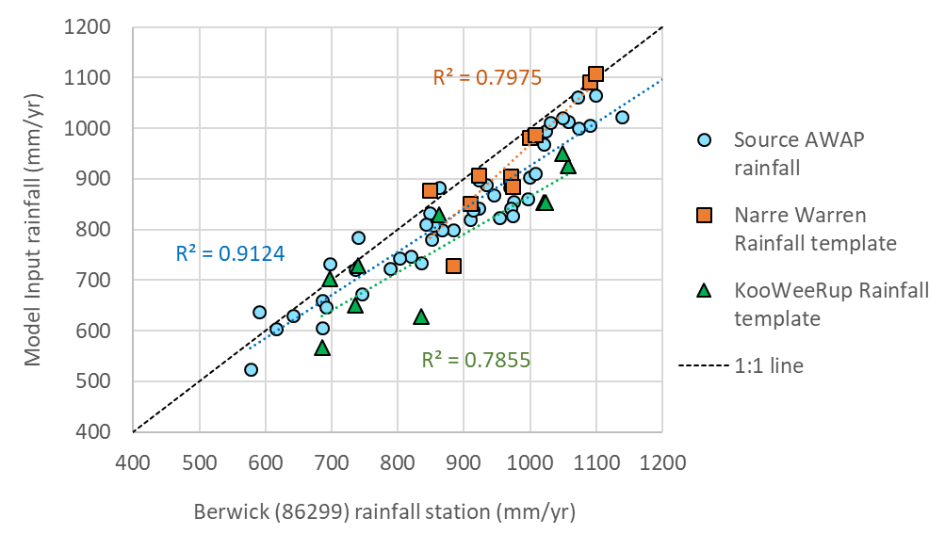

Figure A.2. Comparison of annual total rainfall for model rainfall inputs and measured rainfall at the closest rainfall station (Berwick – 86299).

* 1. Selection of representative climate years

Based on the Berwick rainfall station (86299) data, ‘Wet’ years were calculated as those above the 80th percentile (1023 mm/yr) and ‘Dry’ years as those below 20th percentile (741 mm/yr) total annual rainfall. The long-term (1979 – 2019) average (892 mm/yr) was adopted to define an ‘Average’ year. Table A.2 summarises the total annual rainfall amounts for the selected representative Wet/Dry/Average years, and Figure A.3 illustrates the Wet/Dry/Average annual rainfall thresholds in relation to the total annual rainfall derived from the model rainfall input datasets.

Table A.2. Selection of representative ‘Wet’, ‘Dry’, and ‘Average’ years based on total annual measured rainfall at Berwick (86299) rainfall station.

|  |  |  |  |  |
| --- | --- | --- | --- | --- |
|  | **Measured rainfall threshold (mm/yr)** | **Representative Year in model simulation period** | **Total annual rainfall for representative year (mm/yr)** | |
| **Source AWAP data** | **MUSIC rainfall template** |
| AVERAGE | 892 | 1985 | 843 | 905 |
| WET | 1023 | 1993 | 1065 | 1108 |
| DRY | 741 | 1987 | 799 | 729 |

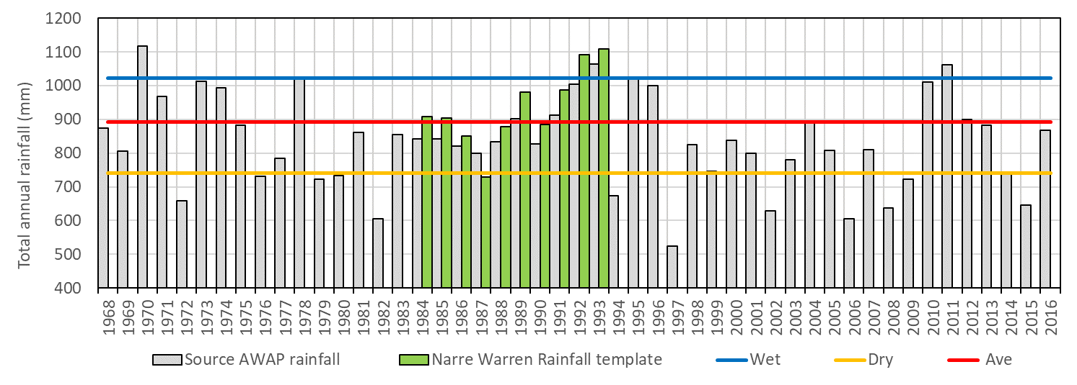

Figure A.3. Total annual rainfall for the Source AWAP rainfall data and MUSIC rainfall template, in relation to the 80th percentile (Wet), 20th percentile (Dry) and average thresholds derived from long-term observed rainfall (1979 – 2019) (Berwick – 86299)

1. Reach 1 - Dwarf galaxias anabranch pools
2. Cardinia Creek Conservation Zone wetland habitat restoration opportunities

1. <https://capim.unimelb.edu.au/news-media-events/news/taking-a-fish-out-of-water-how-it-can-assist-conservation-efforts>, accessed 9th June 2020