|  |  |  |
| --- | --- | --- |
| Officer South Waterway Corridor hydraulic assessment (FINAL v2) | | |
| Date: | 7 March 2023 | **Jacobs Group (Australia) Pty Ltd**  Floor 13, 452 Flinders Street Melbourne, VIC 3000 PO Box 312, Flinders Lane Melbourne, VIC 8009 Australia  T +61 3 8668 3000  F +61 3 8668 3001  www.jacobs.com |
| Project name: | Officer South DSS review project |
| Project no: | IA5000EI |
| Attention: | James Hodgens |
| Company: | Melbourne Water: |
| Prepared by: | Bron Gwyther, Peter Sandercock; Jamie Carroll (Spiire); technical review and input by Adam Hall and Stephen Sonnenberg. |
|  | | |

# Introduction

This memo summarises the findings of the Officer South Waterway Corridor hydraulic assessment, part of the wider Officer South DSS review project.

The DSS area is to be constructed on sodic and dispersive soils[1]. This poses a potential risk to drainage assets as urban development and site construction can cause significant ground disturbance, eliminate vegetative ground cover and expose sodic soils to erosion (see Figure 1-1). Erosion risks are directly influenced by sodic soil exposure and changes in landscape hydrology. Changes to hydrology, including the concentration of flow in culverts, runoff from impervious areas and ponding of rainfall contribute to increased erosion risk (Jacobs, 2021).

| C:\Users\Psandercock\Desktop\Temp Beveridge North West Photos\P6040255.JPG | C:\Users\Psandercock\Desktop\Temp Beveridge North West Photos\P6040284.JPG |  |
| --- | --- | --- |

Figure ‑. Examples of erosion of sodic and dispersive soils which can result in elevated turbidity and sedimentation in waterways (Photos taken of erosion in Kalkallo Creek catchment in Melbourne’s north).

Development on sodic and dispersive soils may have on and off-site impacts. On-site and off-site impacts potentially include:

* Dispersion of topsoil and subsoil.
* Loss of topsoil and subsoil with overland and subsurface flow (sheet, rill, tunnel and gully erosion).
* Poor infiltration and increased volumes of stormwater runoff.
* Water ponding in hollows, break of slope areas or depressions, increasing groundwater recharge.
* Poor ability to establish vegetation due to adverse soil chemical conditions.
* Lack of trafficability.
* Increased turbidity and sediment load in waterways in response to runoff from development areas. This results in deterioration in water quality and degradation of aquatic flora and fauna habitat with effects on populations.

The task objective was to review existing RORB modelling outputs and develop representative cross sections with key hydraulic dimensions for the main waterways in the Officer South DSS, in line with the Melbourne Water Waterway Corridors Guidelines for greenfield development areas within the Port Phillip and Westernport Region (Melbourne Water 2013). The information will become an input to the VPA public exhibition for the Officer South PSP in February 2023.

These findings will enable Melbourne Water to better quantify the required width of the waterways within Officer South DSS based on hydraulic factors. Wider waterway corridors than required by Melbourne Water waterway guidelines are recommended due to the greater erosive risks that are associated with sodic and dispersive soils (compared to soils where the erosion risk is lower). This provides more opportunities for a wider, lower gradient stream bed, reducing flow depths, slowing flows and reducing stream powers and shear stresses (Jacobs 2022b).

# Method

Development of the cross sections included the following steps:

* Reviewed the hydrologic RORB Model for Officer South and established design event flows for future development catchment conditions.
* Determined hydraulic parameters (flow rates, flow velocities, bed shear stress, flow depths, hydraulic width / channel width, dimensions of batters and channel gradient).
* Reviewed LiDAR information (grade and fill level analysis).
* Created cross sections applicable to the waterways and provided sample cross sections appropriate for presentation in MS Excel/PC-Convey.

The following models, data and documents were inputs to the task:

* Hydrologic RORB Model for Officer South.
* 12D models for the site.
* WSP (2021) Officer South Employment Precinct Sodic/Dispersive Soil and Acid Sulfate Soil Investigation.
* Jacobs (2022c) Wallan South and Taylors Creek DSS review Summary Memo.
* Waterway Corridors Guidelines for greenfield development areas within the Port Phillip and Westernport Region (Melbourne Water 2013).
* Constructed Waterway Design Manual (Melbourne Water 2019).

## Assumptions

The assumptions embedded in the results of this assessment are detailed below:

**Sodicity**

* The intent of the proposed cross section dimensions is to ensure that the waterway corridor is adequate based on minimal risk of failure given the potential sodicity. Given that targeted soil testing was delayed at the site due to wet weather, we relied on previous sodic soil assessments (WSP 2021) and took a conservative approach to assigning sodic soil risk, assuming that it was present at all waterways. If future sodic soil testing indicates that sodic soils are not present at some waterways then waterway corridor widths may be reduced at a later date.

**Flow rates**

* Low flow channels are designed to cater for 1EY flows as the maximum storm event.
* Shear stress values provided are based on 1% AEP flow. The 1EY, 10% and 1% flows were also checked however we have based this assessment on the 1% AEP flows (waterway to convey 1% AEP flows with shear to remain below nominated thresholds).
* The 1% AEP flow rate for the Gum Scrub Creek (GSC) downstream of Lecky Rd is lower than the GSC upstream of Lecky Rd (despite being downstream, with flow rates expected to increase). This is because there is a large retarding basin along Lecky Rd which is reducing the flows by approximately 20m3/s.

**Shear stresses**

* Waterways may fail as a result of erosion. To reduce the likelihood or erosion Melbourne Water constructed waterway guidelines set a threshold for shear stresses of 80 N/m2. The consequence of erosion occurring is more severe when sodic soils are present as compared to when sodic soils are not present.
* The assumptions behind the analysis are more conservative than current Melbourne Water constructed waterway guidelines (Melbourne Water 2019) to account for the sodic soil environment. To maintain a similar risk profile to current constructed waterways, it is appropriate to address the higher consequence of waterway failure due to the sodic environment by decreasing the likelihood of asset failure. The assumptions related to design velocities and shear within the waterways are therefore lower than current Melbourne Water guidance.
* To decrease the likelihood of asset failure we have decreased the 1% AEP shear stress threshold allowable in the low flow channel of the waterway to be 45 N/m2 (+10% for the 1% AEP = 49.5 N/m2), which is appropriate for short native and bunch grasses, this is lower than current guidelines of 80 N/m2 for long native grasses within the low flow channel. This was difficult to achieve along Gum Scrub Creek, so the section has been maxed out with a 30m low flow channel base and 20m batters which results in a maximum shear of 51.96 N/m2.
* To achieve this lower shear stress in the low flow channel, the base width of the low flow channel has been markedly increased from the standard guidelines. Similarly, the overall bench width is larger than what could be designed under the current guidelines to ensure the depth of flow in the waterway is lower in the 1% AEP event to again minimise the shear stress values.

**Channel construction**

* A Manning’s n roughness value of 0.05 has been adopted throughout and is appropriate for a vegetated waterway with short native and bunch grasses. However immediately post construction, during the vegetation establishment phase, roughness will be lower and other means of scour protection may be warranted in the interim (e.g. jute matting). Whilst the proposed Manning’s n values are appropriate during the vegetation establishment phase of the channel, appropriate construction methodology will need to be employed. For example, a temporary bypass channel/pipe may be installed outside of the waterway corridor whilst the waterway vegetation is establishing, with the waterway not coming “online” until the vegetation is established.

**Vegetation**

* As previously highlighted, this analysis is based on the assumption that vegetation forming the channel boundary would be short native and bunch grasses, the channel would have a Manning’s n value of 0.05. These grasses would be resistant for flows generating shear stresses up to 45 N/m2 (+10% for the 1% AEP = 49.5 N/m2).
* The channel could be made more resistant to shear stresses by changing the structure of the vegetation. For example, long native grasses and sedges have a shear stress erosion threshold of 80 N/m2. Further consideration could be given to varying the composition and structure of vegetation in the channel so as to increase the resistance of the channel boundary to erosion (see Table 2‑1).

Table ‑. Erosion thresholds for different waterway boundary materials (Fischenich 2001, Melbourne Water 2019).

|  |  |  |
| --- | --- | --- |
| Boundary Category | Boundary Type | Shear Stress Erosion Threshold (N/m2) |
| Soils | Fine colloidal sand | 1.5 |
| Alluvium silt and silty loam (non-colloidal) | 3 |
| Fine loam and gravels | 4 |
| Stiff clay and alluvial silts (colloidal) | 12 |
| Gravel/Cobble/Boulder | 25 mm, 51 mm, 152 mm and 305 mm | 16, 32, 96 and 192 respectively |
| Large boulders | 630 mm | 612 |
| Vegetation | Turf | 45 to 177 |
| Short native grass | 45 |
| Long native grass | 80 |

**Other assumptions**

* Batter slopes of benches - Ideally these should be between 1V:20H and 1V:40H[2]. Some sections have benches at 1V:60H. These were flattened out to 1 in 60, to ensure the 10% AEP was above the batter slopes.
* Freeboard - 300mm freeboard has been included into the design as per MW constructed waterway guidelines.
* Waterway corridor width recommendations have been developed with reference to the 1% AEP (i.e. the corridor needs to convey this flow and also be resilient to erosion).

# Results

Cross section locations are shown in Figure 3‑1; summarised results in Table 3‑1; full details in Appendix A.

Table ‑. Draft cross section dimensions and shear stress.

|  |  |  |  |  |  |  |
| --- | --- | --- | --- | --- | --- | --- |
| Location | Flow (m3/s) | Slope | Base Width (m) | Bench Width (m) | Total hydraulic width (m) | Max Shear (N/m2) |
| **Stephens Rd Waterway** | | | | | | |
| D/S RB-A | 4 | 525 | 3 | 3 | 19.08 | 20.66 |
| D/S RB-C | 4.9 | 210 | 3.5 | 3 | 18.56 | 43.05 |
| D/S RB-E | 6 | 210 | 4 | 4.5 | 21.72 | 44.5 |
| **Officer South RD Waterway** | | | | | | |
| D/S RB-B | 4.1 | 594 | 3 | 3 | 19.44 | 19.12 |
| D/S RB-D | 7.2 | 288 | 3 | 3 | 20.22 | 43.38 |
| D/S RB-F | 10.9 | 288 | 5 | 5 | 25.98 | 44.8 |
| **Gum Scrub Creek Waterway** | | | | | | |
| Officer DSS Waterway | 52 | 300 | 25 | 20 | 75.16 | 49.54 |
| GSC U/S Lecky Rd | 64 | 300 | 30 | 20 | 80.7 | 51.96 |
| GSC D/S Lecky Rd | 45.5 | 300 | 30 | 18 | 75.5 | 43.08 |

Note: Recommendations regarding temporary construction and permanent sodicity setbacks are not included in this table.

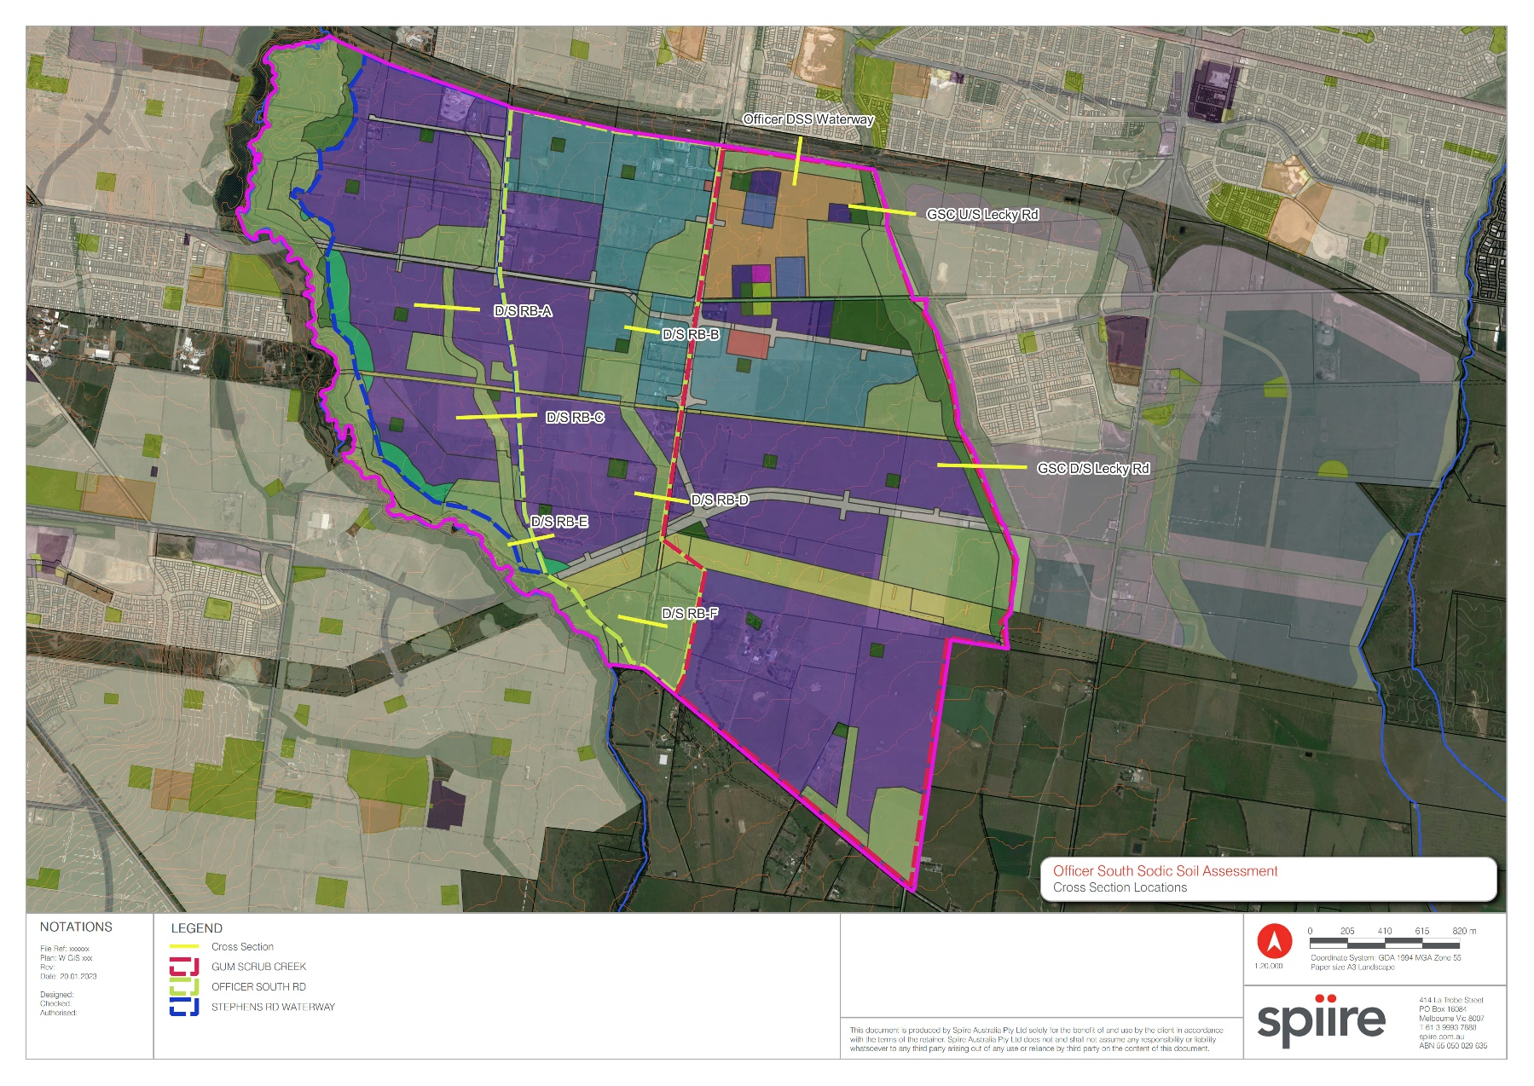

Figure ‑. Cross section locations.

# Corridor width and sodicity

Whilst not explicitly included within the scope of this assessment, it is acknowledged that Melbourne Water are also interested in further advice on an appropriate setback beyond the 1% AEP.  We note that the Waterway Corridors Guidelines for greenfield development areas within the Port Phillip and Westernport Region (Melbourne Water, 2013) describe minimum widths for waterway corridors. While the guidelines provide reasonable advice for waterways with a relatively small hydraulic width, the larger hydraulic widths (e.g. 50m plus) are not as well served, with additional offset/setback from hydraulic width likely to be required. The guidelines do however note that *“In situations where the standard waterway corridor width – as specified in these guidelines – is less than the width of the post development 1 in 100 year ARI flood extent [1% AEP], the waterway corridor will be extended to include the entire 100 year ARI flood extent i.e. the 100 year ARI line becomes the waterway corridor boundary. Under these circumstances, the corridor width required in excess of the ‘minimum setback width’ will be treated as ‘vegetated buffer’”.*

They also note that waterway corridor widths may be increased to reflect site specific factors including “*If there is risk of significant channel migration in the future (presence of highly erodible soils)”.*

Therefore, in addition to hydraulic width calculations outlined in this memo we have adopted recommendations regarding temporary construction width and permanent sodicity setbacks to reduce sodic soil risks, taken from earlier work done for sodic soils in Melbourne’s north (Wallan South and Kalkallo) for Melbourne Water (Jacobs 2022c, 2022d) (outlined in subsequent sections) as similar soil type and construction risks are present at the sites.

These recommendations regarding corridor widths were developed based on sodicity risk and management but do not take into account additional relevant factors for MW to assess in regards to environmental, social, cultural, and built asset requirements that may require additional width. These widths may be revised once additional information becomes available or following further investigations and design of drainage infrastructure assets.

**Temporary construction setback**

A wider corridor width is likely to be required for each of the channels for several years during PSP development to enable diversion of flows[3] (due to erosion risk) during construction and establishment. For Wallan South, Jacobs (2022c) assumed a general 15m temporary setback on one side of the waterway to allow for plant, stockpiling etc. to be subsequently decommissioned & rehabilitated. Note that temporary diversion channels will vary in size required according to flow and soil conditions and must be managed to reduce mobilisation of sodic soils into receiving waterways.

**Sodicity buffer**

In addition to minimum width guideline requirements in Melbourne Water’s guidelines and a temporary construction setback, Jacobs (2022c) proposed extra corridor width (20m assumed for each future constructed channel, 10m setback on each side of the channel with reference to 1% AEP) for management of hydraulics and other factors until shear stress risk & the associated required management is established.

The extra width would provide further contingency for:

* Flattening of banks and or the installation of other protection measures that may be required to manage soil erosion risks during and post construction (i.e. geotextile fabrics and mattings to provide short term protection, organic matter, hydro-mulching, vegetation).
* Changes to depths of cut for earthworks works and exposure of sodic soil (subject to outcomes of future geotechnical and soil investigations).
* Topsoil to be used more effectively from a wider waterway corridor, or reused more effectively for stabilizing works, allowing smaller volumes of sodic clay subsoil to be handled in general.

For recent work completed for Kalkallo Creek, Jacobs (2022d) recommended provision of a 30m setback with reference to the 1% AEP + Climate Change design flow. This setback is to function as a vegetated buffer and also provide space for inclusion of utilities (buried infrastructure assets) and amenity features such as pedestrian paths. For eastern tributaries, a 20 to 25m setback was included, this was considered to provide a reasonable buffer to the constructed waterways.

For Officer South, it is recommended that Melbourne Water gives further consideration to a minimum (10m) and maximum permanent setback (30m), with reference to the 1% AEP:

* Minimum 10m setback on each side of the channel is broadly consistent with that outlined in Melbourne Water’s guidelines to provide shared/trail maintenance track either side of channel.
* Maximum 30m setback on each side of the channel, which is particularly wide, but is consistent with what has previously been recommended for the upper Kalkallo Creek.

These proposed widths for each waterway corridor cross section point have been outlined below in Table 4‑1. These recommendations regarding corridor widths were developed based on sodicity risk and management but do not take into account additional relevant factors for MW to assess in regards to environmental, social, cultural, and built asset requirements that may require additional width. For example, if the proposed methods of reducing the sodic and dispersive soils risk conflict with the intent of the setback in the guidelines (e.g. in the core riparian zone (CRZ) the provision of high quality native vegetation for habitat value) then the sodicity buffer would need to be added in addition to and outside of the CRZ or vegetated buffer. It is preferable that shared pathways (such as walking / cycling / equestrian trails) and infrastructure are located outside the waterway corridor to minimise disturbance to ground and also future erosion risks such as ground disturbance caused by traffic of people/animals along paths, future issues with buried underground services and the associated settlement/subsidence of overlying material.

We note that the final decision regarding waterway corridor widths will require Melbourne Water to balance a range of factors and may not strictly reflect the recommendations of this report. These widths may also be revised once additional information becomes available or following further investigations and design of drainage infrastructure assets.

Table ‑. Proposed corridor widths for consideration.

|  |  |  |  |  |  |  |
| --- | --- | --- | --- | --- | --- | --- |
| **Cross Section location** | **Hydraulic Width (m)** | **Corridor width according to MW guidelines (m) + *(*A*ctive edge)*** | **Corridor width according to MW guidelines (m)* *(No active edge)*** | **Range of proposed sodicity setback (within vegetated buffer and CRZ) (m)** | **Minimum proposed corridor width (10m setback each side)^%** | **Maximum proposed corridor width (30m setback each side)^%** |
| **Stephens Rd Waterway** | | | | | | |
| D/S RB-A | 19.1 | 40 | 50 | 10 - 30 | 40 | **80** |
| D/S RB-C | 18.6 | 40 | 50 | 40 | **80** |
| D/S RB-E | 21.7 | 45 | 55 | 45 | **85** |
| **Officer South RD Waterway** | | | | | | |
| D/S RB-B | 19.4 | 40 | 50 | 10 - 30 | 40 | **80** |
| D/S RB-D | 20.2 | 45 | 55 | 45 | **85** |
| D/S RB-F | 26 | 45 | 55 | 50 | **90** |
| **Gum Scrub Creek Waterway** | | | | | | |
| Officer DSS Waterway | 75.2 | 70 (80~) | 80~ | 10 - 30 | 100 | **140** |
| GSC U/S Lecky Rd | 80.7 | 70 (85~) | 85~ | 105 | **145** |
| GSC D/S Lecky Rd | 75.5 | 70 (80~) | 80~ | 100 | **140** |

*+ Taken from waterway corridor guidelines (Melbourne Water 2013) Table 3, assumes active edge.*

*\*Taken from waterway corridor guidelines (Melbourne Water 2013) Table 4 (includes additional shared trail/maintenance track either side of channel (within vegetated buffer).*

*~Note that the highest corridor width noted by the guidelines is 70m, but where the post-development hydraulic width is greater than the standard waterway corridor width, the 1% AEP line becomes the waterway corridor boundary, as ‘vegetated buffer’.*

*^ Rounded up to nearest 5m increment.*

*%Shared pathways (including equestrian trails) and infrastructure to be located outside the waterway corridor.*

References

Fischenich, 2001. Stability Thresholds for Stream Restoration Materials.

Jacobs, 2022a. . Client memo for Melbourne Water.

Sandercock, P. 2022b. Expert Witness Statement. Prepared for Ministerial Advisory Committee: Beveridge North West Precinct Structure Plan and draft Mitchell Shire Planning Scheme Amendments C158 and C161mith (<https://vpa-web.s3.amazonaws.com/wp-content/uploads/2022/05/Beveridge-North-West-PSP-040.-Evidence-Statement-Peter-Sandercock-Jacobs.pdf>)

Jacobs, 2022c. Wallan South and Taylors Creek DSS review Summary Memo. Client report for Melbourne Water, Docklands.

Jacobs 2022d. Kalkallo Creek Development Services Scheme (DSS) Design: Preliminary assessment of waterways and conceptual options. Client report for Melbourne Water.

Jacobs, 2021. Wallan South Sodic Soils Assessment. Client report for the Victorian Planning Authority.

Melbourne Water, 2019. Constructed Waterways Design Manual. Docklands.

Melbourne Water, 2013. Waterway Corridors Guidelines for greenfield development areas. Docklands.

WSP, 2021. Officer South Employment Precinct Sodic/Dispersive Soil and Acid Sulfate Soil Investigation. Client report for the Victorian Planning Authority.

Appendix A Cross section outputs (PC-Convey)

1. Note that some sodicity testing has been undertaken (WSP 2021) and indicated variable sodicity in the upper 0.5m of the soil profile with consistent strongly sodic to very strongly sodic soils below 1m. Additional review and potentially sampling has been recommended (Jacobs 2022a) with sampling planned for 2023.
2. Deemed criteria CS12 advises bench slope between 1:20 to 1:40 (Melbourne Water 2019).
3. Note that diversion of a waterway during construction doesn't necessarily need to be a channel. It could include a pipe, dam, or being undertaken during low flows. Attenuation of flows in the catchment could assist by reducing flows in the channel.