JACOBS GROUP

SODIC SOIL ASSESSMENT

for the

OFFICER SOUTH PRECINCT STRUCTURE PLAN AREA

including

RETARDING BASIN SITES.

Prepared for: Jacobs Group (Australia) Pty Ltd.

Prepared by: Christian Bannan. Ba. Ag (Hons), Adv. Dip Ag. CPSS. Certified Professional Soil Scientist.

Date: 4th July 2023.

Postal: PO Box 5097, SANDHURST EAST. VIC. 3550.
Phone: Mob. 0439 341 265. Office. 03 5443 5139
Website: www.sesw.com.au E-mail: info@sesw.com.au

Sodic Soil Assessment Report.
Client name: Jacobs Group (Australia) Pty Ltd
Project name: Officer South DSS Sodic Soil Assessment
Date: 4 July 2023
Prepared by: Christian Bannan South East Soil & Water

Document history and status:

Revision | Date | Description | Author | Reviewed | Approved
01 | 16/05/23 | Draft Report | C. Bannan
02 | 17/05/23 | Draft Report | C. Bannan | P. Sandercock | S. Sonnenberg
03 | 04/07/23 | Final Report | C. Bannan | P. Sandercock | B. Gwyther
Distribution of copies
Revision | Issue approved | Date issued | Issued to | Comments
02 | 17/05/2023 | 17/05/2023 | N. Polon | Draft Report
03 | 04/07/2023 | 4/7/2023 | N. Polon | Final Report

South East Soil & Water Pty Ltd.
PO Box 5097
Sandhurst East.
Vic. 3550.
T + 61 3 5443 5139.
M +61 439 341 265.
W www.sesw.com.au

Copyright © 2023 South East Soil & Water Pty Ltd. All rights reserved.

DISCLAIMER: This report is intended to serve as a guide only. Because soil chemical, physical and biological properties, and any other factors relating to soil, water and effluent may be influenced by factors beyond the author’s control, South East Soil & Water. their staff & contractors hereby disclaim any liability for commercial loss or damage to any person, property or thing in respect to the information and recommendations contained in this document. Every effort has been made to ensure that the recommendations in this report are based the scientific knowledge collected to this point at the date of printing of this document.

This document has been prepared exclusively for the use of the client listed on this report cover. SESW accepts no liability or responsibility for any use or reliance upon this document by any third party.

TABLE OF CONTENTS

EXECUTIVE SUMMARY vi
1. INTRODUCTION. 1
1.1. Investigation Outline & Scope. 1
1.2. Location. 1
1.3. Background. 2
2. DISPERSIVE & SODIC SOIL CHARACTERISTICS. 3
2.1. Dispersive Soils. 3
2.2. Sodic Soils. 4
2.2.1. Definition. 4
2.2.2. Classification & Distribution. 4
2.2.3. Sodic Soils, Urban Development & Potential Impact on Drainage Services Scheme Infrastructure. 4
3. METHODOLOGY. 7
3.1. Planning. 7
3.2. Fieldwork, Sample Point Locations & Sample Depths. 7
3.3. Laboratory Analysis. 8
3.4. Guidelines for this Assessment. 9
3.4.1. Sodicity. 9
3.4.2. Emerson Dispersion. 10
3.4.3. Loveday & Pyle Score. 10
3.4.4. Slaking Class. 10
3.4.5. Organic Carbon. 10
3.5. Gypsum Calculations. 11
3.6. Environmental Variables & Literature. 11
3.6.1. Surface Geology & Soils. 11
3.6.2. Rainfall & Evaporation. 11
3.6.3. Groundwater Information. 11
3.6.4. Waterways & Watercourses. 11
3.6.5. Land Levels & Slopes. 11
4. ENVIRONMENTAL VARIABLES. 12
4.1. Geology & Soils 12
4.2. Rainfall & Evaporation 13
4.3. Groundwater. 14
4.4. Waterways & Watercourses. 14
4.5. Land Levels & Slope. 14
5. DRAFT VPA AGENCY VALIDATION PLACE BASED PLAN 15
6. SITE CONDITIONS & LAND USE. 16
7. SUMMARY OF RESULTS. 17
7.1 Soils, Geotechnical Classification, Laboratory Texture & Geology. 17
7.2 Soil Classification 19
7.3 Soil Sodicity & Dispersion Results 20
7.4 Soil Sodicity & Dispersion Interpretation. 21
8. SODIC SOIL EXPOSURE & EROSION RISKS. 23
8.1. Types of Erosion Risks. 23
8.2. Exposure Risk. 23
9. GENERAL CONSIDERATIONS & RECOMMENDATIONS FOR DESIGN AND CONSTRUCTION OF RETARDING BASINS 25
9.1. Types of Assets Supporting Retarding Basins. 25
9.2. Primary DSS Asset Design Principles. 25
9.3. Construction & Earthworks Considerations. 26
9.4. Managing Waterway Flows & Diversions. 28
9.5. General Engineering Measures for Erosion & Sediment Control. 29
9.6. 29
Gypsum Stabilisation Rates. 29
10. CONCLUSION 31
11. REFERENCES 32

LIST OF APPENDICES.

All Appendices are listed as individual documents.

APPENDIX A. SOIL CHEMICAL TEST RESULTS – EXCEL FILE OF DATA. Separate document.
- Appendix A1. All data.
- Appendix A2. All data, by inspection point / borehole.
- Appendix A3. All data, by depth.
- Appendix A4. Summary and averages of all data.

APPENDIX B. SOIL CHEMICAL TEST RESULTS – PDF FILES FROM LABORATORY. Separate Zip File.

EXECUTIVE SUMMARY

This report summarises the results of a sodic and dispersive soil assessment across proposed retarding basin areas forming part of the DSS within the Officer South Precinct Structure plan area. The investigation identifies widespread occurence of sodic and dispersive soils within all areas of proposed retarding basin areas, confirming a need for implementing appropriate treatment and management options.

Exposure of sodic soils and erosion risks will increase proportional to the area, depth and time in which sodic soils are exposed without adequate treatment or protection from rainfall and runoff. Exposure further increases with high average annual rainfall.

DSS assets need to be designed with specific consideration to the erosion risks associated with sodic and dispersive soils. It is expected that all of the DSS assets will need to be designed with appropriate surface linings and/or armouring designed to provide protection for dispersive subsoils. It is expected that this would include the use of chemical and physical ameliorants to treat and stabilise the sodic and dispersive soils. Primary design principles have been documented in this report, the specifics of the design response to soil conditions will need to be worked through as part of the Functional Design Phase of the Officer South DSS Design Project.

Sodic and dispersive soil exposure is likely to be high during the construction phase and is expected to reduce in a developed and operational condition, should the primary design principles and all construction and earthworks conisderations be evaluated and adopted where necessary. Treatment and protetion measures must be increased proporional to the level of exposure and risk which each DSS asset poses.

1. INTRODUCTION.

1.1. Investigation Outline & Scope.
South East Soil and Water (SESW) has prepared this sodic soil assessment in conjunction with staff of Jacobs to support the functional design of retarding basins for the Officer South Precinct Structure Plan (PSP) Drainage Services Scheme (DSS). Jacobs are commissioned by Melbourne Water (MW) to prepare the DSS. SESW are providing technical assistance with respect to sodic and dispersive soils across the retarding basin sites. Outcomes of the assessment will support decisions around management of sodic soils for use in constructing DSS assets.

The scope of the assessment is as follows:

- Confirm the presence and magnitude of sodic and dispersive soils within 8 retarding basin sites across the PSP area.

- Define the risks of erosion from exposure of sodic and dispersive soils across the retarding basin sites following disturbance during construction and operation, and

- Provide recommendations for the management of sodic and dispersive soils during construction and operation, along with other erosion and sediment control measures to prevent or minimise erosion and environmental impact.

The report also covers further details on standard erosion and sediment control measures required for developments of this type.

Samples were collected by staff of Jacobs during two rounds of fieldwork between January and April 2023 where geotechnical assessment occurred. SESW provided support with planning, sampling and management of samples for laboratory analysis. Samples were forwarded directly to Nutrient Advantage Laboratory, Werribee for laboratory assay. Results of geotechnical assessment and photographs were provided electronically to SESW. Staff of SESW have not visited the site.

The report does not discuss the impact of sodic soils for geotechnical use. Results from this investigation may be used by others to inform the impact of sodic and dispersive soils on the geotechnical performance.

1.2. Location.
The precinct area subject to investigation is located at Officer South, covering approximately 1400 hectares bordering the Princess freeway on the north and Cardinia Road on the east. The location and approximate boundaries with respect to local rural and metropolitan townships are shown in Figure 1.

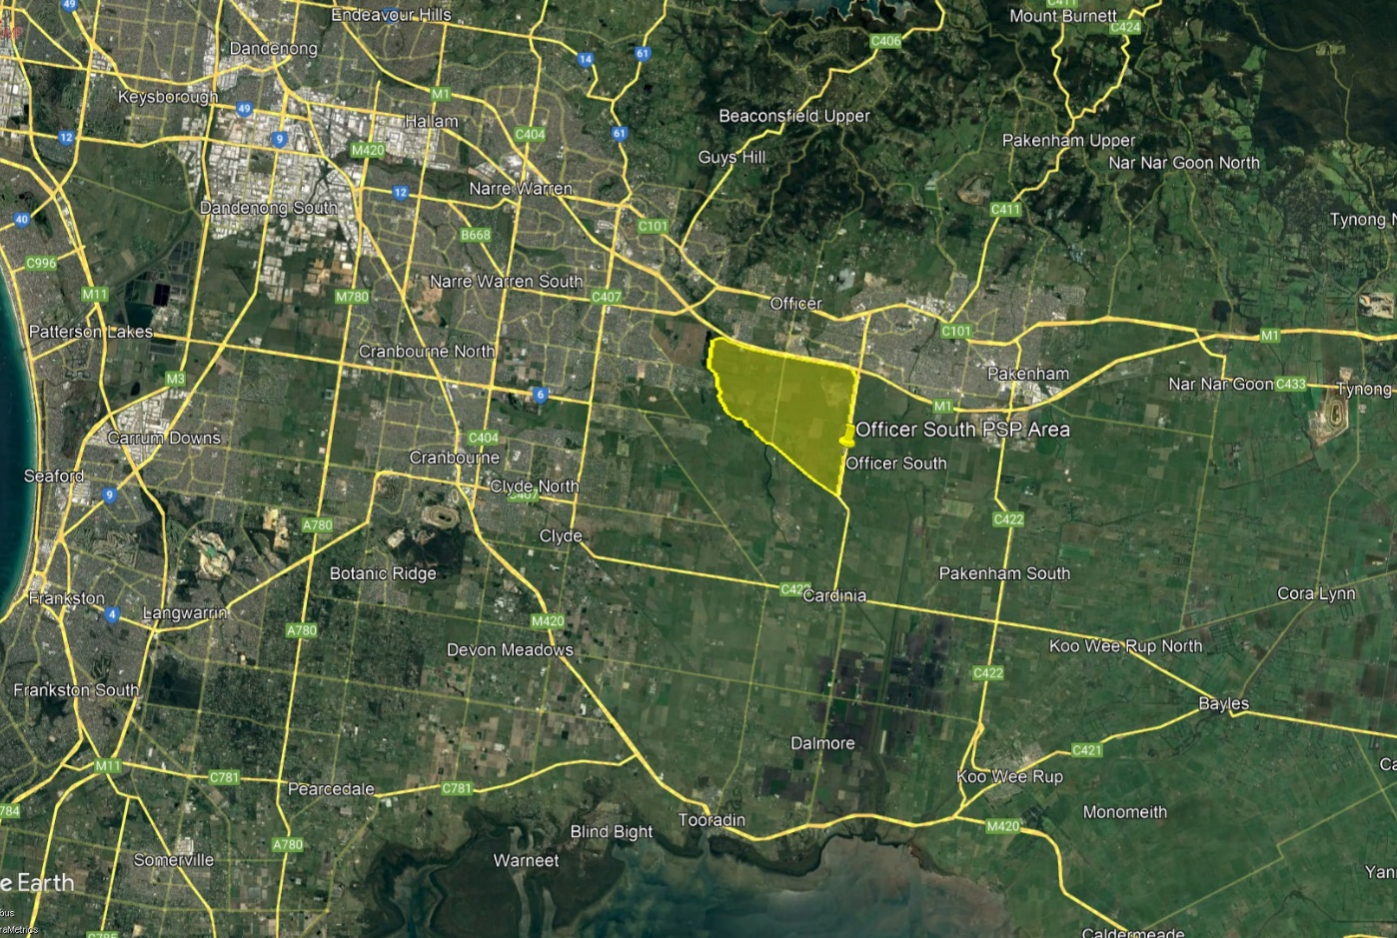

Figure 1. Location of the Officer South PSP area with respect to local rural and metropolitan townships (Google Earth, 2023).

1.3. Background.
Jacobs are currently engaged by MW to prepare the DSS plan covering the Officer PSP. In carrying out this plan, sodic soils require assessment for the purpose of supporting decisions around management of soils during all phases of construction and operation of these assets.

Victorian Planning Authority (VPA) previously engaged WSP to carry out a sodic and acid sulphate soil assessment, titled Officer South Employment Precinct Sodic/Dispersive Soil and Acid Sulphate Soil Investigation (WSP, 2021). The purpose of the investigation was to assist the VPA in understanding the presence and extent of sodic and dispersive soils within the precinct to inform the precinct structure planning being undertaken and provide options for their management in a property development context.

Jacobs were engaged by MW to review the WSP report in February 2022 in their report titled Officer South Sodic Soil Assessment - Functional Designs of Retarding Basins, Wetlands, Waterway and Drainage Outfalls - Office South Employment PSP. SESW provided assistance with this review. One of the main conclusions was that the WSP report did not provide sufficient detail to inform the risk from sodic soils to development as a whole, or for DSS infrastructure. For supporting the construction of DSS infrastructure including wetlands, waterways and drainage lines cut deep into natural strata to depths of 4-5 metres into natural soil, further information was required to fill in knowledge gaps on the presence and magnitude of sodic and dispersive soils. Laboratory data is required at targeted locations around or within proposed retarding basin sites and to depths covering intended excavation.

2. DISPERSIVE & SODIC SOIL CHARACTERISTICS.

2.1. Dispersive Soils.
Dispersive soils are those which evince dispersion of clay particles into suspension when immersed in fresh water, due to osmotic stresses between negatively charged clay particles (Emerson, 1967; Loveday and Pyle, 1973). Following separation of clay particles when wet, structural breakdown, loss of aggregation and poor stability all occur leaving soils vulnerable to erosion. Rapidly dispersed clay particles can readily become entrained in stormwater, causing soil erosion and significant environmental impacts downstream including the occurrence of highly turbid water. Types of erosion by water on dispersive soils include splash, sheet, rill, gully and tunnel erosion (FAO, 2019).

Dispersion is also influenced by other factors including clay mineralogy, clay percentage, soluble salts, organic carbon and organic matter and relationships with other cations, including potassium and magnesium (Loveday and Pyle, 1973; Smiles, 2006; Marchuk and Rengasamy, 2012; Dang et al, 2018).

Figure 2 provides examples of the Emerson Aggregate Test where varying levels of slaking and dispersion are recorded (NSW DPI, 2017). In the example shown, all subsurface samples are dispersive. Dispersive soils can be managed temporarily by application of gypsum and an abundance of organic matter. Long term management for disturbed sites involves previously mentioned techniques along with coverage by physical amelioration or engineering options, eliminating exposure to rainfall and runoff.

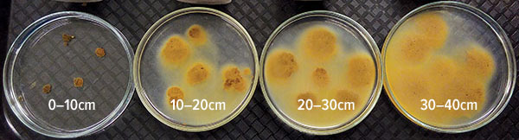

Figure 2. Examples of soil aggregates subject to the Emerson Aggregate Test, showing nil dispersion on the left with increasing levels of dispersion to the right (NSW DPI, 2017).

Figure 3 provides further details of the Emerson Aggregate test and generally interpretation (Hardie, u.d). Slightly dispersive or discolouration surrounding particles is common within Class 3 and 2 aggregates. Dispersive aggregates are usually Class 2. Highly dispersive aggregates are usually Class 1. The Loveday and Pyle (1973) method and the ASWAT test (McKenzie and Koppi, 1997) also provides a method for assessing dispersive soils, providing an index which can be used to infer the likely gypsum response.

Figure 3. Describing the Emerson Aggregate test for dispersive samples (Hardie, u.d).

2.2. Sodic Soils.

2.2.1. Definition.
Sodic soils are defined in Australia as those with an exchangeable sodium percentage (ESP) of 6% or greater (Northcote and Skene, 1972). Sodicity is a measure of sodic soil, defined by an ESP level of 6% or greater. At an ESP of 6%, soils with a clay fraction are commonly found to disperse leading to soil structural decline. Sodic soil conditions are inferred as an indicator of dispersive soil conditions.

2.2.2. Classification & Distribution.
The Australian Soil Classification outlines 14 soil orders, several of these contain soil materials that are sodic and dispersive (Isbell and the NCST, 2021). The soil order ‘Sodosol’ is a specific class that has strong texture contrast between the A horizon and sodic B horizon, with the latter characteristically being dispersive.

Sodosol soils generally evince strong texture contrast, with a clear or abrupt A horizon topsoil layer overlying a finer textured, clay-dominant B horizon subsoil. Subsoils are of a low permeability. Some Vertosol soils of the region, also known as Clays of Heavy Texture or Uniform Soils are also sodic throughout the whole profile (Isbell and the NCST, 2021; Northcote, 1979; Stace et al, 1964).

Ford et al (1993) documents the distribution of sodic soils across Victoria. Charters (1993) documents the formation and distribution of sodic soils across Australia. Across Victoria, sodic soils are common across large expanses of soils where clay-dominant subsoils are encountered. They are found in most low to moderate rainfall regions of Victoria where average annual rainfall is less than 700mm/year.

Sodic soils evolve from geology type and parent material, geomorphic processes influencing soil development, cation composition, particle size distribution, rainfall and leaching. The author notes that sodic soil conditions are highly common across all regions of Victoria throughout agricultural and urban regions.

2.2.3. Sodic Soils, Urban Development & Potential Impact on Drainage Services Scheme Infrastructure.
In addition to soil structural issues described in Section 2.1, sodicity may impact on the construction of DSS scheme infrastructure through disturbance and exposure of these soils associated with construction activities. Impacts arise following the stripping and removal of topsoil and organic matter, exposing unstable sodic and dispersive clay subsoil to rainfall and runoff. Where this practice occurs, the velocity and intensity of catchment runoff may increase, with the potential to entrain dispersive clay causing soil loss. Runoff velocity and intensity may also increase with the construction of significant areas of impervious surfaces across PSP’s. This can in turn impact on waterways, either as a result of increased turbidity generated from runoff areas and/or higher velocity flows within waterways contributing to greater potential for erosion. Management measures are required to mitigate these potential impacts.

Sodic soils within the bed, banks and riparian zones of waterways and drainage lines must also be managed to ensure drainage assets are protected. With changes in flows arising from future urban development, sodic soils within waterways are vulnerable to erosion if they are not adequately stabilised. Significant stabilisation is required to minimise waterway impacts. The construction of retarding basins is one technique to be used to manage hydrological changes associated with future urban development, however where basins are cut into sodic soil there are significant management measures required to minimise exposure during construction and operational phases.

During and following urban development, off-site impacts may include the following where not managed appropriately:
- Erosion of drainage lines throughout subdivisions
- Increased turbidity in waterways and a deterioration in water quality
- Impacts on aquatic flora and fauna habitat
- High erosion potential from increasing stormwater flow intensity

Hazelton and Murphy (2011) and Charman and Murphy (2007) provide details of the impacts of sodic soils in urban environments, with potential impacts listed as follows:
- Waterlogging
- Trafficability and access problems
- Dispersion of topsoil and subsoil, particularly where deficient in organic matter
- Loss of soil by overland flow from sheet, rill or gully erosion
- Loss of soil by subsurface flow by tunnel erosion
- Poor infiltration and increased stormwater runoff by comparison with undisturbed soil
- Water ponding in hollows, causing slow groundwater recharge and discharge
- Problems with the establishment of vegetation from adverse soil chemical conditions
- Seepage along the base of trenches, both exposed and backfilled, from runoff collection and flow.

Figures 4-7 are examples of dispersive soils from urban growth areas in the north-east of Melbourne, all collected by the author. These show waterlogging, rill, tunnel and gully erosion along with turbidity impacts. Waterways, watercourses and drainage lines are impacted by sedimentation, from erosion and deposition.

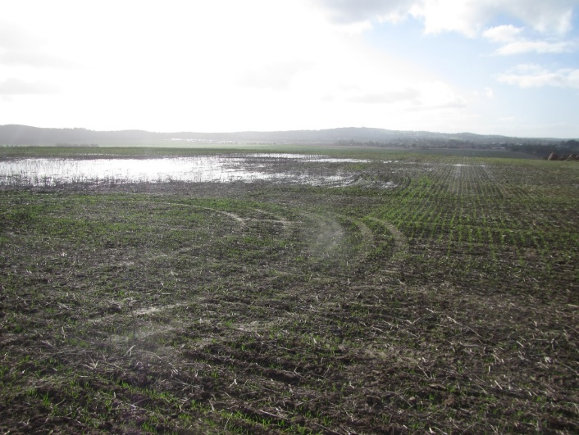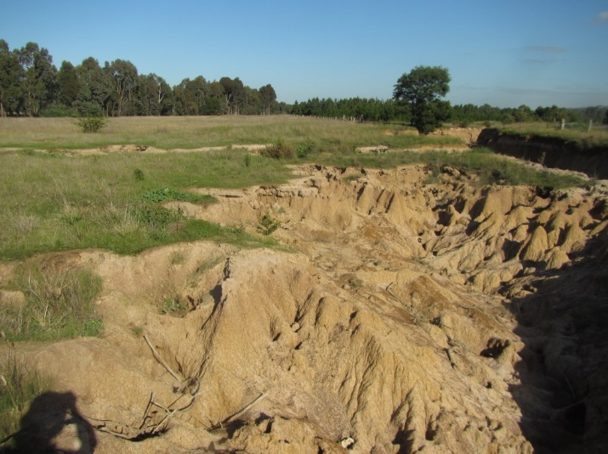

Figure 4. Sodic soils influencing waterlogging Figure 5. Rill erosion influenced by sodic soil.

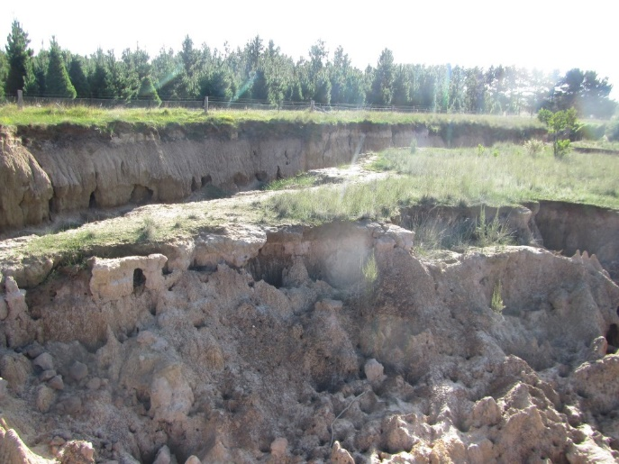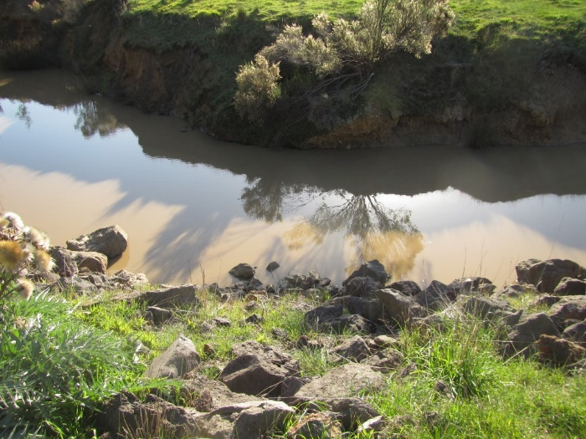

Figure 6. Gully and rill erosion on sodic and dispersive soil. Figure 7. Turbid water in waterways from dispersive soil.

3. METHODOLOGY.

3.1. Planning.
SESW provided support to Jacobs during the planning stages of the project. Much of this has involved support and decision-making covering sampling of soils for sodic soil assessment. With the requirement for geotechnical investigations, it was decided that Jacobs staff supporting the geotechnical investigation will carry out sampling of soils for sodic soil assessment.

Christian Bannan of SESW provided assistance with the management of sample bags, order sheets, testing chain of custody and management of results.

3.2. Fieldwork, Sample Point Locations & Sample Depths.
Fieldwork was carried out by staff of Jacobs in conjunction with Douglas Partners undertaking geotechnical investigations on the following dates:

Round 1. 23-30 January 2023.
- Borehole BH 01, Retarding Basin WLRB A
- Borehole BH 02, Retarding Basin WLRB B
- Borehole BH 09, Retarding Basin WLRB I

Round 2. 27 March to 4 April 2023.
- Borehole BH 04, Retarding Basin WLRB C
- Borehole BH 05, Retarding Basin WLRB D
- Borehole BH 07, Retarding Basin WLRB E
- Borehole BH 08, Retarding Basin WLRB F
- Borehole BH 10, Retarding Basin WLRB J

A total of 8 sample points from proposed retarding basins were assessed in this investigation. GPS coordinates listed in Table 1. Figure 8 shows the location of these sites across the precinct area.

Table 1. GPS coordinates for soil sample points with reference to Borehole Number/Site and DSS Asset No.

Borehole Number | Site | Retardation Basin | Zone | GPS Easting | GPS Northing
BH 01 | 1 | WLRB A | 55H | 358693 | 5784144
BH 02 | 2 | WLRB B | 55H | 359901 | 5783959
BH 04 | 4 | WLRB C | 55H | 358698 | 5783360
BH 05 | 5 | WLRB D | 55H | 358609 | 5783244
BH 07 | 7 | WLRB E | 55H | 358977 | 5782664
BH 08 | 8 | WLRB F | 55H | 361585 | 5782226
BH 09 | 9 | WLRB I | 55H | 359645 | 5781875
BH 10 | 10 | WLRB J | 55H | 361170 | 5780667

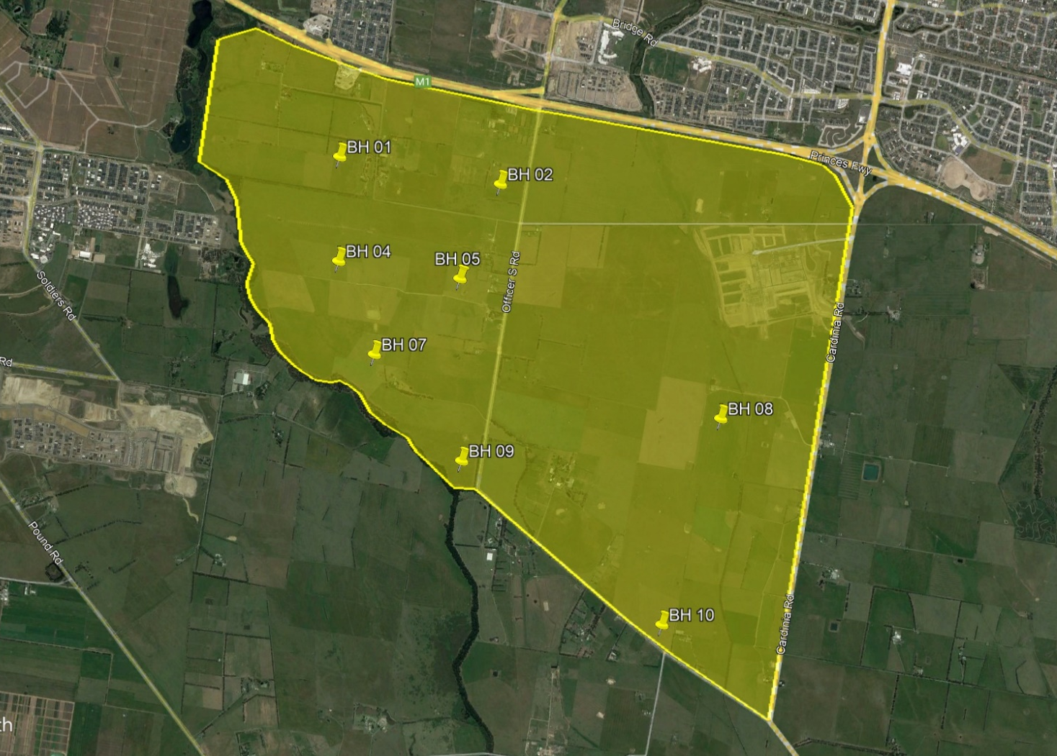

Figure 8. Borehole locations across the Officer South precinct area subject to sampling.

For each site the following samples were collected:

- Surface A₁ horizon topsoil sample from 0-10cm. 10 samples.
- Subsoil B2₍₁₎ horizon subsoil sample from 10-50cm. 10 samples.
- Deep subsoil B2₍₂₎ horizon sample from 50-100cm. 10 samples.
- Deep subsoil B2₍₃₎ horizon sample from 100-150cm. 10 samples.
- Deep subsoil B2₍₄₎ horizon sample from 200-250cm. 10 samples.

The total number of samples collected was 50. Results enable a detailed review of sodic and dispersive soil conditions across the site at five separate depth intervals, covering both shallow and deep zones within soil profiles.

3.3. Laboratory Analysis.
Following field sampling, staff of Jacobs dispatched samples to Nutrient Advantage (NA) laboratory, Werribee for chemical assay following the two rounds of field investigation. NA are an ASPAC and NATA accredited laboratory. Results are provided in Appendix A (interpreted data with colour coding) and Appendix B (laboratory data files). Results are discussed in Section 7 along with gypsum calculations.

A list of tests carried out and test codes used for assessment in accordance with Rayment and Lyons (2010) are provided in Table 2.

Table 2. Laboratory testing and test methods.

Laboratory Test | Test Method – Rayment and Lyons (2010)
Electrical Conductivity (1:5 water) | 3A1
pH (1:5 water) and pH (CaCl2) | 4A1,4B4,
Organic Carbon | Walkley & Black
Organic Matter | Calculation, Organic Carbon x 1.72.
Emerson Dispersion | AS 1289.C8.1-1980, based on Emerson, 1967.
Dispersion and Slaking Index | Loveday & Pyle (1973), Index 1 to 16
Exchangeable Cations, including Calcium, Magnesium, Potassium & Sodium | 15D3
Exchangeable Aluminium (KCl) | 15G1
Cation Exchange Capacity | Calculation from exchangeable cation results
Calcium / Magnesium Ratio | Calculation from exchangeable cation results
Exchangeable Sodium Percentage | Calculation from exchangeable cation results
Emerson dispersion test observations on dry and remoulded aggregates at 2 and 20 hours. | Visual

Emerson dispersion score was requested for testing by NA, however aggregates which do not slake receive an Emerson score of 7 or 8. Their presence of dispersion remains unknown under score 7 or 8. To identify if these samples dispersed, we have obtained Emerson test observations of both dry and remoulded aggregates at 2 and 20 hours to ensure any level of dispersion is detected. Furthermore, the Loveday and Pyle Dispersion Index was also carried out to further confirm the soils propensity to disperse.

Organic carbon was tested on all 0-10cm topsoil samples to gain an understanding of the influence of organic carbon and organic matter on surface soil behaviour.

Calculations were carried out on all samples to calculate cation levels in mg/kg. Indicative gypsum calculations were carried out by SESW and results are provided in this report as a guide to gypsum requirements for minimising or eliminating soil dispersion, by reducing the soils exchangeable sodium percentage (ESP) and by flocculating clay from the addition of a salt (calcium sulphate).

3.4. Guidelines for this Assessment.
Guidelines used for key soil chemical test results in Appendix A are listed below in the following sections.

3.4.1. Sodicity.
Table 3 lists the guidelines used for this assessment to describe sodic soils.

Table 3. Sodic soil guidelines used for this investigation.

Colour | ESP Range | Interpretation
 | <6%. | Non-Sodic. | Non-sodic, unlikely to reveal dispersion when in contact with fresh rainfall or runoff.
 | 6.1-10%. | Moderately Sodic | Moderate to high sodicity. Dispersion likely to occur when in exposed to fresh rainfall or runoff.
 | 10.1-15.0% | Strongly Sodic | High to very high sodicity. Dispersion likely. Significant erosion risk when exposed to fresh rainfall or runoff.
 | >15.1% | Very Strongly Sodic | Very high to extreme sodicity. Significant erosion risk when exposed to fresh rainfall or runoff.

3.4.2. Emerson Dispersion.
Table 4 lists the guidelines used for this assessment to describe Emerson Dispersion Class.

Table 4. Emerson Dispersion Class guidelines used for this investigation.

Colour | Emerson Class | Interpretation
 | 7, 8 | Non-slaking, dispersion unknown.
 | 4, 5, 6 | Slaking, nil dispersion after remoulding
 | 3 | Partial dispersion after remoulding
 | 2 | Partial dispersion
 | 1 | Complete dispersion

3.4.3. Loveday & Pyle Score.
Table 5 lists the guidelines used for this assessment to describe the Loveday and Pyle dispersion score.

Table 5. Loveday and Pyle dispersion score guidelines used for this investigation.

Colour | L&P Score | Interpretation
 | 0, 1, 2, 3, 4 | Low to moderate. Nil to slight gypsum response expected where dispersive.
 | 5, 6, 7, 8 | Moderate to high. Gypsum response expected to control dispersion.
 | 9, 10, 11, 12 | High. Gypsum response expected to control dispersion. High rates required.
 | 13, 14, 15, 16 | Very high. Very high rates required to control dispersion.

3.4.4. Slaking Class.
Table 6 lists the guidelines used for this assessment to describe Slaking Class.

Table 6. Slaking Class guidelines used for this investigation.

Colour | Slaking Class | Interpretation
 | Water Stable | Aggregate stable when wetted, nil or minimal breakdown in structure.
 | Partial | Low aggregate stability. Partial breakdown in structure when wetted.
 | Considerable | Unstable. High or significant loss of structure when wetted.

3.4.5. Organic Carbon.
Table 7 lists the guidelines used for this assessment to describe Organic Carbon.

Table 7. Organic Carbon guidelines used for this investigation.

Colour | Organic Carbon % | Interpretation
 | <1.0 | Low to deficient. Low or poor aggregate stability expected.
 | 1.0-1.9 | Slightly low. Aggregates expected to be unstable, or partially stable.
 | 2.0-2.9 | Acceptable. Variable water stability expected.
 | 3.0-3.9 | Optimal. Water stable aggregates expected.
 | 4.0+ | Optimal to high. Aggregate stability likely.

3.5. Gypsum Calculations.
Gypsum modelling is provided using methods adopted by Ayres & Westcot (1985) and Thomas (1983), modified to suit. The objective of these calculations is to define the rates of gypsum required to displace soil cations back to a ‘balanced’ or improved condition for stabilising dispersive soil. Laboratory soil test results were used for calculations are results summarised in Section 7.

3.6. Environmental Variables & Literature.

3.6.1. Surface Geology & Soils.
Details on surface geology are provided using referenced literature from Douglas and Ferguson (1990) and Geovic (2023). No soil literature is available for the site.

3.6.2. Rainfall & Evaporation.
Historic rainfall and evaporation records for this region were accessed using point sourced data from SILO (2023) for coordinates -38.10, 145.45 which lie within the PSP area.

3.6.3. Groundwater Information.
Groundwater information is sourced from Visualising Victoria’s Groundwater (VVG, 2023), detailed in Section 4.4. Information is cited at www.vvg.org.au.

3.6.4. Waterways & Watercourses.
Waterway and watercourse information has been sourced from Geovic (2023), VicPlan (2023) and VVG (2023).

3.6.5. Land Levels & Slopes.
Information on land levels and slopes has been sourced from Geovic (2023), Google Earth (2023) and Douglas Partners (2023).

4. ENVIRONMENTAL VARIABLES.

4.1. Geology & Soils
An extract of site geology from Geovic (2023) is provided in Figure 9. Across the site there is one geological unit, listed as ‘Qa1’, an abbreviation for ‘Quaternary, alluvium. Materials of this origin are young and reflect an age of up to 1.6 million years. Alluvium is found overlying bedrock. Across the Officer South PSP area, boreholes indicate that no rock was encountered up to 8.5 metres.

Soils on alluvium are often found to be sodic and dispersive, as they are formed from deposition of material from highlands forming old seabed material. Soils of this origin are generally clay-dominant and poorly drained.

Figure 9. Surface geological units, with waterways also shown in blue (Geovic, 2023).

4.2. Rainfall & Evaporation
Average annual rainfall and evaporation for the precinct area was sourced from SILO (2023) for coordinates -38.10, 145.45 which lie within the PSP area. The data range selected is from 1900-2022. The average annual rainfall for this period is 821mm while annual evaporation is 1201mm. Average monthly rainfall and evaporation are presented in Figure 10.

Figure 10. Average monthly rainfall and evaporation for Officer South, Victoria. Data obtained from SILO (2023).

The site lies within a high rainfall zone of Victoria. Average monthly rainfall equals or exceeds evaporation over the months of April to September, or a period of 6 months. During the months of May to August where average rainfall is significantly higher than evaporation, surface runoff, deep infiltration and accessions to groundwater are all likely.

For sites with sodic soil conditions within high rainfall environments, runoff is likely at any time when soil profiles are at field capacity (full), or when rainfall intensity exceeds infiltration rate. Where sodic soils occur, or where sodic horizons are exposed, runoff is likely to entrain clay dispersed by water where there are no protection measures. Should protection measures be used, the risk of erosion by dispersion may be reduced.

Rainfall harvesting on-site with minimal runoff is influenced by surface organic matter, along with the stabilisation of surface soil by gypsum. Where soils are unstable or lacking in organic matter, dispersive soils will seal, restricting infiltration. For optimal landscape stability in this region, topsoil stabilisation, retention, reinstatement and drainage control are imperative for managing dispersive soil conditions. Topsoils must be stabilised (treated for dispersion and rendered non-dispersive) and at all times possible, topsoils should be actively growing vegetation to provide structure and protection of dispersive subsoil horizons, particularly clays. Where sodic clay subsoils are exposed, they should be managed in one of several ways:
- treated with gypsum,
- protected (covered) with non-sodic, stable topsoil, or
- protected using engineering methods of stabilisation.

4.3. Groundwater.
Groundwater data and information has been accessed from Visualising Victoria’s Groundwater, sourced at www.vvg.org.au (VVG, 2023). In accordance with available mapping, groundwater characteristics are summarised as follows:
- Depth: <5 metres.
- Salinity: 3,500-7,000 mg/L TDS.
- Beneficial Use Class: C (3501-13,000 mg/L TDS).

4.4. Waterways & Watercourses.
In accordance with VicPlan (2023) and Geovic (2023), presented in Figure 9, several waterways and drainage lines pass through the site, running from north-west to south-east in the direction of water flow. Almost all waterways have other tributary streams that contribute to watercourses above and within the PSP site. The larger, marked watercourses include:
- Cardinia Creek
- Toomuc Creek
- Deep Creek
- Cardinia Road Drain
- Lower Gum Scrub Creek.

4.5. Land Levels & Slope.
Based on contours available from Geovic (2023), Google Earth (2023) and information from Douglas Partners (2023), site elevation is highest in the far north-west of the PSP area recorded at approximately 36-37 metres AHD. Levels fall to the south-east recorded 9-10m AHD. The average slope is approximately 0.4-0.5% from north-west to south-east.

Based on information available from Douglas Partners (2023) and local site knowledge, the site consists of several small farming blocks with pasture production and beef cattle grazing identified as the primary land use.

5. DRAFT VPA AGENCY VALIDATION PLACE BASED PLAN
The following draft plan was prepared by the VPA as part of Agency Validation. The plan shows the proposed retarding basins at the time, which has now been superseded. The plan shows there are 10 proposed retarding basin sites, 8 of these have been sampled as part of this investigation.

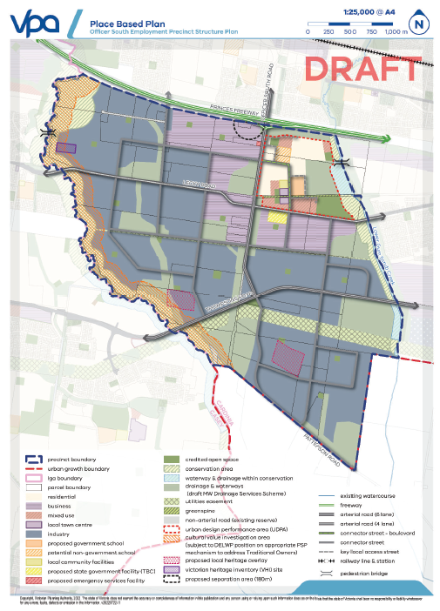

Figure 11. Draft PSP Agency Validation plan.

6. SITE CONDITIONS & LAND USE.
Details of existing site conditions were provided by staff of Jacobs undertaking fieldwork, supported by Douglas Partners (2023) who carried out a geotechnical investigation on the site to support soil sampling. The site consists of a number of farming paddocks or blocks with a dominance of native and introduced pasture and weed species. The dominant land use is grazing.

Pasture and groundcover varied from dense to sparse, where grazing had occurred. Overall the site contains a dense stand of groundcover which is supporting surface soil stability in the current, undisturbed state.

Photographs are included in Figures 12 and 13.

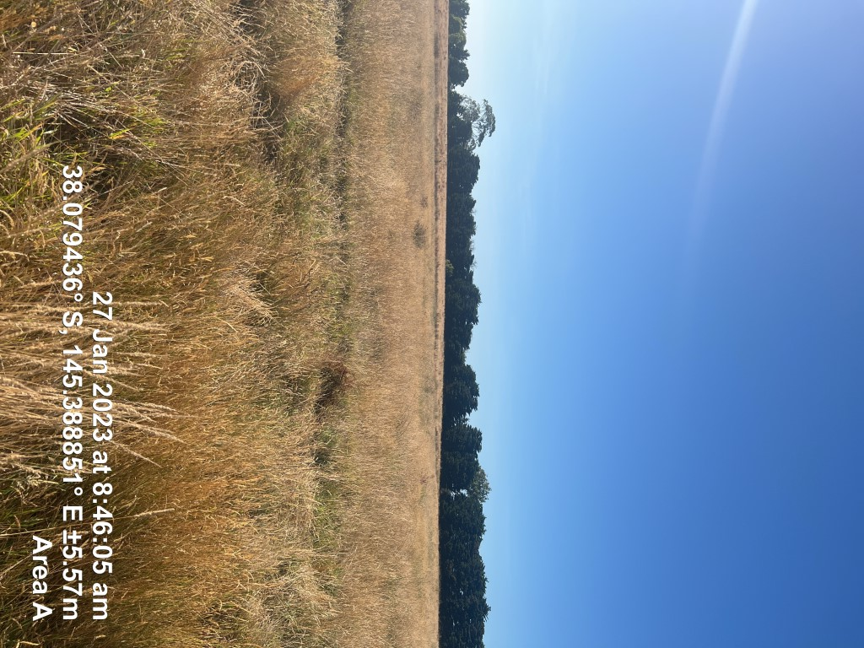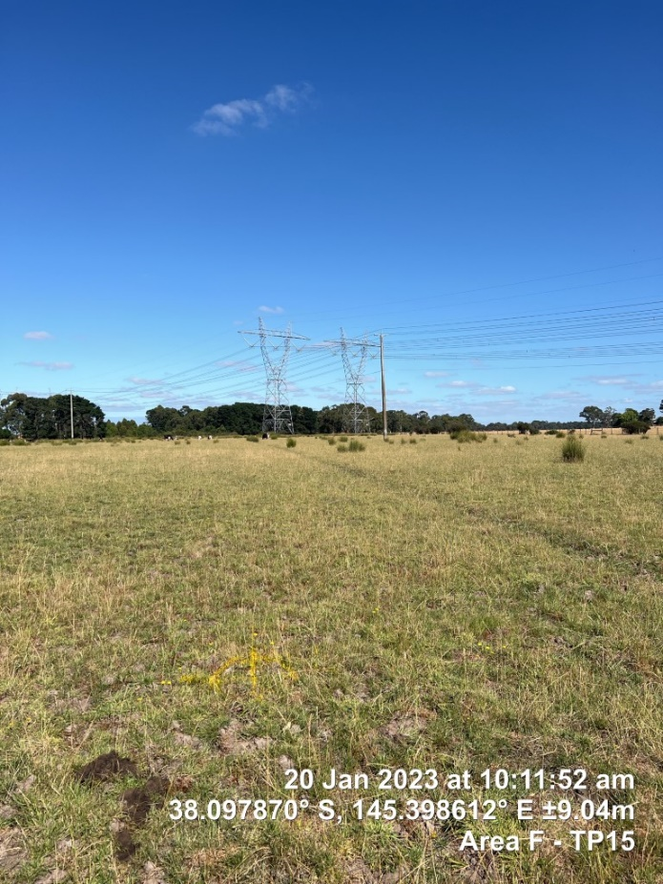

Figure 12. Photograph of dense pasture cover. Figure 13. Photograph of grazed pasture.

7. SUMMARY OF RESULTS.

7.1 Soils, Geotechnical Classification, Laboratory Texture & Geology.
In accordance with the results of geotechnical assessment (Douglas Partners, 2023) and soil analysis by Nutrient Advantage, soil condtions across the 8 sites subject to sampling are of a high uniformity. All 8 borelogs revealed similar geotechnical classifications, with descriptions varying slightly between site and mainly varying within the upper 0.5 metres. An average soil profile description based on geotechnical logs is listed in Table 8. Soil textures based on particle size analysis (hydrometer method) are listed in Table 9.

Table 8. Average soil profile description, extracted from Douglas Partners (2023) and laboratory results for sodic soil testing.

Depth | Geotechnical Classification AS 1726: 2017 | Geotechnical Description | Agricultural Texture Equivalent (Estimate based on Geotechnical Logs) | Particle Size Analysis Classification – Nutrient Advantage
0-10cm | ML | Topsoil. Sandy SILT and clayey SILT, fine to medium sand, pale brown to grey, stiff, sometimes low plasticity | Sandy Clay Loam. Topsoil layer with organic matter. | Loam to Silty Loam, sometimes clayey (Sandy Clay Loam). Topsoil layer with organic matter.
10-50cm | ML | Sandy SILT, fine to medium sand, pale brown to grey, stiff, sometimes low plasticity where clayey | Sandy Clay Loam. Bleached A2 horizon above clay. | Loam to Silty Loam, sometimes clayey (Clay Loam). Bleached A2 horizon above clay.
50-100cm | CH | Silty CLAY, high plasticity, brown mottled grey, soft, occassional bands of coarse clayey sand, | Medium-Heavy Clay | Clay-Loam to Clay
100-200cm | CH | Silty CLAY, high plasticity, brown mottled grey, soft. | Medium-Heavy Clay | Clay-Loam to Clay
200-300cm | CH | Silty CLAY, high plasticity, brown mottled grey, soft. | Medium-Heavy Clay | Clay-Loam to Clay

Table 9. Particle size analysis results – Hydrometer method by Nutrient Advantage laboratory.

Depth Range | Silt | Clay | Sand (Coarse) | Sand (Fine) | Sand (Total) | Sand/Silt/Clay Texture |  | Clay & Silt Fraction
cm | % | % | % | % | % |  |  | %
0-10cm | 25 | 16 | 23 | 36 | 59 | Loam to Silty Loam |  | 42
50cm | 22 | 20 | 31 | 29 | 60 | Loam to Silty Loam |  | 41
100cm | 18 | 39 | 19 | 24 | 43 | Clay-Loam to Clay |  | 57
200cm | 17 | 32 | 31 | 21 | 52 | Clay-Loam to Clay |  | 49
300cm | 15 | 39 | 23 | 23 | 46 | Clay |  | 54

A high degree of uniforimty in soil physical condition has been observed across the 8 retarding basin sites sampled. These conditions are reflective of one surface geological unit, alluvial deposits. Alluvial deposits of this region include duplex soil profiles, with loams overlying clay subsoils. The most variable conditions occur within the upper 0.5 metres where surface topsoil varies from loams to clay-loams. Bleached A2 horizons are evident, noted by pale brown to grey silty (loamy) material in the 0.1-0.5m range. These conditions reflect waterlogging and shallow perching of water above clay subsoil.

Subsoil textures are logged consistently as clay of high plasticity, while particle size analysis results indicate that textures range from clay-loam to clay. Clay and silt percentages are almost uniform from 0.5-2.0 metres with the most significant changes noted within the coarse and fine sand fractions.

Under high rainfall averaging 821mm/year, waterlogging is imminent with highly sodic subsoils on full soil profiles. Drainage is critical to establish on this site. Trafficability is expected to be very difficult during winter months. Protection of sodic subsoil clays is critical to minimise erosion.

Laboratory textures from Nutrient Advantage laboratory are generally lighter or less clayeyer by comparison with geotechnical assessment.

7.2 Soil Classification
Soil physical characteristics vary across the investigation area. Across all sites, A horizon topsoils include loams and sandy clay loams to depths of up to 50cm, overlying overlying clays of variable and heavy texture. These soil characteristics are in accordance with Northcote and Skene (1972), evincing strong and generally abrupt texture contrast between A and B horizons.

Across all 8 sites assessed, soils are classified in accordance with Isbell and NCST (2021) as Sodosols, revealing a clear or abrupt textural change between the A and B horizons, with sodic conditions identified throughout the B horizons and pH (water) of >5.5. To confirm this condition, a sodic soil has an average exchangeable sodium percentage (ESP) of 6%, while the average within the upper B horizons recorded at 19.5%. Furthermore, the average soil pH (water) was recorded at 6.0.

There are no distinct differences in patterns of sodicity or classification across the inspected sites, apart from lower ESP within the upper B horizon (50-100cm) of BH10. This site remained sodic with an ESP level of 6.2%. Deeper subsoils across all boreholes are highly sodic, with ESP levels averaging 26.4% in the 100-200cm range and 28.3% in the 200-300cm range.

7.3 Soil Sodicity & Dispersion Results
An Exchangeable Sodium Percentage (ESP), or ‘sodicity’ value of 6.0% has been adopted as the trigger level for a sodic soil, consistent with Australian literature (Ford et al. 1993, Isbell and NCST 2021). ESP is the most common analytical technique used to identify sodic or potentially dispersive soils in Australia and there are general trends showing this correlation (DPIW 2008). ESP results are displayed in Figure 14.

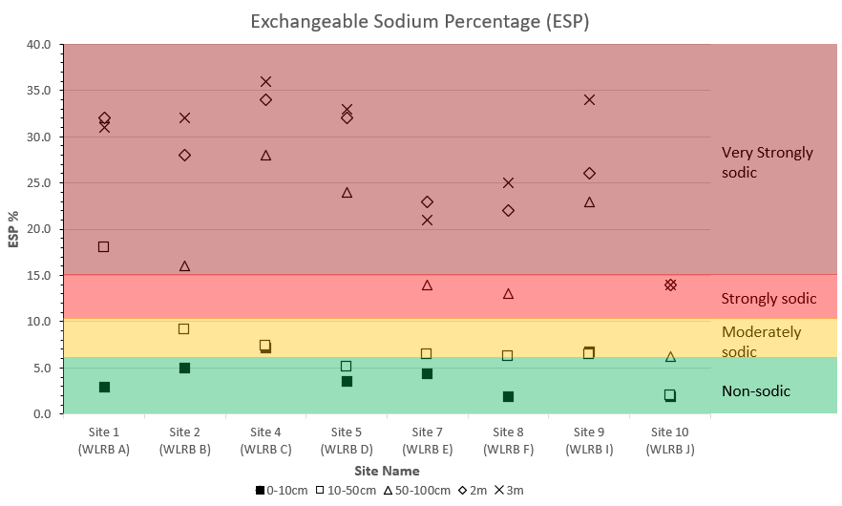

Figure 14. Exchangeable Sodium Percentage (ESP) values across all samples and depths.

To conclusively distinguish between sodic and dispersive soil conditions, dispersion observations were obtained from NA and are discussed below with respect to ESP values. The Emerson test alone does not allow for dispersion within Class 7 or 8 to be identified. Disperison observations are further reinforced with Loveday and Pyle Dispersion Index results. Combined, these measurements allow for strong conclusions to be formed based on sodicity and dispersion. Furthermore, other factors that influence soil dispersion such as high exchangeable potassium and conductivity levels can be identified, should soils be dispersive and non-sodic. In addition, understanding dispersion and behaviour changes between dry and remoulded aggregates provides an indication on how sites will behave in their current and disturbed condition, with disturbed conditions reflecting sites subject to earthworks. Dispersion Score results are displayed in Figure 15.
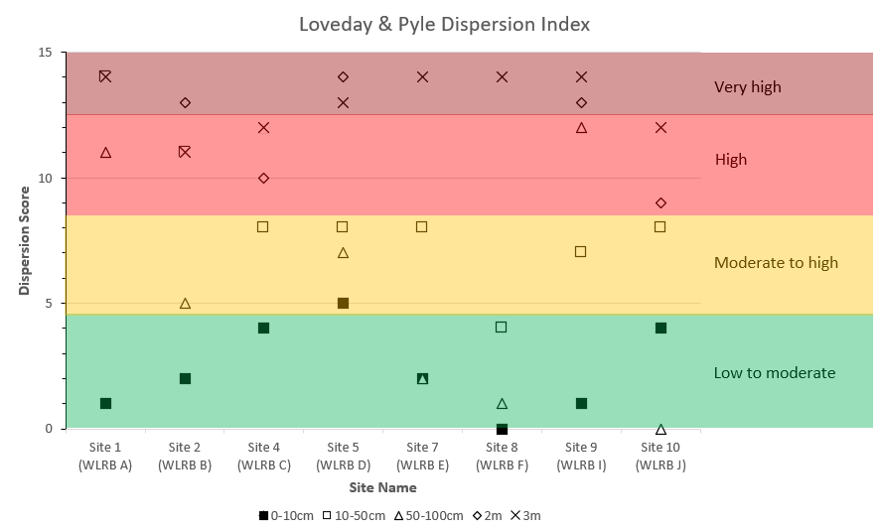

Figure 15. Loveday & Pyle Dispersion Index results across all samples and depths.

7.4 Soil Sodicity & Dispersion Interpretation.
Sodicity results are interpreted and discussed below with respect to their dispersion observations:

- 0-10cm topsoils:
  - An average ESP level of 4.2%, deemed non-sodic. A total of 6 sites were non-sodic, while two sites were sodic. Non-sodic conditions correspond with the presence of sandy loam and sandy clay loam topsoils which may have reasonable surface infiltration and drainage.
  - Dry aggregates recorded nil or slight dispersion at 2 and 20 hours, while remoulded aggregates most commonly recorded slight dispersion at 20 hours. Results also correspond with low Dispersion Index results, averaging 2. Results confirm that while soils are undisturbed, they are of a low risk of dispersion should maintain groundcover be maintained by pasture. Dispersion may occur once soils are disturbed or cultivated.
  - Organic carbon levels averaging 2.6% (organic matter content of 4.4%) may be assisting with aggregate stability, preventing aggregate breakdown and exposure of a larger of surface area of soil to react and disperse.

- 10-50cm samples (including A2 horizon suburface topsoil layers, upper B horizon clays or transition zones between topsoil and subsoil):
  - The average ESP across the 8 retarding basin sites is 7.6%, deemed sodic. Most results tend to be slightly sodic in the range of 6-9%. This is typical of A2 horizon soil above sodic clay subsoil, where water perches and exchangeable sodium remains elevated.
  - All aggregates, both dry or remoulded, evinced dispersion at 20 hours. Results correspond with Dispersion Index results averaging 9, deemed high.

- 50-100cm samples (upper B horizon subsoils):
  - All soils are classified as clays of high plasticity, or clay-loam to clay.
  - Average ESP level of 19.5%, hgihly sodic. All individual samples were highly sodic.
  - Dispersion observations were variable, with some samples (all sodic) revealing nil dispersion. Reasons for the absence of dispersion are not known. There is almost an absence of calcium within samples and a dominance of exchangeable magnesium and sodium.

- 2.0 metre samples:
  - All soils are classified as clays of high plasticity, or clay-loams to clays.
  - Every site was sodic with an average ESP of level of 26.4%.
  - Across all dispersion observations, almost all recorded strong or complete dispersion.
  - The average Dispersion Index result is 13, deemed very high.
  - Soils at this depth are highly unstable and will disperse when exposed to fresh water.

- 3.0 metre samples:
  - All soils are classified as clays of high plasticity, or clay-loams to clays.
  - Every site was sodic with an average ESP of level of 28.3%.
  - Across all dispersion observations, all recording strong or complete dispersion.
  - The average Dispersion Index result is 13, deemed very high.
  - Soils at this depth are highly unstable and will disperse when exposed to fresh water.

Apart from the upper B horizon from 50-100cm where some unexplained reasons for nil dispersion were observed, there is a strong correlation between ESP levels, observations of dispersion of dry and remoulded aggregates and Dispersion Index results. The results confirm that sodicity and dispersion is omnipresent within the proposed retarding basin sites.

8. SODIC SOIL EXPOSURE & EROSION RISKS.

8.1. Types of Erosion Risks.
Types of erosion risks that will exist across on exposed sodic soils across the retarding basin sites include:

- Sheet erosion. Potential to occur from site stripping and exposure of large areas of sodic and dispersive subsoil. Smooth site scraping encourages fast sheet erosion.

- Rill erosion. Potential to occur on any sloping land or batter slope. Risks increase where upslope drainage controls are not installed, or where batters are constructed using sodic and dispersive subsoil.

- Gully erosion. Potential to occur within small drains, larger drainage lines and watercourses collecting multiple sources of stormwater runoff. Risks increase where erosion and sediment control measures are not installed and where runoff is in contact with sodic or dispersive soil.

- Tunnel erosion. Potential to occur across all areas of sodic and dispersive soils where:
  - areas of localised recharge occur, contributing to subsurface or subsoil seepage.
  - areas of trenching occur, with poor compaction around pipework. Risks significantly decrease where adequate compaction is achieved.

- Wind erosion (not dependent on sodic or dispersive soil): Potential to occur during dry periods from vehicle traffic or intensive soil disturbance, causing breakdown of soil particles which become entrained within wind. A water cart and regular wetting is required to minimise risk.

8.2. Exposure Risk.
Risk of exposure of sodic and dispersive soils across the proposed retarding basin sites, their tributaries and drains will increase proportional to:

- Area of disturbance, specifically the areas of topsoil stripping (0-10cm) and exposure of sodic A2 horizon (subsurface topsoil horizon) and sodic B horizon subsoil:
  - 0-10cm topsoils in their undisturbed state evince slight dispersion, with most recorded as slightly sodic. Once disturbed, dispersion potenital increases significantly. Both disturbed and undisturbed topsoils require gypsum stabilisation.
  - Organic carbon and organic matter may be reducing the potential for topsoils to disperse.
  - A2 horizon topsoil material from 10-50cm is highly dispersive.
  - B horizon clay subsoil below 50cm is highly dispersive.

- Depth of disturbance:
  - All subsoils are highly sodic, with sodicity levels increasing with depth to 3.0 metres.
  - Dispersion observations are most commonly strong or complete at depth.

- Time of exposure. The greater the timeframe of earthworks, the greater the erosion risk.

Sodic soil exposire and risk of erosion remains high during construction. Following PSP development, exposure will significantly reduce following the implementation of treatment measures provided in Section 9.

9. GENERAL CONSIDERATIONS & RECOMMENDATIONS FOR DESIGN AND CONSTRUCTION OF RETARDING BASINS

9.1. Types of Assets Supporting Retarding Basins
The types of assets which may be designed in association with retarding basin assets within sodic and dispersive soils across the PSP area include:
- Retarding basins, of various depths;
- Wetlands, both seasonal or permanent;
- Waterways and drainage lines, along natural or engineered flow paths; and
- Sedimentation ponds, for improving stormwater quality and minimising sediment discharge off-site.

All asset types require soil protection measures to be designed, with design speciation’s to suit their size, shape and level of exposure to risks associated with sodic and dispersive soils.

9.2. Primary DSS Asset Design Principles
The following design considerations should be considered initially when designing retarding basins:

- Restrict or minimise the area and depth of earthworks disturbance:
  - Keep earthworks areas to the minimum area required for achieving the required basin volume and function;
  - Avoid disturbance to topsoils, surface organic matter and vegetation, unless within earthworks areas or until necessary;
  - Avoid steeper slopes, as exposure of sodic soils on steeper sites presents a high erosion risk.
  - Restrict or minimise the depth of cut or borrow, as sodic and dispersive conditions become more prevalent with depth increasing risk of exposure

- DSS assets need to be designed with specific consideration to the erosion risks associated with sodic and dispersive soils
  - A high level of engineering will be required to create retarding basins and interconnected waterway/drainage corridors that are stable and can withstand the volume of water that will be generated from the developed areas.
  - It is expected that all of the DSS assets will need to be designed with appropriate surface linings and/or armouring designed to provide protection for dispersive subsoils.
  - A primary method for controlling risks is the stabilisation and covering of sodic and dispersive soils. Where appropriate, chemical and physical ameliorants should be factored into the design to treat and stabilise sodic and dispersive soils.
    - Soil chemical ameliorants are recommended for short-term stabilisation of soils on construction sites (i.e., Gypsum, Hydrated Lime and Agricultural Lime). These ameliorants function to reduce or eliminate sodicity and dispersion, by displacement or flocculation.
    - Examples of soil physical ameliorants and options include: geotextile fabrics and mattings to provide sodic soil protection; organic matter used as protective shroud on topsoils; and seeding of fast growing species or application of instant turfs.
    - Design of protective covers to shroud sodic and dispersive soil from contact with fresh water. Examples include:
      - Topsoil (gypsum stabilised with organic matter).
      - Engineering options, such as geofabric or rock beaching
      - Physical amendments to support plant growth and soil anchorage, such as hydro-mulching, direct seeding, planting, application of organic materials and other amendments that promote vegetative growth.
  - Where vegetation forms a part of the surface treatment, plant selection needs to consider vegetation species and community water regime requirements. A planting design will need to be prepared. Vegetation treatments also need to be designed to be resistant to scour.

- Develop drainage plans for earthworks areas:
  - Upslope diversions around earthworks areas;
  - Containment of runoff from disturbed areas; and
  - Retention of stormwater on site, with treatment and release, or reuse in earthworks.

- Create waterway diversions, ensuring retarding basin areas subject to earthworks can be constructed without impacts from waterway flow.
  - Consider flow rate and velocity for each segment of waterway.
  - Apply treatment and protection measures which increase proportional to increasing flow rates and/or waterway velocity/shear stress.

- Increasing protection measures where exposure risks increase, in areas such as:
  - Steeper slopes
  - Narrower waterway passages
  - Deeper cuts

9.3. Construction & Earthworks Considerations.
Standard erosion and sediment control measures traditionally allow for flow to be slowed, more tortuous or provide time in detention, allowing sand and silt to be captured. These measures are not effective for reducing or eliminating sodic and dispersive soil from becoming entrained in drainage water, or provide options for removing clay from stormwater. Dispersive clay within stormwater will stay suspended in solution, unless runoff is contained and treated by flocculation.

Detailed earthworks considerations in addition to the primary design principles and cosniderations listed in Section 9.2 include, but are not limited to the following:
- Creating drainage diversions around earthworks sites, preventing the ingress of overland, waterway or drainage line flows from entering sites;
- Avoid commencing earthworks until absolutely necessary;
- Minimising timeframes by staging earthworks;
- Avoiding earthworks during periods of high-risk of rainfall and runoff including winter months or times of high frequency rainfall (section 4.2);
- Applying gypsum to topsoils prior to stripping, ensuring the process of earthworks allows for adequate mixing of gypsum;
- Applying gypsum to bare and exposed soil material:
  - Following topsoil stripping.
  - At any time that clay is freshly exposed without treatment;
  - Maintaining gypsum stockpiles for application ahead of forecast rainfall;
- Installing surface drainage and drainage water collection points within earthworks sites, preventing ponding across earthworks areas. Runoff collected should be treated by flocculation;
- Applying adequate compaction of controlled fill, minimising ingress of fresh water into sodic and dispersive soil (particuarly clay subsoil) causing slumping and failure. This includes all backfilled soils used within trenches;
- Select geotextile materials suitable for specific applications, particularly for site-specific applications such as around structures, on steep batter slopes or areas of high velocity water flow;
- Topsoil retention and reuse:
  - Stockpiles made available for spreading over any finished surface (finished subsoils should be roughened for topsoil placement prior to topsoil spreading);
  - 0-10cm topsoil is the lowest ESP and most stable of all materials identified. Topsoil is also the most cost effective for treatment and the first material avaialble for use. Topsoil is easily ameliorated with gypsum when added homogeneously at rates in excess of 0.14% w/v (see Table 3-2). Stockpiled topsoil can be readily available for application alongside earthworks areas;
- Revegetating finished earthworks areas which are topsoiled, immediately by fertilizing, hand planting or seeding;
- Organic materials including straw, straw bales, mulch and compost should can be kept on hand and spread over finished surfaces (exposed subsoil or finished topsoil) for minimising rainfall impact, filter drainage water and minimize loss of sand, silt and dispersed clay;
- Retention and treatment of turbid stormwater within sedimentation ponds or retarding basins should be practiced;
- Gypsum treated topsoil may be subject to slaking and entrainment, with minimal or nil dispersion. Sediment basins will provide a means for capturing entrained sediment.
- Gypsum treated topsoil contains seed which is likely to germinate upon placement and rainfall, as well as provide a suitable seedbed for planting.
- Gypsum treated topsoil requires anchorage on any founding material by pre-ripping or roughening the surface prior to spreading.

The effectiveness of each measure is proportional to the level of protection. High risk areas require increasing levels of protection, or engineering measures which provide full cover.

Stormwater should be:
- Captured within a retarding basins or wetland, if possible. Examples of sediment or retention basins can be observed within SCA (1979), page 34, Figure 6.13;
- Captured stormwater can be treated with clay recovered by flocculation using products such as Alum or polyacrylamide. Erosion and sediment control measures may be effective for capturing eroded sand and silt particles only.

There will be a significant amount of topsoil available within each retarding basin construction zone for reuse as a protective shroud. Even with a significant volume available, topsoil must be carefully calculated and balanced to ensure there is enough material to cover all areas post earthworks. Options for gaining more topsoil include:
- Topsoil from below the surface, including A2 horizon loam above clay. This material can be used but it must be treated with gypsum and/or other ameliorants appropriately to render materials stable and of a similar stability to those from 0-10cm. A minimum gypsim rate of 2.1 t/Ha/100mm, or 0.21% is required.
- Ideally, organic matter including compost or straw should be incorporated at a rate of 2% w/v.

There are three main soil ameliorants readily available for stabilizing soils and minimising dispersion during construction. These include:
- Gypsum (CaSO₄), primarily for stabilising dispersive topsoil or subsoil not intended for construction or geotechnical use. Gypsum flocculates soil and increases soil permeability, rendering materials less favourable for compaction. Furthermore, gypsum promotes flocculation and water movement. With flocculation, gypsum significantly reduces dispersion of clay and turbidity of runoff. Rates of gypsum are discussed below in Section 7.2.3.
- Hydrated Lime (Ca(OH)₂). When slaked in water, hydrated lime stabilises soil cations by supply of calcium (reducing or eliminating dispersion and sodicity) and increases soil strength. Hydrated lime is the favoured soil chemical ameliorant for stabilisation of soils in civil and geotechnical works such as around pipes, structures, roads, trenches and any works requiring compaction upon reinstatement.
- Agricultural Lime (CaCO₃). Standard agricultural lime will provide minor soil stability however the solubility is low and immediate response is poor. Topsoils including those from across this site with acidic soil pH (water) levels averaging 6.0 can be partly ameliorated with agricultural lime. Although Ag Lime may not provide significant effects on eliminating dispersion, it is favoured for improving plant growth conditions by adjustment of soil pH. Ag Lime will not provide effective stability of B horizon subsoils.

A range of technical guidelines and manuals are available which provide advice on options for reducing the risk of soil erosion during construction arising from development works on dispersive soils (SCA 1979, DPIW 2008, Witheridge 2012, ICC 2016). Management options start with preservation and treatment of topsoil, with options variable depending on the level of disturbance. Management options in addition to those provided in this report may be available.

9.4. Managing Waterway Flows & Diversions.
Managing flows from waterways and drainage lines around the basin and other large scale earthworks areas starts by installing temporary diversions. Any form of diversion will require stabilization to reduce exposure and risk of erosion of freshly cut channels into high-risk soil. Approaches may include:
- Minimising cut depth, while ensuring any trapezoidal channel section can convey the required flow to match high intensity or duration events;
- Minimising the timeframe in which diversions are in place.
- Use of ameliorants, including gypsum for short term (daily, weekly and monthly) stabilisation;
- Engineered options for protection, such as geotextile matting.
- Topsoil placement and natural seeding, if diversions are to be retained for more than 12 months (1 season), allowing plant growth to occur.
- Ensuring all disturbed soils are replaced to a firm conditon, ensuring loose and/or hard soils are not subject to erosion. Loose material may be subject to dislodgement and entrainment within runoff while hard soils increase soil velocity.

9.5. General Engineering Measures for Erosion & Sediment Control.
Engineering measures for erosion and sediment control include, but are not limited to the following:
- Install drainage and ensure all stormwater is controlled.
- Geofabric or geotextile matting or blankets, including organic mesh matting, Jute matting or other similar materials.
  - Essential on high-risk areas in contact with runoff following rain events of any magnitude. Example sites for use include permanent drains, around culverts, wing walls, drain batters and other structures.
  - Long batter slopes where drainage control is difficult or where physical measures are difficult to install.
- Silt traps, from earthen structures, hay bales, rock filters or other types of traps for removing energy from stormwater, allowing sand and silt to drop out of suspension.
- Sediment or filter fences, retaining sediment and slowing the flow of stormwater.
- Sandbags, matting rolls or other materials to slow the flow of stormwater.
- Earthen or rock checks within drainage lines.
- Rock armouring, for energy dissipation, erosion protection and anchorage of geotextiles.
- Impervious or flexible pavements, such as bitumen, concrete or HDPE.
- Wire netting, supporting other materials for erosion protection.
- Retaining walls and other fixed structures.

9.6. Gypsum Stabilisation Rates.
Table 10 provides calculated rates of gypsum to reduce or minimise or eliminate dispersion, to be used as a guide during earthworks across retarding basin sites. Table 11 provides these as a percentage weight to volume calculation. Calculations adopt the following criteria:
- Reduce ESP to below 5%
- Reduce exchangeable magnesium to below 15%
- Reduce exchangeable potassium to below 5%.
- Recommendations based on averages of each data set (0-10cm, 50cm, 1.0m, 2.0m and 3.0m).

Individual calculations for each sample can be provided, should these be necessary for specific sites.

Table 10. Calculated rates of gypsum to minimise or eliminate dispersion (t/Ha/100mm of soil).

GYPSUM RATES | Full Rate | Exc. Sodium | Exc. Mg | Exc. K
Average Gypsum Rate A1 Horizon (t/Ha/100mm): | 1.39 | 0.05 | 1.15 | 0.18
Average Gypsum Rate B2(1) Horizon (t/Ha/100mm): | 2.12 | 0.27 | 1.77 | 0.09
Average Gypsum Rate B2(2) Horizon (t/Ha/100mm): | 11.54 | 2.60 | 8.94 | 0.00
Average Gypsum Rate B2(3) Horizon (t/Ha/100mm): | 11.81 | 3.80 | 8.01 | 0.00

Table 11. Calculated rates of gypsum to minimise or eliminate dispersion (% weight to volume).

GYPSUM RATES | Full Rate | Exc. Sodium | Exc. Mg | Exc. K
Average Gypsum Rate A1 Horizon (% w/v): | 0.14% | 0.01% | 0.12% | 0.02%
Average Gypsum Rate B2(1) Horizon (% w/v): | 0.21% | 0.03% | 0.18% | 0.01%
Average Gypsum Rate B2(2) Horizon (% w/v): | 1.15% | 0.26% | 0.89% | 0.00%
Average Gypsum Rate B2(3) Horizon (% w/v): | 1.18% | 0.38% | 0.80% | 0.00%

10. CONCLUSION
This report summarises the results of a sodic and dispersive soil assessment across proposed retarding basin areas forming part of the DSS within the Officer South Precinct Structure plan area. The investigation identifies widespread occurence of sodic and dispersive soils within all areas of proposed wetlands and basins, confirming a need for implementing appropriate design, treatment and management options.

Exposure of sodic soils and erosion risks will increase proportional to the area, depth and time in which sodic soils are exposed without adequate treatment or protection from rainfall and runoff. Exposure further increases with high average annual rainfall.

DSS assets need to be designed with specific consideration to the erosion risks associated with sodic and dispersive soils. It is expected that all of the DSS assets will need to be designed with appropriate surface linings and/or armouring designed to provide protection for dispersive subsoils. It is expected that this would include the use of chemical and physical ameliorants to treat and stabilise the sodic and dispersive soils. Primary design principles have been documented in this report, the specifics of the design response to soil conditions will need to be worked through as part of the Functional Design Phase of the Officer South DSS Design Project.

Sodic and dispersive soil exposure is likely to be high during the construction phase and is expected to reduce in a developed and operational condition, should the primary design principles and all construction and earthworks conisderations be evaluated and adopted where necessary. Treatment and protetion measures must be increased proporional to the level of exposure and risk which each DSS asset poses. All components of a final DSS design require individual consideration.

11. REFERENCES

Ayres and Westcott, 1985. Water Quality for Agriculture, FAO Irrigation and Drainage Paper 29, Revision 2, Food and Agriculture Organisation of the United Nations.

Charman, P.E.V. & Murphy, B.W. 2007, Soils: Their Properties and Management, 3rd edition, Oxford University Press, Melbourne.

Charters, C.J. 1993, Sodic Soils – An Introduction to their Formation and Distribution across Australia, Australian Journal of Soil Research, vol. 36 (6), pp. 751-760.

Dang, A., Bennett, J., Marchuk, A., Biggs, A. and Raine, S. 2018, ‘Evaluating dispersive potential to identify the threshold electrolyte concentration in non-dispersive soils’, Soil Research, vol. 56(6), pp. 549-559.

Douglas, J.G. & Ferguson, J.A. 1988, ‘Geology of Victoria’, Geological Society of Victoria.

Douglas Partners, 2023. Report on Geotechnical Investigation, Officer South Retarding Basins, Officer South.

Emerson, W.W. 1967, ‘A classification of soil aggregates based on their coherence in water’, Australian Journal of Soil Research, 5, pp. 47-57.

FAO, 2019. Soil erosion: the greatest challenge to sustainable soil management, Food and Agriculture Organisation of the United Nations, Rome. 100 pp. Licence: CC BY-NC-SA 3.0 IGO.

Ford, G.W., Martin, J., Rengasamy, P., Boucher, S.C. and Ellington, A. 1993, ‘Soil sodicity in Victoria’, Australian Journal of Soil Research, vol. 31(6), pp. 869-909.

Geovic, 2023. Victorian Geology, Earth Resources, Victoria. https://earthresources.vic.gov.au/geology

Google Earth, 2023. Satellite Imagery. Cited at https://earth.google.com/web/

Hardie, M. Undated, Management of Dispersive Soils in Urban Areas. PowerPoint presentation, University of Tasmania.

Hazelton, P. & Murphy, B. 2011, Understanding Soils in Urban Environments, CSIRO Publishing, Melbourne.

Loveday, J. and Pyle, J. 1973, The emerson dispersion test and its relationship to hydraulic conductivity, Division of Soils Technical Paper No. 15., Commonwealth Scientific and Industrial Research Organisation, Australia.

ICC, 2016. Implementation Guide No. 28: Dispersive Soil Management. Ipswich Planning Scheme, Ipswich City Council.

Isbell, R. F. and the National Committee for Soil and Terrain, 2021. The Australian Soil Classification, third edition, CSIRO Publishing, Melbourne.

Marchuk, A. and Rengasamy, P. 2012, ‘Threshold electrolyte concentration and dispersive potential in relation to CROSS in dispersive soils’, Soil Research, vol. 50(6), pp. 473-481.

Melbourne Water, 2021. Principles of erosion management: Reducing the extent of disturbance, cited at https://www.melbournewater.com.au/building-and-works/developer-guides-and-resources/standards-and-specifications/stormwater-0

McKenzie and Koppi, 1997, ‘ASWAT Aggregate Stability in Water’, Australian Journal of Soil Research, Vol. 35, pp 843-852.

Northcote, K. H. and Skene, J.K.M., 1972, Australian soils with saline and sodic properties, CSIRO Publishing, Melbourne.

NSW DPI, 2017. Dispersion test photographs from soils at Rand, NSW, Department of Primary Industries, NSW, viewed in Groundcover Issue 130, September-October 2017, Grains Research and Development Corporation.

Ransom, 1987. Control of Erosion from Construction Sites, Department of Conservation, Forests and Lands, Victoria.

Rayment, G.E. & Lyons, D. 2010, Australian Laboratory Handbook of Soil and Water Chemical Methods, Inkata Press, Melbourne.

RMS, 2015. Guideline for Batter Surface Stabilisation Using Vegetation, Roads and Maritime Service, New South Wales.

SCA, 1979. Guidelines for minimising soil erosion and sedimentation from construction sites in Victoria, Soil Conservation Authority, Victoria.

SCS, 1991. Earth movers training course, Soil Conservation Service of New South Wales, prepared by Peter Charman, Geoff Cunningham and Brian Reardon.

Stace, H.C.T., Hubble, G.D., Brewer, R., Northcote, K.H., Sleeman, J.R., Mulchay, M.J. & Hallsworth, E.G. 1968, ‘A Handbook of Australian Soils’, Relim Technical Publications, Glenside, South Australia.

SILO, 2023. Scientific Information for Landowners, Australian Climate Data for coordinates -38.10, 145.45, Queensland Government. Cited at https://www.longpaddock.qld.gov.au/silo/point-data/

Smiles, D. 2006, ‘Sodium and potassium in soils of the Murray–Darling Basin: a note’, Australian Journal of Soil Research, vol. 44(7), pp. 727-730.

Thomas, J.W. 1983, ‘Guidelines for Wastewater Irrigation’, Publication No. 168, Environmental Protection Authority, Victoria.

VicPlan, 2023. Property Planning Reports & property mapping information, Victorian Government. Cited at https://mapshare.vic.gov.au/vicplan/

VVG, 2023. Visualising Victoria’s Groundwater, Groundwater information for the Officer South area, cited at https://www.vvg.org.au/

Witheridge, G. 2012, Erosion and Sediment Control – A Field Guide for Construction Site Managers, Catchments and Creeks Pty Ltd, Brisbane, Queensland.

APPENDIX A.

SOIL CHEMICAL TEST RESULTS – EXCEL FILE OF LABORATORY SOIL CHEMICAL TEST RESULTS.

Separate Zip File.

APPENDIX B.

SOIL CHEMICAL TEST RESULTS – PDF LAB REPORTS.

Separate Zip File.

